Table of Contents
A Dietitian’s Approach to Low Car Diet—Caryn Zinn (43:12) 2
A Natural Approach to Men’s Health Issues—Geo Espinosa (39:18) 4
Advanced Functional Testing for Personalized Diabetes Care—Peter Osborne (48:51) 6
An Evidence-Based Approach to End Diabetes—Joel Fuhrman (52:03) 8
Diabetes Without Drugs...It Can Be Done! --Suzy Cohen (49:59) 9
Gluten and Diabetes—Tom Obryan (45:38) 12
How Gut Problems Can Cause and Exacerbate Diabetes—Steve Wright (58 :49) 14
How Stress and the Adrenal Glands Affect Blood Sugar Control—Chris Meletis (43:34) 15
How To Benefit From The Online Diabetes Community—Kerri Sparling (37:18) 17
How to Live to 110 Years Old—Wendy Myers (37:47) 18
Intensive Dietary Management for Diabetes Care—Jason Fung (49:58) 20
It’s All About The Cell Membrane—Dan Pompa (39:53) 21
Joining The Food Revolution—Ocean Robbins (36:44) 23
Low Carb Controversy—Jimmy Moore (45:21) 24
New Insights About Diabetes and the Brain—David Perlmutter (50:14) 26
Overcoming and Eliminating Food Addiction—Sara Gottfried (55:18) 28
Reversing Insulin Resistance—Josh Axe (44:50) 29
The Four Pillars to Diabetes Care—Jody Stanislaw (36:55) 30
Vaccines Revealed Episode 1 (2:05:12) 32

A Dietitian’s Approach to Low Car Diet—Caryn Zinn (43:12)
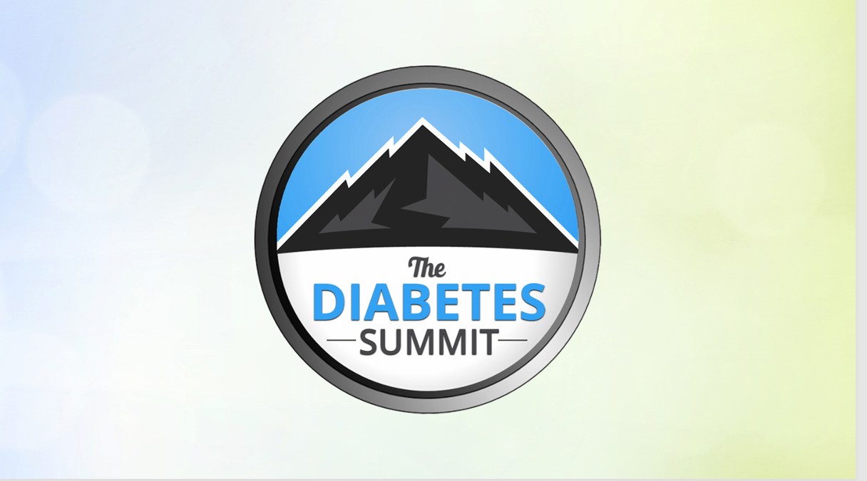
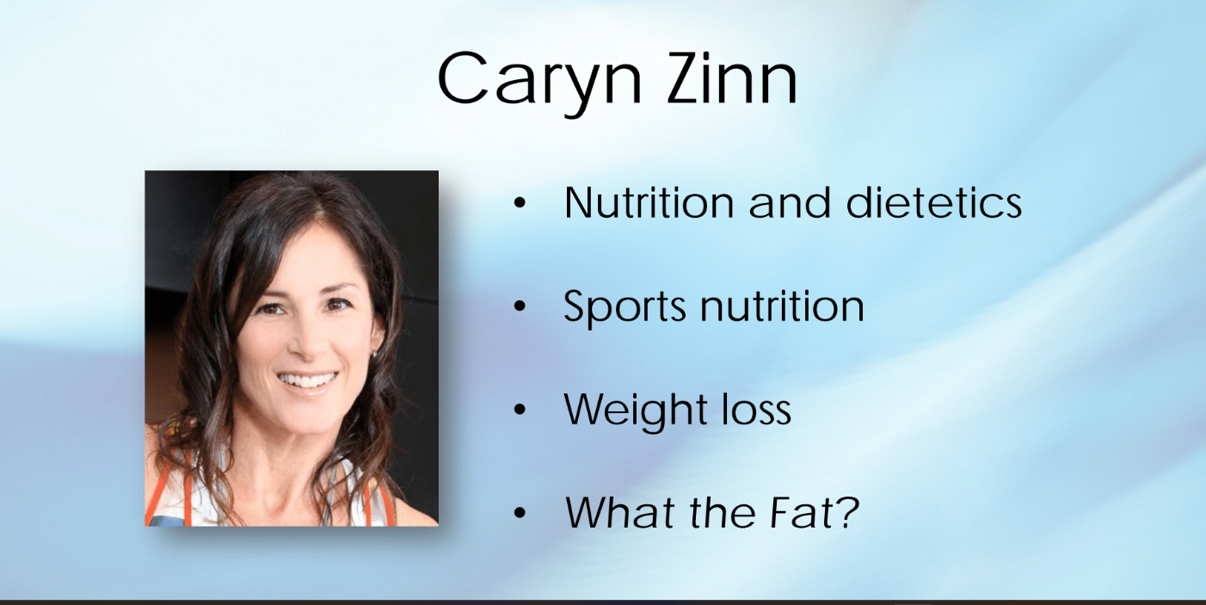
Caryn Zinn has been a Public Health dietitian for about 20 years. She focused on a low carbohydrate, high healthy fat diet and its effect on diabetes—specifically the insulin resistance faced in Type 2 diabetes. Caryn is known to be a whole food dietitian; therefore, she focuses on unprocessed fats for butter and animal fat with no sugar added. She stresses the avoidance of trans-fat and vegetable oils/fat. When looking at fat, there needs to be a shift in understanding total cholesterol and not looking at it negatively overall. She also emphasizes that a low-carb diet <130g/day is helpful because the body can make its own glucose. The diet would basically look more like a ketogenic diet. With this type of diet, one can get a better nutritional profile and benefit from an insulin surge.
A testimonial from one of Caryn’s patients was that while on this low-carb, high-healthy fat diet, he lost a lot of fat, and his prostate issues disappeared. For athletes using this diet style, recovery was better after exercise, but they lost their top end edge of their performance. These testimonials show to have positive effects from a low-carb, high healthy fat diet. It appears that it not only can benefit one who has diabetes with a natural insulin surge, but also others with underlying issues or even athletes.
I believe this type of diet can be applied in dietetics practice as a start to a healthy journey to see how the body tolerates it and observe the benefits. Caryn closes her discussion by stating she has a passion to help other dietitians and envisions them to be open-minded and read the research available to see at what outcomes they arrive.

A Natural Approach to Men’s Health Issues—Geo Espinosa (39:18)

Geo Espinosa is a naturopathic doctor, focused on men’s health. He claims that erectile dysfunction can be caused from organic diseases like pre-diabetes, but it is also reversible. In addition, Geo states that prostate problems lead to more aggressive cancers affected by diabetes. Diabetes can affect mental health and can have a systemic effect. Some individuals with diabetes found that the use of metformin increased insulin sensitivity. One notable point was that high insulin can cause cancer cell proliferation and uncontrolled insulin can cause an imbalance in the body.
Geo stated that one must look outside of urological problems and take a more holistic approach. For individuals suffering from erectile dysfunction and hyperglycemia resveratrol can be used which is helpful and can induce nitric oxide. Nitric oxide opens blood vessels for better blood flow. Additionally, magnesium and selenium are also protective against prostate cancer. It is important to note that the lowest effective dose of natural minerals should be used, especially in those with diabetes.
Geo stresses that diabetics should stay moving (about 8,000- 10,000 steps daily, with 30 minutes of moderate intensity. Interval training appears to be most effective. Geo explains that everything is connected: erectile dysfunction is related to metabolic syndrome. Metabolic syndrome is related to diabetes and the best way to fight that is to keep moving which will lead to good blood flow.

Advanced Functional Testing for Personalized Diabetes Care—Peter Osborne (48:51)
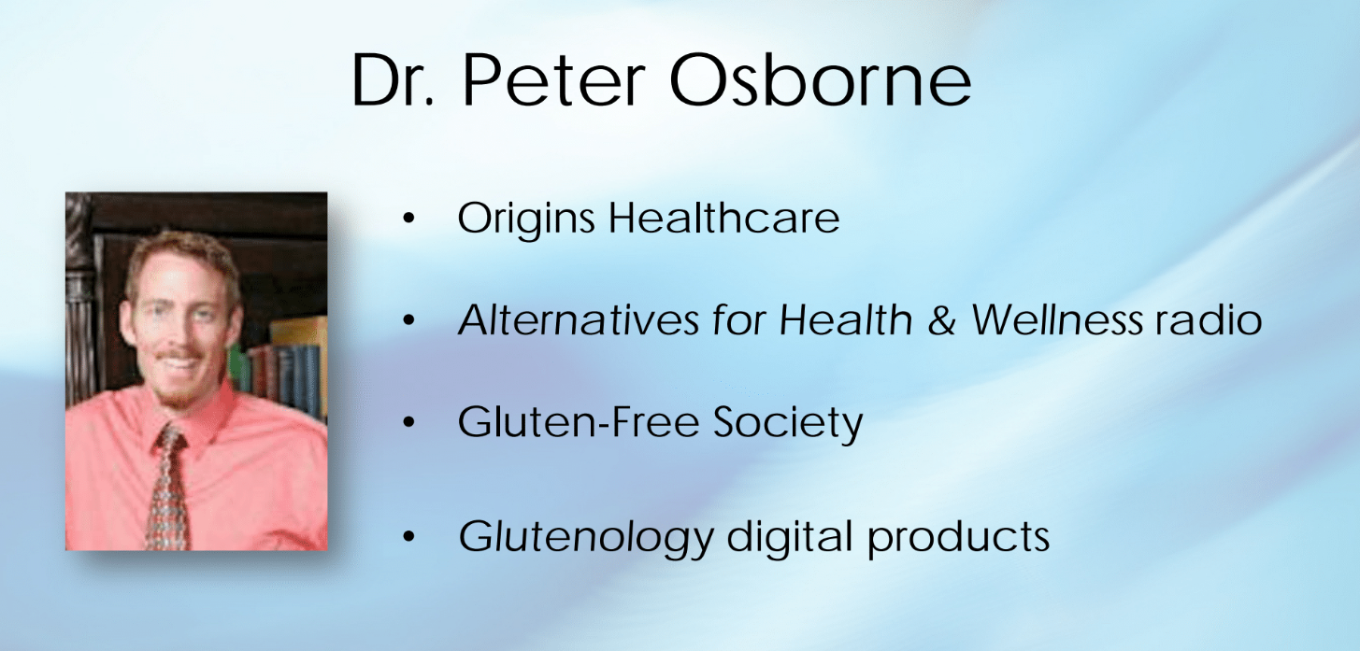
Peter Osburn stressed that patients should learn the value of certain functional tests. When patients go to their primary physician for care, they get a standard metabolic panel and HbA1C test completed. The problem is, however, that these basic tests measure for end-state abnormalities and not for early stages of disease. With this process, diseases are treated after the body is already damaged instead of being prevented 10 years prior.
Nutrition plays a vital role in regulating insulin. Looking at a micronutrient array and focusing on vitamin B, one will see how that helps in the breakdown process of glucose. Niacin, one of the B vitamins helps to lower cholesterol and opens the cellular door for glucose. Glucose gets into cells and out of the blood. When too much glucose is present in the blood, it makes it sticky and viscous, leading to hormone abnormalities. We need all the B vitamins at adequate quantities at the proper place in the cell. If this does not happen properly, it can cause a domino effect: abnormal breakdown of glucose leading a patient to feel fatigued, not wanting to exercise which can further slow down glucose breakdown and uptake. This can lead to metabolic syndrome and metabolic challenges which can lead to diabetes. Vitamin D helps in insulin production and antioxidant function to keep blood thin and not viscous. Viscous blood can lead to stroke and heart attack. Peter mentions that the center piece holding insulin together is a mineral called zinc but needs chromium to work efficiently. Metformin, a drug known to make insulin more sensitive, is used in the treatment of diabetes. Metformin and other diabetic medications are effective, but it can block vitamin synthesization over time.
Magnesium, an important mineral, is used to maintain active muscle tissue and good muscle tone. The more magnesium is present, the more insulin would be stable. Magnesium deficiency is induced by uncontrolled sugar intake. Peter states that it is better to test patients to see their deficiencies, using targeted supplementation, instead of just medicating in assumption. The patient’s health is on the line. Physicians can observe these good markers as a baseline: insulin, glucose, HbA1c, C-peptide, C-reactive protein, and micronutrition. It is important to note that micronutrition can measure food allergies and can be used for better blood sugar control.

An Evidence-Based Approach to End Diabetes—Joel Fuhrman (52:03)
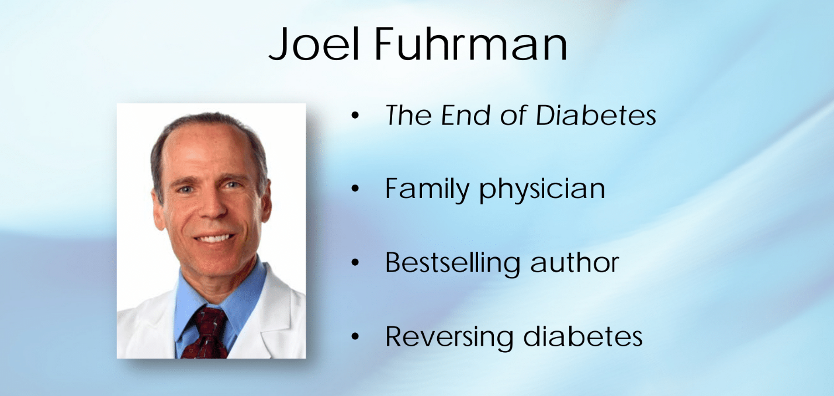
Joel Furman stated that markers for people with diabetes should be normalized. Individualized care is important for people Type 2 diabetes. Conventional medicines burnout the pancreas. The drugs that are prescribed cause damage in other areas of the body. Processed food, including oils leads to high glycemic index. The growth hormone IGF1 leads to increased cardiovascular disease risk. A diet containing more animal protein [eggs and red meat] leads to a predisposition of diabetes. A diet should be hormonally favorable. A diet should be clean and high in nutrients. Diets can increase the risk of getting diabetes.

Diabetes Without Drugs...It Can Be Done! --Suzy Cohen (49:59)
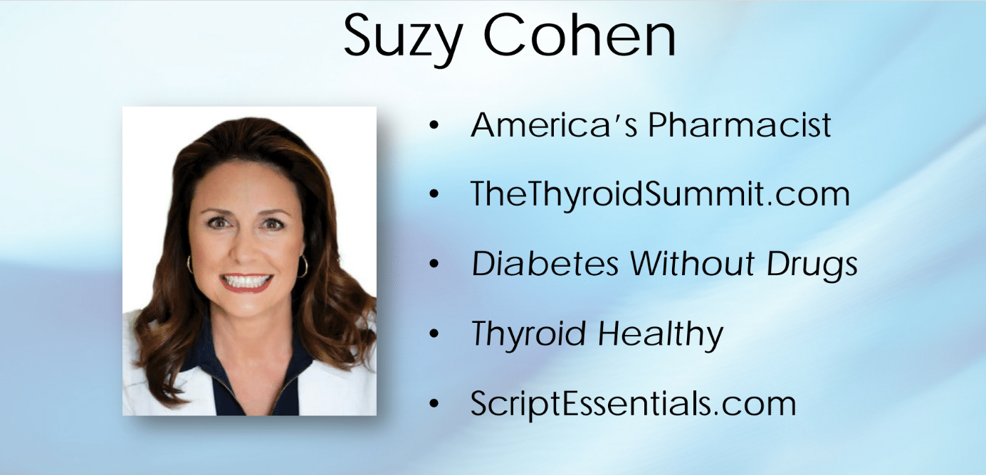
Susie states that bleached flour damages the beta cells. There was a study shown where ingredients in white flour purposely damaged beta cells in dogs. She mentioned that the drug, Abilify, causes diabetes: the statin induces hyperglycemia. Diuretics can cause insulin insensitivity and increase insulin resistance. The drug metformin leads to B12 deficiency. Susie says that if we marry our medicine with the right nutrients, we should be okay, but do not compromise on medications because it depletes other nutrients. She gave a list of things that lower blood sugar including lipoic acid, berberine, resveratrol and curcumin.

Examining the Research on Diabetes Cause, Prevention, and Treatment—Sayer Ji (41:36)
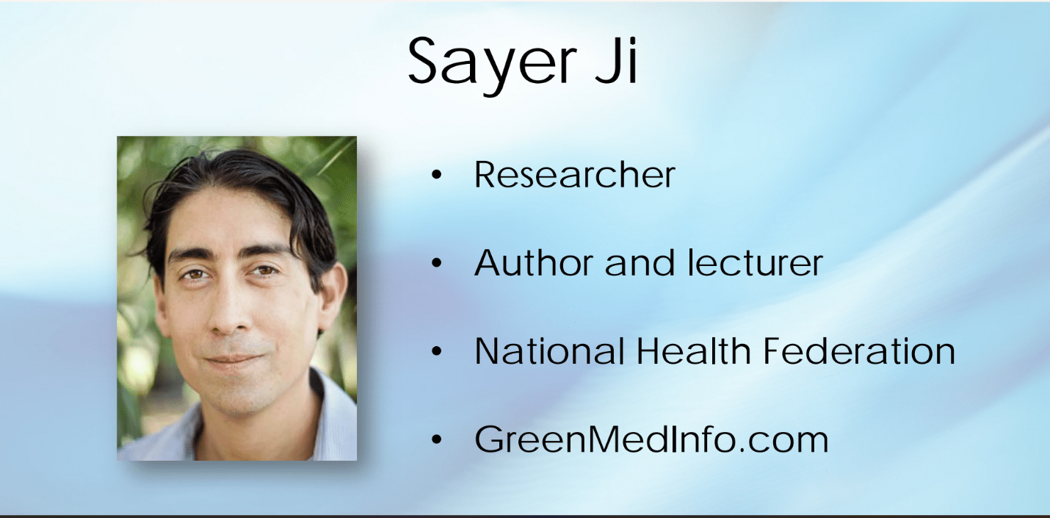
Sayer states that wheat and type 2 diabetes are linked together. Wheat and cow’s milk lead to autoimmune diseases like type 1 diabetes. Insulin therapy can destroy or have negative effects in the body that would not occur with insulin naturally derived from the body. It is important to deal with the root cause. The pancreas tries to overcompensate and in theory it burns out the beta cells causing reliance on insulin. Sayer states that honey, black cumin oil, and turmeric can all help with beta cell regeneration.

Gluten and Diabetes—Tom Obryan (45:38)
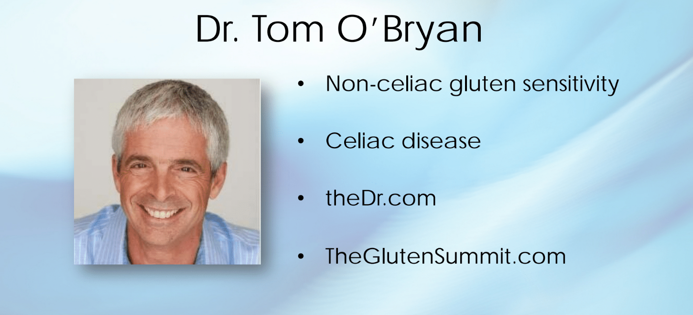
Tom states that there is gluten in a lot of things. Bad gluten is bad for you. There are many different components to gluten, and one can have sensitivity to it. The bacteria in the gut controls the brain function. The entire nervous system in the gut impacts blood sugar. Focus on the bacteria in the gut and you will feel better. Eat a fork full of fermented vegetables and feed the good bacteria in your gut. Proteins are hundreds of amino acids long. For example, the protein can match that of the pancreas and damage the cells. The body will send a signal for antibodies to the pancreas to get rid of the damaged cells. You can further damage cells by eating foods that have gluten which will damage the pancreas and can lead to type 1 diabetes. That is how gluten can contribute for some people with type 1 diabetes. Gluten free diets can improve insulin sensitivity in type 1 diabetes. Gluten can affect your brain and lead to Alzheimer's disease. If gluten is affecting you negatively stop eating it. Gluten makes small tears in the gut leading to leaky gut. Gluten free has increased glycemic index which increases blood sugar more.
For type 2 diabetes the receptor sites for the pancreas are attacked. Those with insulin resistance experience insulin not getting in the cells. The cells then send a signal to the brain to excrete more insulin.

How Gut Problems Can Cause and Exacerbate Diabetes—Steve Wright (58 :49)

Steve states that the microbiome in the gut has a lot to do with diabetes (pre-diabetes, Type 1 diabetes, and Type 2 diabetes. One can make changes to their diet and health to improve their body function. The digestive tract is constantly changing, and it is important in one’s health because it interacts with the immune system. The chemicals from the plants react with our immune system and can confuse our immune system. In the process of saving the body, good cells end up dying. Plants contain a chemical called prolamin. It is important to note that gluten is a prolamin. If we cut grains out of our diet that can be helpful in removing the risk of getting diabetes. Real food affects us differently from processed food. 3TC HCl is used to check if one has low stomach acid. Apple cider vinegar is helpful and can contribute to healthy stomach acid.

How Stress and the Adrenal Glands Affect Blood Sugar Control—Chris Meletis (43:34)
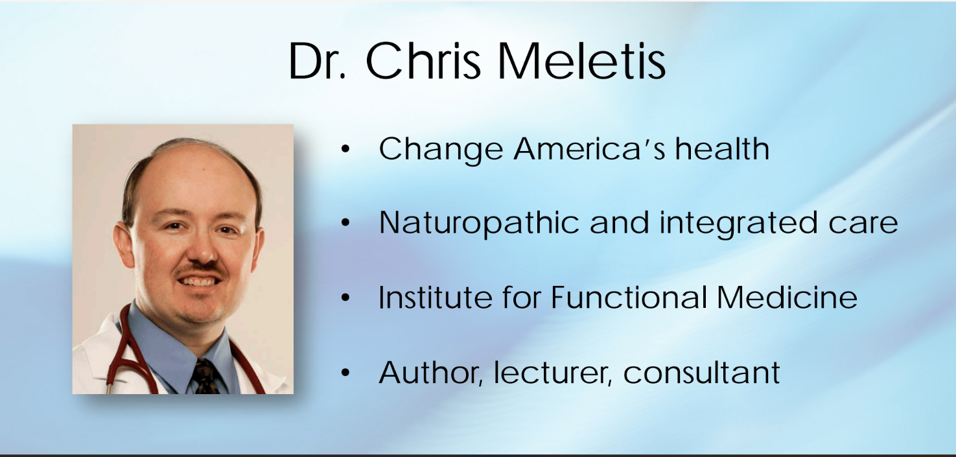
Chris states that stress can lead to a cascade of problems. Sometimes when people are stressed, they revert to having sweet cravings. When a person is stressed, the body is in distress which leads to unease and access to disease. Insulin resistance can lead to an increase in leptin and a decrease in adiponectin. Without consciously knowing, a person can be predisposed to diabetes from stress and the cascade that it causes.

How To Benefit From The Online Diabetes Community—Kerri Sparling (37:18)
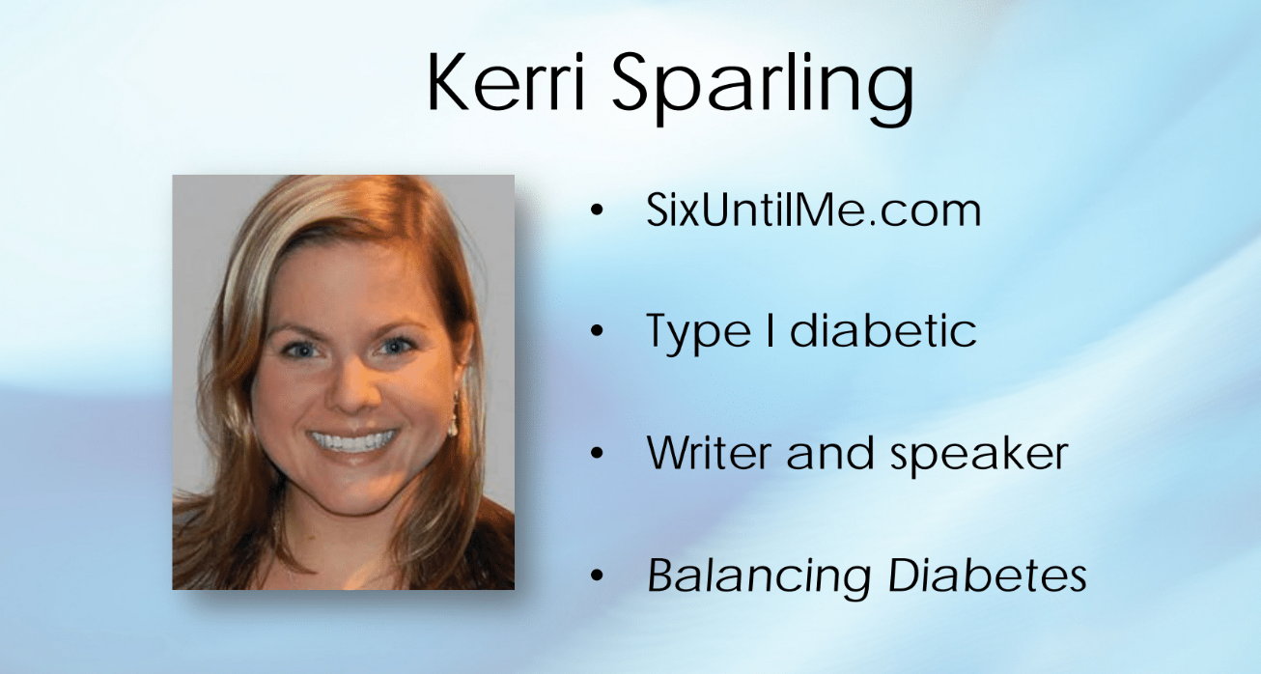
Kerry states that type 1 diabetes has an emotional layer to it. She says to just eat healthy. Indulging in not so healthy food should be occasional and not daily. It all has to do with self-control. Kerry states that the diabetes exchange system does not work and medication is helpful. However, that does not mean to just eat whatever you want because you have medication. The challenges of type 1 diabetes include burnout of the pancreas, hoping for the best, but planning for the worst. She says to stop using this scare tactic of the “or else”. Lean on people for the emotional part of having type 1 diabetes.

How to Live to 110 Years Old—Wendy Myers (37:47)
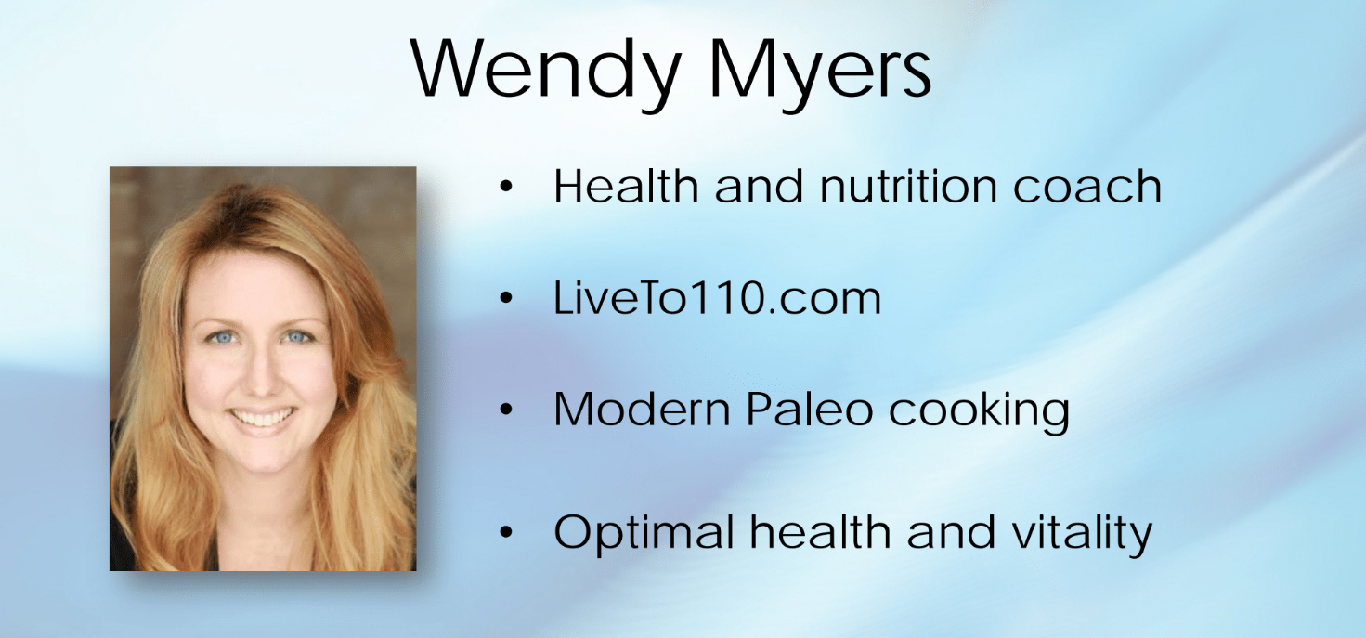
Wendy states that mineral depletion can lead to diabetes and further lead to decrease in insulin production from the pancreas. Zinc, manganese, calcium, and chromium promote pancreas insulin release. Doing a very involved hair mineral analysis test and correcting imbalance is helpful in treating or preventing diabetes. Wendy states that adrenal fatigue leads to copper toxicity which leads to an increase in calcium. Copper toxicity can cause a person to have headaches, fatigue, and low thyroid function which can all further lead to adrenal fatigue. Cadmium accumulation can slow metabolism. Selenium decreases zinc and mercury causes zinc deficiency. Besides this, sugar and carbs deplete magnesium. Arsenic causes insulin resistance and decreases the metabolism of glucose, leaving an open window to disease. Wendy states that reducing carbs to 25g per day is good for diabetics. She claims that one can take collated calcium at 750 milligrams per day, magnesium at 450 milligrams per day, zinc at 60 milligrams per day, manganese at 2 milligrams per day, chromium at 200 micrograms per day, selenium at 200 milligrams per day, kelp which contains iodine and 20 to 30 trace minerals, and vitamin D at 5000 IU per day. Diet, proper, supplementation, detoxification, and infrared sauna can sweat out chemicals and kill parasites.

Intensive Dietary Management for Diabetes Care—Jason Fung (49:58)
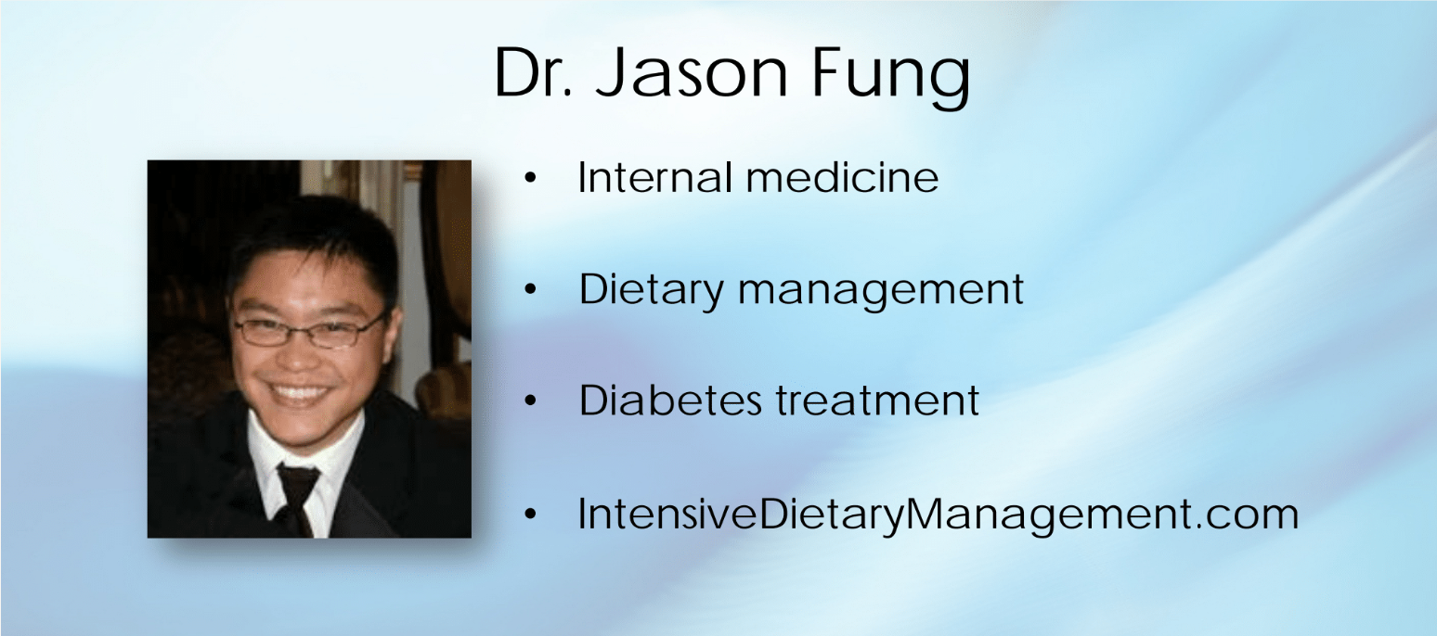
Jason Fung states that medication for diabetes is guaranteed to make diabetes worse. He states that diabetes is curable because it has been proven in patients with bariatric surgery. Insulin makes you gain weight. People take medications for diabetes because the doctor says that they must. Even if the doctor says you must, diabetes can be treatable with diet and lifestyle. Insulin resistance can be treated in diabetes by dealing with decreased insulin. If one decreases the amount of insulin needed to be produced or injected, it will help to take care of insulin resistance. It is wise to treat type 1 diabetes with insulin but not type 2 diabetes. A fatty liver leads to insulin resistance. Diabetes affects the whole body because the sugar is being shoved around in the bloodstream. Metformin does not always address Type 2 diabetes. Jason gives the garbage in the house analogy; a person did not get rid of the garbage, they just redistributed it. SGLT 2 inhibitors move sugar out of the body which can lead to urinary tract infections. It is a good start to lower insulin levels which can better treat Type 2 diabetes. The incretin effect increases insulin and not glucose. Hormones in the stomach increase insulin. This idea shows that the pill form of insulin is more effective. Hormones in the GI system caused this effect. Eating lots of meat has an insulin effect and a person won't do well. Eating unrefined foods, especially unrefined carbohydrates, intermittent fasting, and natural foods can help cure the disease. It is not easy but doable. It is not an incurable progressive disease that leaves people hopeless.

It’s All About The Cell Membrane—Dan Pompa (39:53)
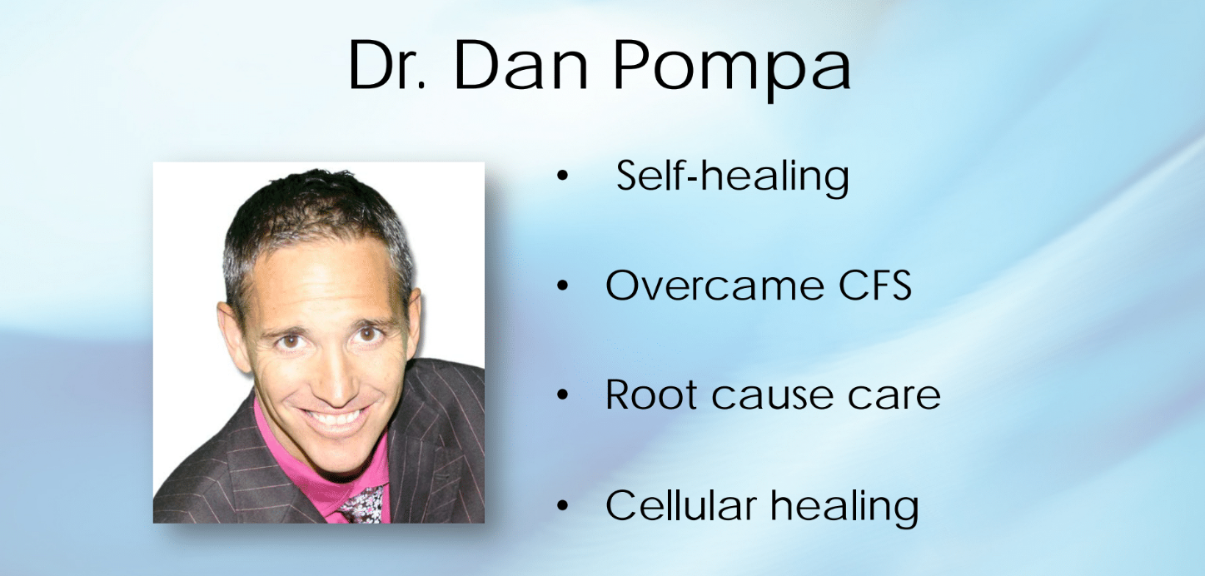
Dan states that toxins drive inflammation. Modern day medication does not fix the problem; it only treats the symptoms. Turn off the gene for diabetes expression. Vegetable fats turn rancid in the body and lead to inflammation. A person will never get well until they fix the cell. Pesticides increase chemicals in the body which can negatively drive diabetes. Glyphosate chemicals in grains are what the animals eat and that can get into our system when we eat meat. This is also found in the grains that we eat which can affect other conditions. Detox the cell to get well. Dan found that there is a problem with the receptor for insulin to get attached which leads to needing more insulin. Saturated fat and cholesterol are the two fats needed to stabilize and fix the cell membrane for diabetes and correct the problem. We need cholesterol. There are 5 levels in fixing the cell membrane and are as follows; R1: remove the source by taking grains and toxins out of our diet. R2: regeneration of the cell membrane. R3: restore cell energy. R4: reduce cell inflammation. R5: reestablishing methylation because toxins deplete methylation.
Cells detoxify via glutathione. Diabetes does not have to be a lifelong disease.

Joining The Food Revolution—Ocean Robbins (36:44)
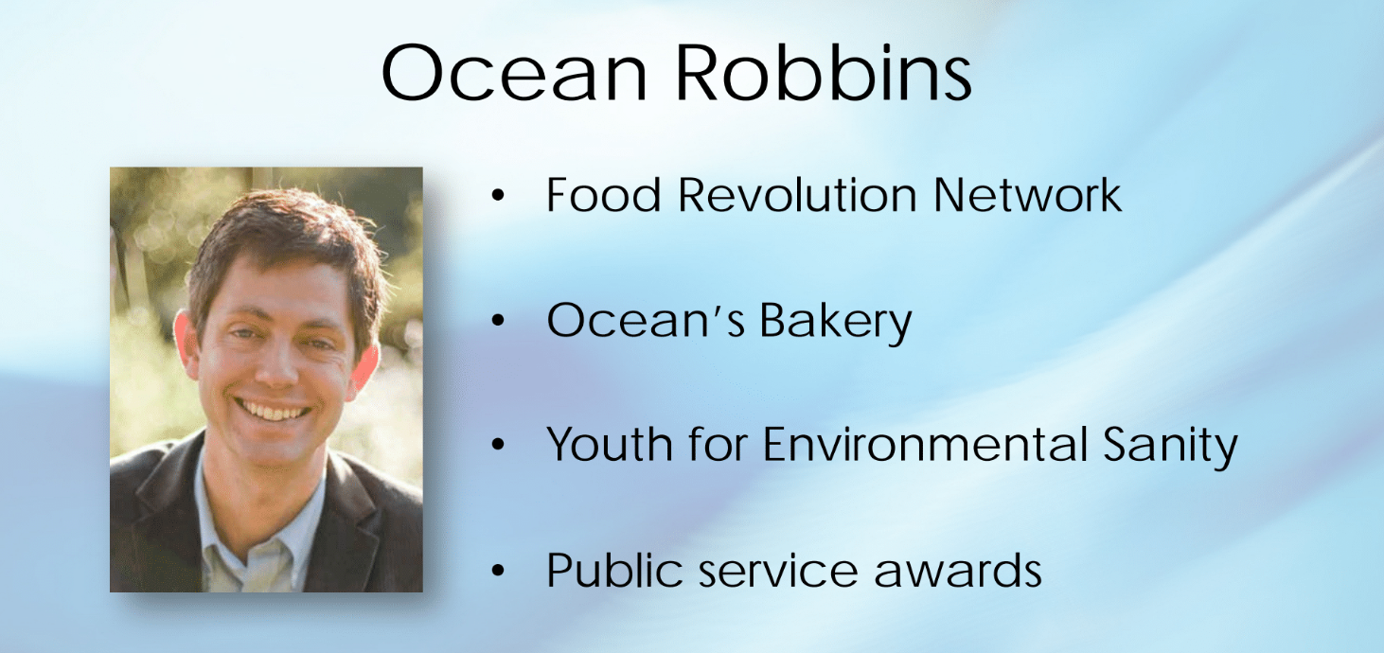
Ocean is family to Baskin Robbins ice cream but interestingly the family turned to eating healthily. Americans typically consume about 150 lbs of sugar a year. Eating highly processed foods and artificial junk leads to chronic disease. Taxing sugar or highly sweetened foods can lead to less purchases of those foods. Meat can also trigger diabetes. The animals are not moving much and so they are fattier and grain fed. We must make food healthier and more sustainable. Pesticides tend to accumulate up the chain leading to highly toxic food or contamination. Ocean speaks about the food revolution and the Clean 15. He says to eat wild fish, avocados, and nuts which are low food on the chain and plant strong. Plants can withstand herbicides and now absorb them. Glyphosate has an impact on bacteria. There is a dramatic correlation with food allergies and roundup, but more study is needed. Plants grow to produce their own pesticide. Focus on non-GMO or organic as much as possible. The dangers of artificial sweeteners are that more people consume them. As a result, there is an increase in obesity and an increase in sugar rates leading to an increase in the incidence of diabetes. Choose whole real foods. Get sugary sodas out of the schools, more drinking fountains, and change the school lunches. Any change can be difficult but then it could become the new normal. We can break or change habits for a new change. Protect kids from junk food.

Low Carb Controversy—Jimmy Moore (45:21)
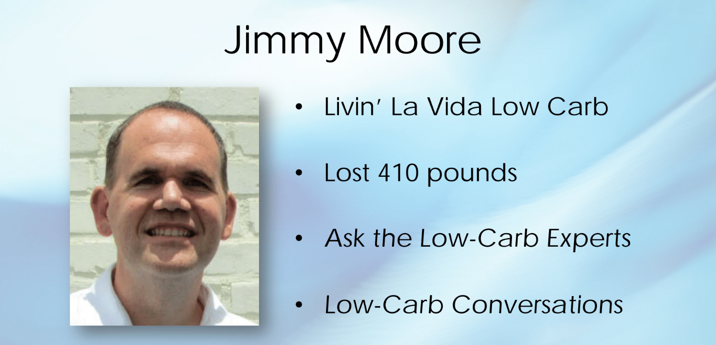
Jimmy states that eggs do not contribute to diabetes. Eat the egg yolk! He asks how red meat can contribute to diabetes? Cholesterol looks like the villain. HS CRP is highly sensitive C reactive protein. The villain is inflammation. Refined carbs, some whole carbs, and vegetable oils increase inflammation. If LDL is low, then don't stress. Total cholesterol is not the best way to contribute it to heart disease. HDL is a great cardiovascular risk marker. Triglyceride is also a great cardiovascular risk marker. Less than 100 is optimal. To test for heart disease try the CT heart scan or CIMT for carotid plaque. It tests for hard and soft plaque. The problem with the older generation is that they don't ask questions. Doctors are not necessarily trained in nutrition in medical school and don't have the best alternative nutrition advice to give. A very low carb diet is not the best idea for a diabetic. A ketogenic diet is better for a diabetic.

New Insights About Diabetes and the Brain—David Perlmutter (50:14)
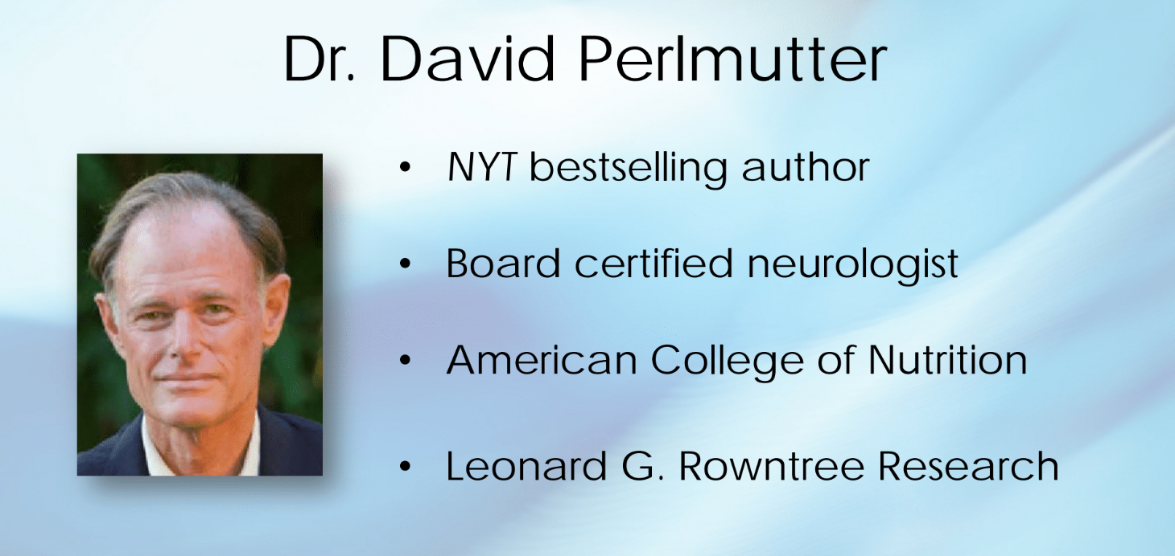
David states that food can affect our microbiome. The choices we make affect our gut. Sugar imbalance affects brain health. Refined grain increases carbs. Grain affects gut health. Gliadin breaks down epithelial cells of the gut barrier. The risk of Type 1 diabetes increases by 70% of those born by C-section and not getting the initial inoculation of microbiome. Antibiotics change the gut environment. Higher levels of firmicutes increase the change of gene expression, which leads to metabolic synthesis risks. C difficile can occur when someone takes too many antibiotics and it becomes an issue. It is treated with vancomycin or more effectively by taking fecal matter from a person with good gut health and inserting it in the colon of one with C difficile. What would happen if one did a good gut fecal transplant in those with diabetes? Studies have been carried out which reversed issues in those with diabetes. Their gut was reprogrammed.
Short chain fatty acids are relevant in terms of increased insulin sensitivity and effectiveness of butyrate. Artificial sweeteners have a huge damaging effect on the microbiome and the risk for diabetes is much greater. Fructose and artificial sweeteners don't cause an insulin surge. Other issues in the gut can affect the brain. The brain affects gut permeability. The gut bacteria manipulate the gut. Curcumin effects levels of DHA by increasing it. Coconut oil is a super fuel for the brain and is saturated fat. Saturated fat can't be oxidized and it's very resistant to free radicals. Eggs are a brain friendly antioxidant.

Overcoming and Eliminating Food Addiction—Sara Gottfried (55:18)
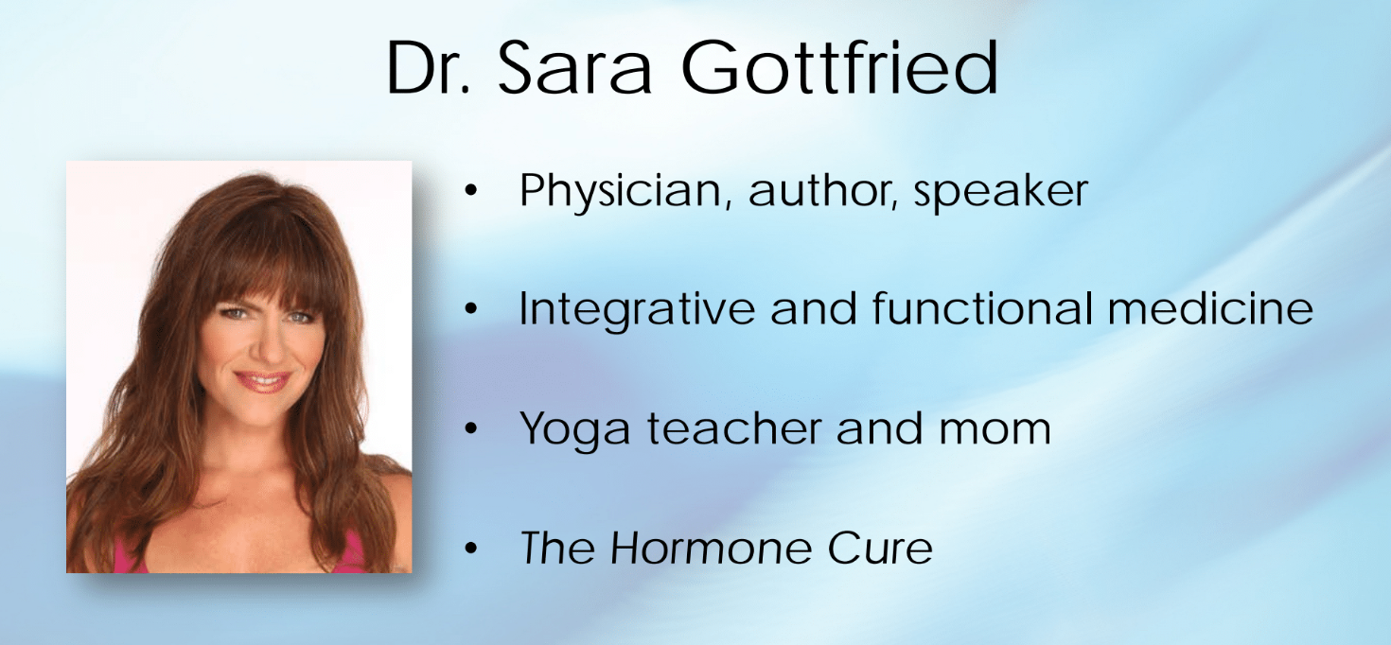
Sarah states that the body craves food that has the nutrients the body needs. Stress releases cortisol making a person gain weight. One will have better energy with better gut health. Willpower has an upper limit which leads to habit formation to shift mindset into healthy eating. Loneliness is as bad as smoking which increases oxytocin. Blood sugar decreases cortisol and the thyroid becomes more deficient. It takes 72 hours to make a major shift. Intermittent fasting works better in stabilizing insulin. Increased fat increases insulin production which leads to more insulin resistance.

Reversing Insulin Resistance—Josh Axe (44:50)
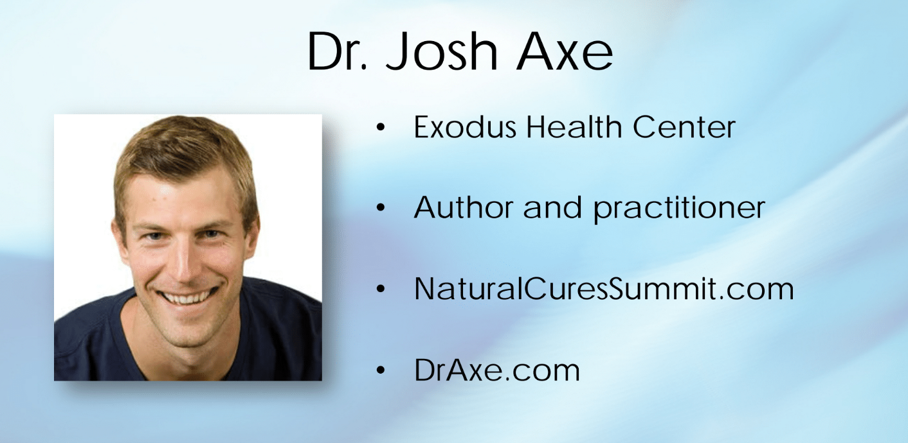
Josh states that insulin helps promote absorption of sugar. It is the most important hormone that can lead to increased overall weight and promote metabolism. Hyperinsulinemia causes sugar cravings, but eating a ton of sugar can lead to hyperinsulinemia. This leads to insulin resistance and burning out of insulin function. Sucralose like Splenda may be associated with increased risk of diabetes. Insulin affects estrogen and progesterone balance which affects fertility and can affect testosterone production. Insulin is an extremely important hormone. Josh states ways to balance insulin levels: increase sprouted chia, increase flaxseed, decrease grains, increase cruciferous vegetables, increase chromium, increase short chain and medium chain fatty acids, add cinnamon or turmeric to dishes, decrease milk, increase omega-3 and wild caught meat, and increase fiber.

The Four Pillars to Diabetes Care—Jody Stanislaw (36:55)
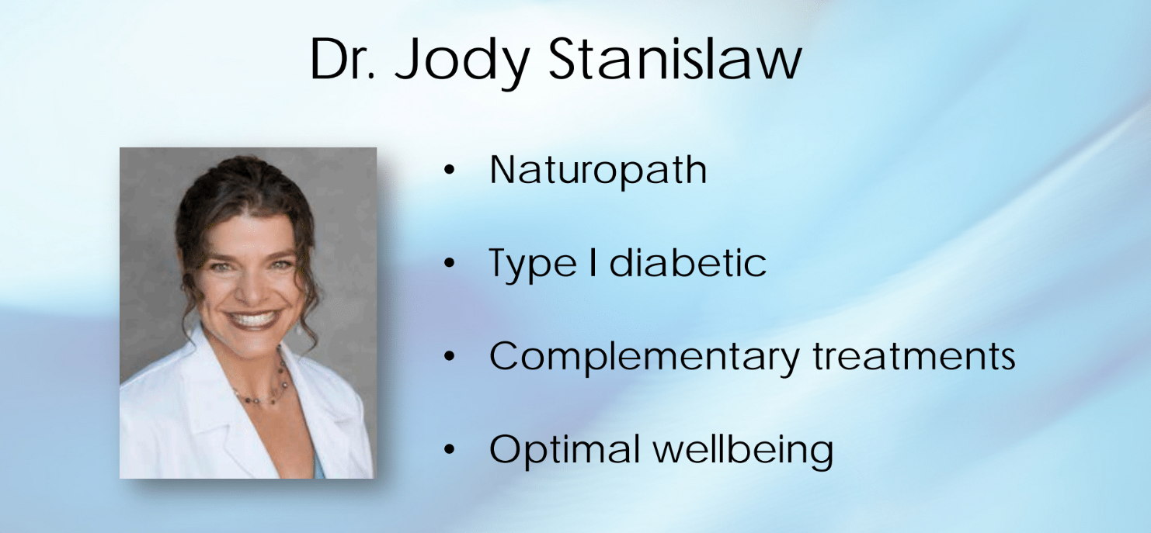
Jodi states that every time you have high blood sugar, it is damaging which causes free radicals in the system. Sleep is the best antioxidant. Take care of your body at an extra level as a diabetic. Check in on the emotional level of diabetics and the attitudinal area. Whole body naturopathic approach should be taken when dealing with diabetics. If you want to be as healthy as you can be you have to eat low carbs and whole foods. Smoothies, salads, fish, and nuts are a good start to eating healthy. Eliminate stress with Type 2 diabetes. The pancreas is under stress from trying to make insulin but can't. One can have good blood sugar levels with a low carb low dose method. Adopt a good healthy lifestyle with support overtime. People are in different stages of their readiness to change. It is good to understand what the diabetics emotional needs are. When your blood sugar is out of control it affects the emotions of a person with diabetes.

Vaccines Revealed Episode 1 (2:05:12)

Andy Wakefield states that there is pushback on denying vaccines because it will be at the expense of those who worked hard to create the vaccines. What is the science behind vaccination safety? The MMR vaccine can possibly cause autism. The first case was reported in the United Kingdom in 1992. Behavior in children changes with improvements of better diet. There was an epidemic causing autism related to vaccines. Vaccines can contain other variants that you may be unaware of. The body may not be able to cope well. Not having a vaccine can cause a child to not be eligible to go to school. If something goes wrong with the vaccine, compensation is available, but it is a long road. Behavioral issues are denied by doctors. Things are being swept under the rug. Then it takes special education to care for the child. Examine the children and examine their behaviors. Treating a child's bowels leads to stopping vulgar behaviors. Andy lost his license from the medical board for suggesting certain treatment for autism. Measles, mumps, and rubella vaccines are given in two doses: the first dose at nine months to 15 months of life and the second dose at four to six years old. The mumps vaccine uses rabbit blood serum which produces an artifact and makes it look like one is immune. The chicken pox vaccine, which is also called varicella, is given at 12 to 15 months of life for the first dose and four to six years old for the second dose. Parents must represent the interests of their children. What is the public view on vaccines? Parents believe doctors. Some parents don't believe the rhetoric from CDC. 87% of parents want more information. More than 57% of parents believe vaccinations can cause autism. The CDC gets angry that there is mistrust in the government. A child died 10 days after the MMR vaccine and the parents are receiving compensation. One needs a comprehensive study of vaccinations versus unvaccinated groups, and the CDC is highly reluctant to do that study.
Gary, a sole resource analyst looked at the chicken pox vaccine and saw that kids were reporting to have shingles which was abnormally high in its incidence rates. These children were not vaccinated with varicella but had chicken pox naturally. There is a connection between chicken pox and shingles with shingles being the secondary disease. Shingles is the second manifestation of chickenpox and adults get boosted for the varicella vaccination. As children's vaccination treatment decreases, the shingle outbreak increases. The CDC did not want Gary Goldman to look at any shingles outbreaks and did not want any paper on varicella published. Through all of this, he kept an active study going. Cost to treat chickenpox and shingles is 25% and 75% respectively. It is more about saving money than lives for the government. The chicken pox vaccination was pushed even more because it allowed parents to be able to be at work more than at home taking care of a sick child with chicken pox. With one vaccination dose of shingles, the efficacy decreases. If all children get the chicken pox vaccine there is no need for the booster and less chance of a shingles outbreak. Gary had to resign because he didn't want to be part of research fraud and stopped conducting research at the CDC. He was able to publish three papers in the European Journal on vaccinations. The CDC did not want any parts of his publication, and he was asked by the county judge not to publish. Because of this, he got a lawyer and a cease to desist letter was dropped. His paper was stalled from being published which was buying the CDC more time to vaccinate other people. The CDC just wants to promote vaccination. Each vaccination needs to be judged on its own merit. Getting chickenpox virus can help prevent other viruses.
Tony Bart explains that you cannot just listen to what a physician tells you. Pediatricians really believe what they are told from higher. Don’t listen to everything your pediatrician or doctor is telling you. The Gardasil vaccination was created to prevent HPV, but it is being questioned because cervical cancer takes 15 years to develop, and only certain strains of HPV can contribute to that. 40% of adults test positive for HPV but it is it clears on its own. Because the take up rate has been poor, it was suggested to give the Gardasil vaccination to newborns. The antibodies for this happen three to five years and you cannot give boosters to newborns. There was a high death rate amongst women over 26 years within seven months. A lot of people receiving HPV vaccination, especially after being exposed greatly, increases their chance of getting cancer. HPV is only sexually transmitted, and it is a money maker. This vaccination has been recommended by the Japanese government, but they rescinded the vaccine. There is a lot of disconnect with this vaccination. In studies, placebos were used but the placebos are experimental vaccines and dangerous adjuvants. The FDA is fully aware of this and helps to design these types of studies. You cannot compare a deathly component to another deathly component. Aluminum adjuvants are used for studies but not in vitro in human subjects. These studies are used to show that the morbidity and mortality rate are about the same as the rate outside in the world. The average doctor or scientist does not know what the placebo is or what it contains. The government or health care system wants you to blow the whistle because that may mean losing funds. The National Vaccination act came out in 1986 which outlined that one cannot sue the vaccination companies, nor can they be sued for faulty design. There is a special vaccination court which is run by the federal government. The Department of Justice will only back up drugs but not vaccines. Guillan-Barre syndrome Is a rare autoimmune disorder that affects the nerves and causes progressive weakness or paralysis. The flu vaccine can affect the myelin if it crosses the brain barrier. There were certain diseases that were not eradicated due to vaccination, but it was due to better public health. The shingles burden shifted, and adults were naturally protected from shingles by staying near predisposed children that may have chickenpox. It keeps the antibodies active. In 1937, the first case of autism in children were of doctors and researchers. Autism is attributed to vaccination but also to the toxins in the environment.

