Assignment 1a.
The concept of motivational interviewing is a beneficial way to gain valuable information during a nutrition education session. The use of open-ended questions is more efficient than closed-ended questions. Some open-ended questions begin with words like what, who, where, when, and how. It is important to properly phrase questions so that the client will not be offended nor shut down. Try to stay away from knowledge questions, but if used, they should be placed in a way not to make the client feel put beneath. Data questions should also be used less frequently because they are normally closed-ended questions and can limit the amount of information received from a client. Feeling questions are encouraged as they promote more conversations.
Using the elements OARS skills can be useful during motivational interviewing to gather, explore, and move toward a productive outcome. OARS stands for open-ended questions, affirmations, reflections, and summarizing. Open-ended questions focus on questions that begin with “how” and “what” as discussed previously. It is also important not to rush the questions. Including affirmations during a nutrition education session helps clients feel more confident. Affirmations should be genuine, respectful, and individualized. Reflections during a session help the counselor to connect to the client and guide them towards change. Reflections can be simple or complex, but it is used to keep the interaction going between counselor and client. It also reflects the need for change. Summarizing pulls the entire conversation back together. The counselor would take what the client has said and present it back to them. This summarizing strategy can also be used to tie up one topic and start on a new one.
Assignment 1b.
SMART goals are a technique that helps to focus on what is important and will produce realistic outcomes. SMART stands for specific, measurable, achievable, relevant, and time bound. Making a specific goal makes it easier to evaluate that goal. A measurable goal is what determines and accurately reflects success. Relevance in a goal is a mechanism that is needed to help monitor goals. The key is to have low effort, high value goals. Time-bound goals encapsules a time by which a goal should be accomplished. It is important to reinforce that SMART goals are an ongoing practice, and it is also dynamic. This helps goals to stay flexible and a counselor can reevaluate the goals regularly.

Assignment 2
Client 1: A.J
SMART Goal: I will drink my ProSource supplement once a day for the next 30 days to help heal my pressure injury at my sacrum and wound on my left shin.
Action Plan:
Week 1: Continue on pureed diet, moderate thick, level 3 consistency. Drink ProSource supplement.
Week 2: Continue on pureed diet, moderate thick, level 3 consistency. Drink ProSource supplement. Check size of wounds.
Week 3: Continue on pureed diet, moderate thick, level 3 consistency. Drink ProSource supplement. Check the size of wounds and continue to monitor healing.
Week 4: Continue on pureed diet, moderate thick, level 3 consistency. Drink ProSource supplement. Check the size of wounds and continue to monitor healing. Reevaluate if additional ProSource supplement is needed to help with healing.
Steps taken to foster cultural sensitivity:
- Check client’s chart to see if there were any language barriers.
- Don’t make assumptions of client background; rather ask questions
- Pay attention avoiding being biased/prejudice
- Use educational material that the client can culturally relate to.
92 y/o female PMHx: dementia, peripheral vascular disease, T2DM, HTN, HLD, glaucoma, generalized weakness, acute cystitis with hematuria, dysuria, bradycardia, COPD, transient cerebral ischemic attack, atrioventricular block, gout, Vitamin deficiency, anemia, and constipation.
Anthropometrics:
Ht: 66"
Wt: 131lbs
BMI: 21.3 (normal)

Labs:
Hgb: 7.8 g/dL (L) possibly due to anemia
Hct: 23.9% (L) possibly due to anemia
BUN: 54 mg/dL (H)
Create: 2.24 mg/dL (H)
Na: 145 mmol/L
Cl: 109 mmol/L
K: 5.0 mmol/L
Medications: Gabapentin, Sitagliptin, Cilostazol, Acetaminophen, Amlodipine Besylate, Rosuvastatin
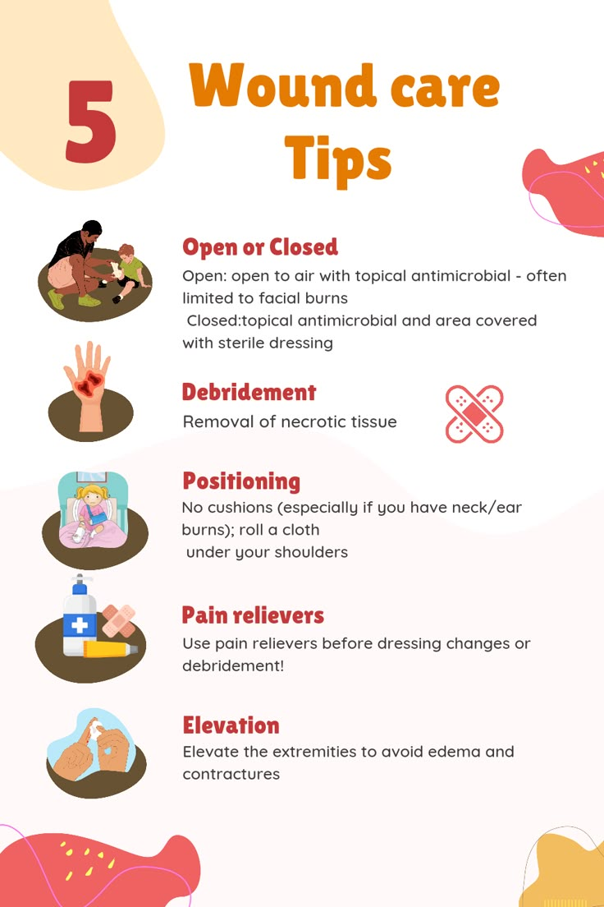

Client 2: E.M
SMART Goal: I will eat a heart healthy diet and continue on my heart medications over the next 60 days and check my ejection fraction to see improvement.
Action Plan:
Week 1: Continue on heart healthy diet, soft and bite-sized, thin consistency. Take heart medication. Check baseline ejection fraction.
Week 2: Continue on heart healthy diet, soft and bite-sized, thin consistency. Take heart medication. Attend physical therapy.
Week 3: Continue on heart healthy diet, soft and bite-sized, thin consistency. Take heart medication. Attend physical therapy.
Week 4: Continue on heart healthy diet, soft and bite-sized, thin consistency. Take heart medication. Attend physical therapy. Monitor labs.
Week 5: Continue on heart healthy diet, soft and bite-sized, thin consistency. Take heart medication. Attend physical therapy. Check ejection fraction.
Week 6: Continue on heart healthy diet, soft and bite-sized, thin consistency. Take heart medication. Attend physical therapy.
Week 7: Continue on heart healthy diet, soft and bite-sized, thin consistency. Take heart medication. Attend physical therapy.
Week 8: Continue on heart healthy diet, soft and bite-sized, thin consistency. Take heart medication. Attend physical therapy. Check ejection fraction.
Steps taken to foster cultural sensitivity:
- Check client’s chart to see if there were any language barriers.
- Don’t make assumptions of client background; ask questions of history
- Pay attention avoiding being biased/prejudice
- Use educational material that the client can culturally relate to.
82 y/o female with PMHx of atrial fibrillation, HTN, HLD, HRrEF, cerebral infarction, depression, UTI, aphasia, muscle weakness, constipation, vitamin B deficiency, heart failure, GERD, and magnesium deficiency.
Anthropometrics:
Ht: 62"
Wt: 124lbs
BMI: 22.7 (normal)
Labs:
Hgb: 11.4 g/dL
Hct: 37.2%
BUN: 24 mg/dL
Creat: 0.7 mg/dL
Na: 140 mmol/L
Cl: 104 mmol/L
K: 4.2 mmol/L
Glu: 80 mg/dL
Medications: Toprol XL, Senokot, Jardiance, Magnesium Oxide, Ergocalciferol, Atorvastatin, Vitamin B-12, Eliquis, Polyethylene Glycol, Tylenol, Maalox Plus Suspension, Famotidine
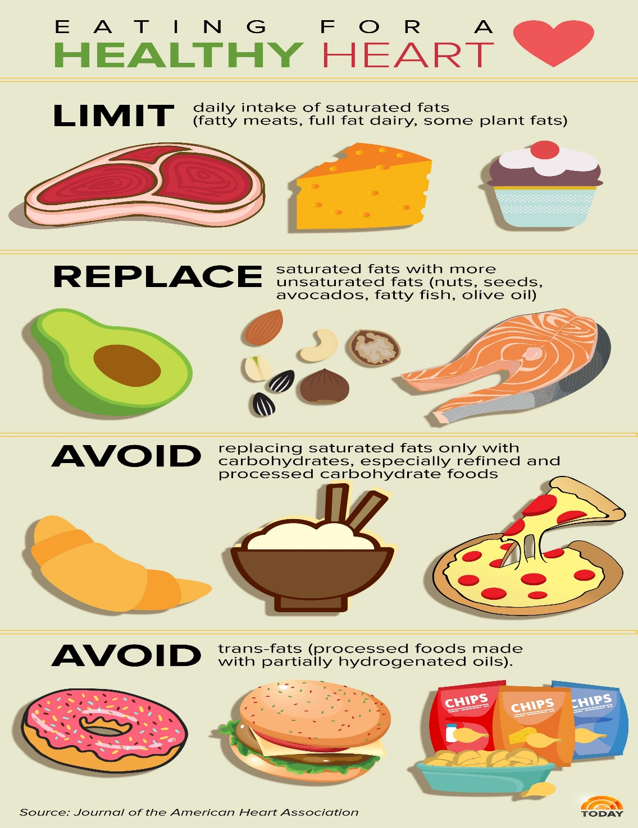

Client 3: C.C
SMART Goal: I will check my blood glucose daily and see how healthier choice foods positively affect the sugar levels for the next 30 days.
Action Plan:
Week 1: Continue on Consistent Carbohydrate diet, regular texture, thin consistency. Check blood glucose baseline.
Week 2: Continue on Consistent Carbohydrate diet, regular texture, thin consistency. Check blood glucose consistency.
Week 3: Continue on Consistent Carbohydrate diet, regular texture, thin consistency. Check blood glucose to see if it is better controlled. Reevaluate if changes are necessary to diet.
Week 4: Continue on Consistent Carbohydrate diet, regular texture, thin consistency. Check blood glucose for consistency.
Steps taken to foster cultural sensitivity:
- Check client’s chart to see if there were any language barriers; use interpreter
- Ask necessary questions
- Pay attention avoiding being biased/prejudice
- Use educational material that the client can culturally relate to.
74 y/o male PMHx: T2DM, HTN, nonobstructive CAD, metastatic RCC, malignant neoplasm of the brain, benign prostatic hyperplasia without urinary tract symptoms, anemia, peripheral vascular disease, nontraumatic subdural hemorrhage, atherosclerotic heart disease, and bilateral inguinal hernia without obstruction or gangrene
Anthropometrics:
Ht: 67"
Wt: 129 lbs
BMI: 20.3 (normal)
Labs:
Hgb: 9.4 g/dL (L) possibly due to anemia
Hct: 30.9% (L) possibly due to anemia
BUN: 13mg/dL
Create: 0.75 mg/dL (H)
Na: 135 mmol/L
Cl: 98 mmol/L
K: 4.4 mmol/L
Glu: 165 mg/dL
Medications: Glipizide ER, Vascepa, Januvia, Lyrica, Pioglitazone HCl, Tamsulosin HCl, Metaprolol Succinate ER, Trulance, Atorvastatin, Acetaminophen, Senna-Time, Metformin HCl
