Biological Data Analysis Assignment

Information for Instructors

Biological Data Analysis

Overview
This assignment will address the Pathways outcome: Apply the scientific method to explore natural phenomena, including hypothesis development, observation, experimentation, measurement, data analysis, and data presentation.

Students will investigate a biological phenomenon using real or simulated data, apply appropriate methods of analysis, and communicate their findings to an audience of nonscientists. The final product will be a written piece that explains the biological context, presents the results of the analysis, and interprets their significance in clear, accessible language for readers outside the scientific community.

Information for Students

Biological Data Analysis

Overview
In this assignment, you will investigate a biological question or problem that can be explored through data analysis. You will formulate a hypothesis, collect or use available biological data, apply relevant analysis techniques, and present your findings in a written document for a general audience. Your goal is to make your work understandable and engaging for readers without specialized biology training while still presenting accurate and well-supported information.

As you work to complete this assignment, you will:
- Select a biological question that can be addressed using data and analysis. Possible topics include:
- examining the relationship between temperature and plant germination rates.
- analyzing bird migration patterns in relation to seasonal temperature changes.
- investigating bacterial growth under different environmental conditions.
- studying the correlation between water quality and aquatic biodiversity.
- comparing rates of photosynthesis under different light conditions.
- Formulate a hypothesis.
- Gather data.
- Analyze the data using appropriate methods.
- Create at least one data table and one visual representation (e.g., graph, chart).
- Interpret your results in relation to your hypothesis and relevant biological concepts.
- Present your findings in clear language that is accessible to non-scientists.

Assignment Format & Guidelines
Your biological data analysis assignment will:
- Be 800–1,000 words in length.
- Have a clearly state your hypothesis, methods, results, and conclusions.
- Be suitable for publication in an online forum, science outreach blog, or educational magazine.
- Use at least two credible data sources and in-text references (e.g., “According to the U.S. Fish & Wildlife Service…”).
- Contain at least one data table and one graph or chart.

Assessment Criteria
Your assignment will be graded on:
- Your hypothesis statement.
- The accuracy of your collected collection
- The use of appropriate data analysis methods.
- The visualization of the data to present your findings.
- Your ability to communicate your finding to nonscientists.
- The organization and formatting of your assignment.

Biological Data Analysis Assignment Grading Rubric
Criteria | Exceeds Expectations | Meets Expectations | Approaches Expectations | Developing
Hypothesis & Problem Definition  (20 points) | Hypothesis is precise, testable, and well-justified; problem is clearly relevant and significant.  (16–20 points) | Hypothesis is generally clear and testable; relevance is adequate.  (13–15 points) | Hypothesis is somewhat vague or partially testable; limited connection to the problem.  (9–12 points) | Hypothesis is vague or poorly connected to the problem.  (0–8 points)
Data Collection & Accuracy  (20 points) | Data is relevant, accurate, and sufficient; sources or collection methods are clearly documented.  (16–20 points) | Data is generally relevant and accurate; some documentation provided.  (13–15 points) | Data is incomplete, somewhat inaccurate, or weakly documented.  (9–12 points) | Data is insufficient, unreliable, or undocumented.  (0–8 points)
Biological Data Analysis  (20 points) | Analysis is thorough, accurate, and uses appropriate biological methods; calculations are correct.  (16–20 points) | Analysis is generally correct; methods are adequate but may lack depth.  (13–15 points) | Analysis shows partial accuracy; methods somewhat appropriate but underdeveloped.  (9–12 points) | Analysis contains significant errors or inappropriate methods.  (0–8 points)
Visual Data Presentation  (15 points) | Visuals are clear, accurate, and effectively illustrate findings.  (13–15 points) | Visuals are adequate but may lack clarity or accuracy. (10–12 points) | Visuals are incomplete, somewhat unclear, or weakly support findings.  (7–9 points) | Visuals are unclear, inaccurate, or missing.  (0–6 points)
Communication to Public Audience  (15 points) | Writing is engaging, clear, and accessible; effectively translates biology for general readers.  (13–15 points) | Writing is mostly clear and understandable; some jargon remains.  (10–12 points) | Writing is partially clear but contains excessive jargon or limited accessibility.  (7–9 points) | Writing is unclear, overly technical, or inaccessible.  (0–6 points)
Organization & Format  (10 points) | Work is well-organized, polished, and meets all formatting/citation requirements.  (9–10 points) | Organization and formatting are adequate; minor citation errors.  (7–8 points) | Work shows uneven organization and multiple citation or formatting errors.  (5–6 points) | Work is disorganized, poorly formatted, or missing citations.  (0–4 points)

Sample Student Submission
Bryson Carver
Introductory Biology

Title: The Effect of Light Color on the Photosynthetic Rate of Spinach Leaves

Photosynthesis is the process by which plants convert light energy into chemical energy. I hypothesized that spinach leaves exposed to blue light would have a higher photosynthetic rate than those exposed to green light, due to the absorption spectrum of chlorophyll.

I obtained fresh spinach leaves and prepared leaf disks, which were then placed in a bicarbonate solution under different LED light colors: blue, red, green, and white (control). I measured the time it took for leaf disks to float as oxygen accumulated in the leaf tissue during photosynthesis. Trials were repeated three times for each light color.

The results showed that blue light had the fastest average float time (4.5 minutes), followed by red light (5.0 minutes), white light (6.0 minutes), and green light (12.5 minutes). A bar graph of the results shows a clear advantage for blue and red light in driving photosynthesis, confirming the hypothesis and aligning with known absorption spectra for chlorophyll a and b.

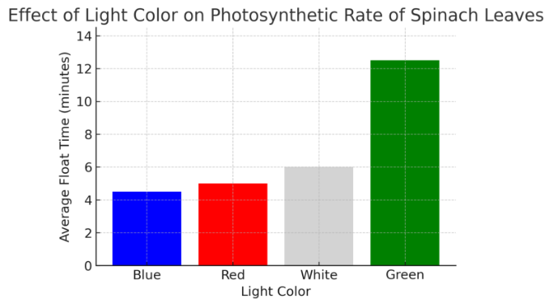

These findings suggest that artificial lighting for plant growth should emphasize blue and red wavelengths for optimal photosynthetic activity. This has implications for greenhouse farming and indoor hydroponics, where light quality can be controlled.

References: - Taiz, L., Zeiger, E., Møller, I. M., & Murphy, A. (2018). Plant Physiology and Development. Sinauer Associates.
- NASA. (2021). Light and Plant Growth. https://www.nasa.gov/education/materials

