Tensile Strength of Metals Analysis Assignment

Information for Instructors
Tensile Strength of Metals Analysis Assignment

Overview
This activity addresses the Pathways outcome: Gather, analyze, and interpret data and present it in an effective written laboratory or fieldwork report.

In this assignment, students will evaluate the mechanical properties, specifically tensile strength, of five metals commonly used in engineering. They will analyze a data set resulting from tensile tests and produce a formal lab report interpreting the material behaviors. This assignment emphasizes data interpretation and effective disciplinary communication.

Information for Students
Tensile Strength of Metals Analysis Assignment

Overview
In this assignment you will analyze a data set resulting from tensile strength testing of five metals. You will use your knowledge about yield strength, tensile strength and Young’s modulus. Using the dataset provided below, you will analyze mechanical properties and write a formal laboratory report.

Metal | Yield Strength (MPa) | Ultimate Tensile Strength (MPa) | Young’s Modulus (GPa)
Aluminum 6061-T6 | 276 | 310 | 69
Mild Steel | 250 | 400 | 200
Brass | 200 | 350 | 100
Copper | 70 | 210 | 110
Stainless Steel 304 | 290 | 620 | 193

As you work on this assignment, you will:
- Interpret stress-strain data.
- Calculate mechanical properties (e.g., yield strength, tensile strength, Young’s modulus).
- Compare materials based on performance.
- Draw reasoned engineering conclusions.
- Communicate findings clearly and professionally in a written lab report.

Assignment Format & Guidelines
Your report will:
- Be 3-4 pages in length, typed, double spaced, using 12-point font.
- Include the following sections:
  - Introduction
  - Methodology- description of the methods used
  - Data analysis, including a graph of the results
  - Discussion
  - Conclusion
  - References

Assessment Criteria
Your assignment will be graded on your:
- Accuracy and completeness of data analysis.
- Interpretation and comparison of material properties.
- Quality of graphs and tables.
- Organization, clarity, and professional tone of the report.
- Use of engineering terminology and concepts.

Tensile Strength of Metals Assignment Grading Rubric
Criteria | Exceeds Expectations | Meets Expectations | Approaches Expectations | Developing
Data Analysis (30 points) | Data analysis is fully accurate; all required values are included with correct units and appropriate methods.  (27–30 points) | Data analysis is mostly accurate; most values are included with appropriate units and methods, with minor errors.  (21–26 points) | Data analysis is partially accurate; some values, units, or methods are missing or inconsistently applied.  (15–20 points) | Data analysis is inaccurate or missing; multiple errors in units, calculations, and presentation.  (0–14 points)
Graph  (20 points) | Graph is clear, accurate, and appropriate for the data, with complete labels and formatting. (18–20 points) | Graph is mostly clear and appropriate; some labels or formatting are incomplete.  (14–17 points) | Graph has errors in choice or labeling. (10–13 points) | Graph is missing, unclear, or inappropriate for the data, with little to no labeling. (0–9 points)
Interpretation & Discussion (30 points) | Provides insightful comparisons and explanations of material behaviors; conclusions demonstrate deep understanding. (27–30 points) | Provides general comparisons and explanations; interpretations are mostly correct with some insight. (21–26 points) | Limited interpretation included; explanations lack detail/clarity.  (15–20 points) | Provides little or no interpretation; explanations are inaccurate or missing.  (0–14 points)
Organization & Communication  (20 points) | Report is logically structured, clearly written, and uses precise terminology and professional tone. (18–20 points) | Report is mostly clear and structured, with minor issues in clarity, tone, or terminology. (14–17 points) | Report is somewhat organized with some areas where tone and terminology are incorrect.  (10–13 points) | Report is unclear with some has organization issues. Tone is not professional, with numerous errors.  (0–9 points)

Sample Student Submission

Lenny DaVinci
ENG 200: Strength of Materials
Tensile Strength of metals report

Introduction
In materials engineering, understanding the tensile strength, yield strength, and Young’s modulus is critical for selecting appropriate materials for specific applications. Tensile strength represents the maximum stress a material can withstand before fracture, while yield strength indicates the point at which permanent deformation begins. Young’s modulus reflects stiffness and resistance to elastic deformation. This report analyzes five metals to compare these properties, providing insights into their suitability for structural and manufacturing purposes.

Methodology
The tensile strength data was obtained from standardized tensile tests, in which a sample is subjected to uniaxial tension until failure. Measurements of yield strength, ultimate tensile strength, and Young’s modulus were recorded for each metal. The provided dataset was tabulated and visualized using bar charts to enable clear comparison between materials.

Based on the provided data, Stainless Steel 304 exhibits the highest ultimate tensile strength (620 MPa), followed by Mild Steel (400 MPa), Brass (350 MPa), Aluminum 6061-T6 (310 MPa), and Copper (210 MPa). This data suggests that Stainless Steel is the most suitable choice for applications requiring high strength. The graph below visually compares the tensile strength of each metal.
The following methodology outlines how students can perform a tensile test using a Universal Testing Machine (UTM) to measure the mechanical properties of metal specimens.

Required Equipment
Universal Testing Machine (e.g., Instron, Tinius Olsen)
Standardized metal specimens (ASTM E8/E8M geometry)
Vernier caliper or micrometer
Safety gear (goggles, gloves)

Procedure
- Prepare the Specimens: Ensure each metal specimen has the correct standardized shape and size.
Use calipers to measure the original gauge length and cross-sectional area.
- Mount the Specimen: carefully install the specimen into the UTM grips, ensuring it is well aligned.
- Configure the UTM. Select the appropriate load cell and test speed based on the material. Zero the force and elongation readings before starting.
- Run the Test: Initiate the machine to apply tensile force at a controlled rate.Record load vs. elongation data via the UTM’s software.
- Complete the Test: Stop the machine after the specimen fractures. Save the raw data and stress-strain curve.
- Post-Test Measurements: Measure the final gauge length and necked-down diameter if applicable. Use this data to compute elongation and reduction in area.

Data Analysis and Results
Metal | Yield Strength (MPa) | Ultimate Tensile Strength (MPa) | Young’s Modulus (GPa)
Aluminum 6061-T6 | 276 | 310 | 69
Mild Steel | 250 | 400 | 200
Brass | 200 | 350 | 100
Copper | 70 | 210 | 110
Stainless Steel 304 | 290 | 620 | 193

The following graphs the yield strength, ultimate tensile strength, and Young’s modulus for each metal.
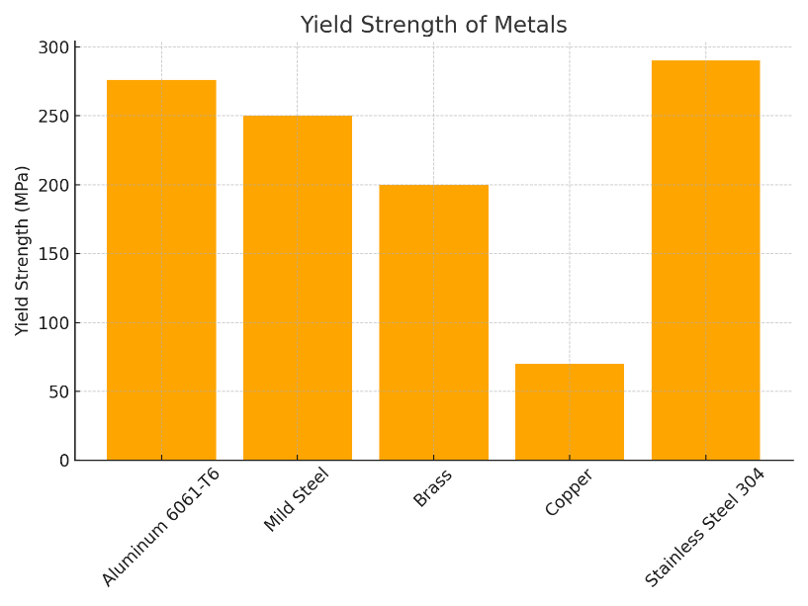
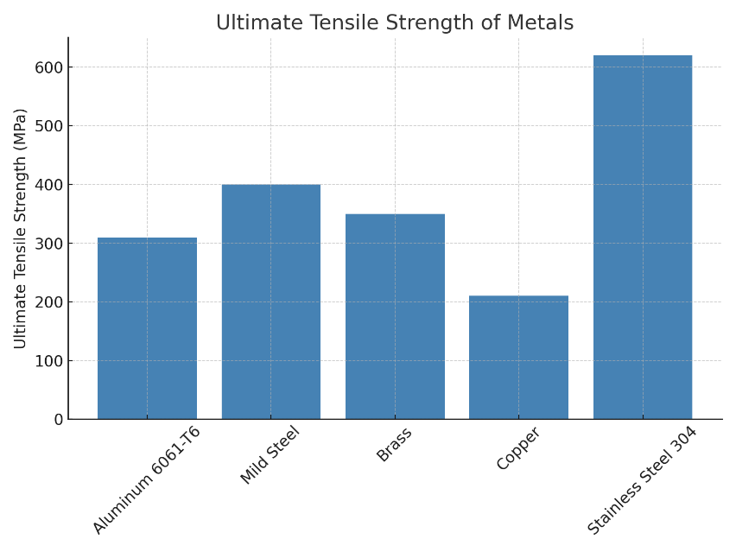

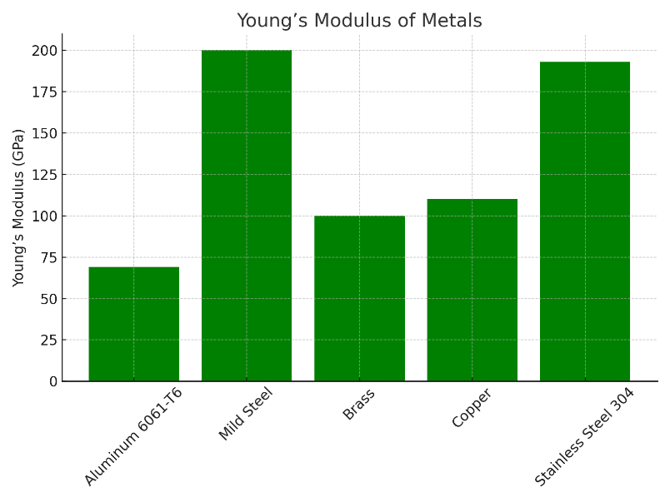
Discussion
The comparative evaluation of the tensile strength, yield strength, and Young’s modulus for the five metals demonstrates significant differences in their mechanical behavior, reflecting their microstructural characteristics and engineering applications

Stainless Steel 304 exhibits an outstanding combination of mechanical properties, with the highest ultimate tensile strength (620 MPa) and a high yield strength (290 MPa). This indicates a high resistance to both elastic and plastic deformation, making it ideal for load-bearing components in critical applications such as aerospace fasteners, pressure vessels, and structural frameworks in corrosive environments. Its high Young’s modulus (193 GPa) further emphasizes its stiffness, which is crucial when dimensional stability is a design priority.

Mild Steel, while slightly lower in strength compared to stainless steel, offers a strong yield strength (250 MPa) and tensile strength (400 MPa) combined with a very high Young’s modulus (200 GPa). This suggests a rigid, ductile material that can absorb significant stress before failure. Its affordability and machinability make it a preferred choice in construction, automotive frames, and heavy machinery. Its combination of ductility and toughness is particularly valuable for structures exposed to fluctuating loads.

Brass demonstrates a moderate tensile strength (350 MPa) and yield strength (200 MPa) with a Young’s modulus of 100 GPa, which is significantly lower than steels. This indicates greater flexibility and reduced stiffness, making brass suitable for components requiring moderate strength but excellent corrosion resistance, such as marine hardware, plumbing fittings, and musical instruments. Its machinability and aesthetic appeal further expand its application range.

Aluminum 6061-T6 presents an interesting balance of mechanical properties: a tensile strength of 310 MPa and yield strength of 276 MPa, combined with a relatively low Young’s modulus (69 GPa). While not as stiff as steel, its high strength-to-weight ratio makes it a premier choice for applications where weight savings are crucial, such as in aircraft frames, automotive parts, and lightweight structural assemblies. Its corrosion resistance and ease of fabrication enhance its versatility.

Copper’s low yield strength (70 MPa) and tensile strength (210 MPa) reflect its high ductility, allowing it to deform significantly before failure. Despite its comparatively low stiffness (Young’s modulus of 110 GPa), copper excels in applications where electrical and thermal conductivity are prioritized over mechanical strength, such as in wiring, electrical connectors, and heat exchangers. Its excellent corrosion resistance also makes it suitable for roofing and water piping in aggressive environments.

Overall, the selection of these materials in engineering design depends on a careful trade-off between mechanical performance, weight, corrosion resistance, cost, and intended application environment. The provided data underscores the importance of aligning material properties with functional requirements to ensure safety, performance, and longevity of the final product.

Conclusion
From the comparative analysis, material selection depends heavily on the intended application. For high-load structural purposes, Stainless Steel 304 is superior, while aluminum offers advantages where weight is a key factor. Mild Steel serves as a versatile, cost-effective choice. Brass and copper are better suited to applications where corrosion resistance, machinability, or electrical conductivity are more critical than tensile performance.

References
Callister, W. D., & Rethwisch, D. G. (2021). *Materials Science and Engineering: An Introduction* (11th ed.). Wiley.
Ashby, M. F. (2011). *Materials Selection in Mechanical Design* (4th ed.). Butterworth-Heinemann.

