Research Logbook Assignment

Information for Instructors
Research Logbook Assignment
Overview
This assignment is designed to assess the Pathways outcome: Use the tools of the scientific discipline to carry out collaborative laboratory investigations.

In this multi-week assignment, student groups will conduct an experiment to investigate how different types of fertilizer influence plant growth. They will formulate a hypothesis and collect data in a research logbook. As a group, students will document their experimental design, procedures, observations, data collection, and analysis.

Information for Students
Research Logbook Assignment
Overview
You will conduct a six-week experiment with your lab group to explore how different types of fertilizer affect plant growth. Throughout this project, you will keep a research logbook as a scientific record of your work. This logbook will include every aspect of your experiment – your hypothesis, details of the experimental setup, weekly observations and measurements, data summaries, and your analysis and conclusions.

The experiment will involve testing multiple fertilizer conditions (for example, comparing an organic fertilizer, a synthetic fertilizer, and a compost-based fertilizer) on plant growth under controlled conditions. You will monitor the growth of plants (e.g. measuring height and counting leaves) in each treatment group over time, while keeping other factors like water, light, soil type, and pot size constant. Careful documentation each week will be crucial for analyzing differences in growth and drawing conclusions about which fertilizer type is most effective and why.

As you work through this assignment, you will:
- Formulate a hypothesis about how different fertilizer types will affect plant growth.
- Design an experiment, identifying your independent variable (fertilizer type), dependent variable (plant growth measurements such as height or leaf count), and a control group (e.g. plants with no added fertilizer) for comparison.
- Set up and carry out the experiment over a 6-week period, applying the different fertilizer treatments to your plants and making regular observations of their growth.
- Record weekly log book entries including note the date, quantitative measurements of plant growth (height in cm, number of leaves, etc.), qualitative observations of plant health/appearance (color changes, leaf texture, any signs of stress or disease), environmental conditions (room temperature, light exposure), and a written recording of observed changes, problems encountered, or any procedural changes.
- Summarize and analyze your data after the six weeks. Compile your measurements into a table and create a graph.
- Determine if you will accept or reject your hypothesis
- Reflect on what you learned from the process and any improvements or follow-up experiments you would suggest for the future.

Assignment Format and Guidelines
Your final research logbook will be an electronic lab notebook with the following sections:
- An introduction that includes your hypothesis.
- A description of your experimental design including variables, controls and your measures.
- Six entries of experimental data including measurements and noteworthy changes or issues in your experiment.
- A compiled summary of your results in the form of a data table and graph.
- A concluding statement, mentioning whether you accept or reject your hypothesis.
- A reflection on your experience that include your experience working collaboratively with your lab partners.

Assessment Criteria
Your research logbook will be graded on:
- The presence of a clear testable hypothesis.
- Identification of variables (dependent and independent) and controls.
- Inclusion of six complete entries for the duration of your experiment.
- Your presentation of your data in the form of a table and a graph.
- Your determination to accept or reject your hypothesis.
- Your written reflection.

Research Logbook Assignment Grading Rubric
Criteria | Exceeds Expectations | Meets Expectations | Approaches Expectations | Developing
Clear Testable Hypothesis (15 points) | Hypothesis is clearly stated, testable, and directly connected to the purpose of the experiment.  (13–15 points) | Hypothesis is present and testable but may lack full clarity or precision.  (10–12 points) | Hypothesis is partially stated, testable in limited ways, or only loosely connected to the experiment.  (7–9 points) | Hypothesis is unclear, not testable, or missing.  (0–6 points)
Identification of Variables & Controls  (15 points) | Independent and dependent variables are clearly identified; appropriate controls are described.  (13–15 points) | Variables are identified but may be incomplete or controls not fully explained.  (10–12 points) | Variables and controls are mentioned but are not clear, accurate, or completely connected to the experiment.  (7–9 points) | Variables and/or controls are unclear, incorrect, or missing.  (0–6 points)
Experiment Entries  (15 points) | Six complete, detailed entries recorded with observations, dates, and consistency. (13–15 points) | Six entries present but with limited detail or consistency.  (10–12 points) | Fewer than six entries or notes are incomplete or lack key details.  (7–9 points) | Very limited or missing entries. (0–6 points)
Data Presentation: Table & Graph (20 points) | Data is clearly organized in a well-labeled table and accurately represented in a correctly formatted graph.  (18–20 points) | Table and graph included, but one may lack clarity, labeling, or accuracy.  (14–17 points) | Table or graph present but with incomplete labels, formatting errors, or partial accuracy. (10–13 points) | Missing or unsatisfactorily constructed table/graph.  (0–9 points)
Hypothesis Evaluation  (15 points) | Clear evaluation with well-reasoned acceptance or rejection of hypothesis supported by data.  (13–15 points) | Evaluation present but reasoning is limited or weakly supported.  (10–12 points) | Evaluation attempts to address the hypothesis but lacks clarity or sufficient support.  (7–9 points) | Evaluation unclear, missing, or unsupported by data.  (0–6 points)
Written Reflection  (20 points) | Thoughtful reflection that analyzes results, discusses implications, and acknowledges errors or future improvements. (18–20 points) | Reflection present but limited in depth or missing some analysis.  (14–17 points) | Reflection addresses results but lacks key details or full analysis of implications.  (10–13 points) | Reflection is incomplete, unclear, or missing.  (0–9 points)

Sample Student Submission

George Arber
Research Log Book
General Biology

Introduction & Hypothesis
This experiment investigates how different fertilizer types influence plant growth in bean plants (Phaseolus vulgaris).

Hypothesis: Plants treated with organic compost will grow taller and develop more leaves than those treated with synthetic fertilizer or no fertilizer, because compost improves soil structure and provides a slow, balanced release of nutrients.

Experimental Design
- Independent Variable: Type of fertilizer (organic compost, synthetic NPK fertilizer, no fertilizer/control).
- Dependent Variables: Plant height (cm) and number of leaves.
- Controls:
- Soil type: identical potting soil used in all pots.
- Water: 200 mL per pot every other day.
- Light: placed under the same grow lights (14 hrs/day).
- Pot size: all 6-inch pots.
- Replication: Three plants per treatment group for reliability.

Weekly Entries

Week 1 (Day 7):
Heights: Compost (4.1 cm avg), NPK (3.8 cm avg), Control (3.5 cm avg).
Leaves: Compost (2), NPK (2), Control (1).
Observations: All seedlings emerged healthy; compost group slightly greener.

Week 2 (Day 14):
Heights: Compost (8.7 cm), NPK (7.9 cm), Control (6.2 cm).
Leaves: Compost (4), NPK (3), Control (2).
Notes: Compost plants sturdier, NPK slightly paler green.

Week 3 (Day 21):
Heights: Compost (14.3 cm), NPK (12.6 cm), Control (9.8 cm).
Leaves: Compost (7), NPK (6), Control (4).
Notes: Compost group with broader leaves; no signs of disease.

Week 4 (Day 28):
Heights: Compost (19.6 cm), NPK (16.5 cm), Control (12.9 cm).
Leaves: Compost (10), NPK (8), Control (6).
Notes: Control showing slight yellowing; compost still vigorous.

Week 5 (Day 35):
Heights: Compost (25.1 cm), NPK (21.7 cm), Control (15.8 cm).
Leaves: Compost (13), NPK (11), Control (7).
Notes: Compost and NPK groups developing small buds; control lags.

Week 6 (Day 42):
Heights: Compost (30.4 cm), NPK (25.6 cm), Control (18.4 cm).
Leaves: Compost (16), NPK (13), Control (8).
Notes: Compost group strongest overall; NPK plants thinner stems.

Data Summary
Table 1. Average Growth of Bean Plants Under Different Fertilizer Conditions (n=3 per group)
Week | Compost Height (cm) | NPK Height (cm) | Control Height (cm) | Compost Leaves | NPK Leaves | Control Leaves
1 | 4.1 | 3.8 | 3.5 | 2 | 2 | 1
2 | 8.7 | 7.9 | 6.2 | 4 | 3 | 2
3 | 14.3 | 12.6 | 9.8 | 7 | 6 | 4
4 | 19.6 | 16.5 | 12.9 | 10 | 8 | 6
5 | 25.1 | 21.7 | 15.8 | 13 | 11 | 7
6 | 30.4 | 25.6 | 18.4 | 16 | 13 | 8

Graph 1. Plant Height Over Six Weeks by Fertilizer Treatment

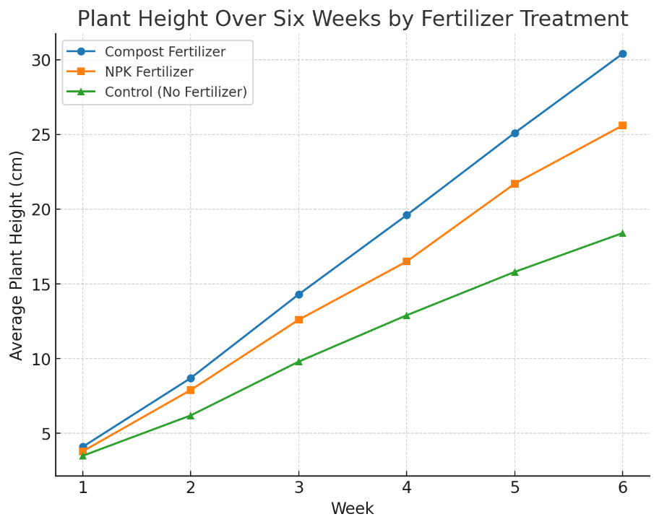

Graph 2. Number of Leaves Over Six Weeks by Fertilizer Treatment
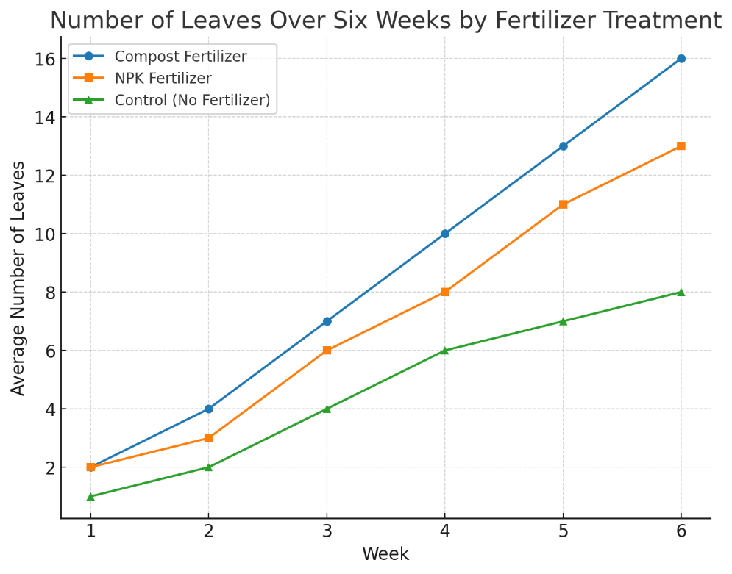

Conclusion
The data support the hypothesis. Plants grown with organic compost consistently outperformed both synthetic fertilizer and control groups in height and leaf production. Therefore, I accept my hypothesis that compost would yield superior growth.

Reflection
This experiment deepened my understanding of how nutrient sources affect plant development. Compost provided steady growth and healthier appearance, while synthetic fertilizer gave faster but less sustainable growth. Working collaboratively with my group improved the project: one member specialized in data recording, another in plant care, and I compiled results. Challenges included keeping water amounts exact and ensuring uniform light. If repeated, I would expand sample size and measure additional variables (e.g., biomass or root length). Overall, this project reinforced the importance of experimental design, collaboration, and careful observation in scientific research.

