Projectile Motion Experiment: Applying the Scientific Method

Information for Instructors

Projectile Motion Experiment: Applying the Scientific Method

Overview
This assignment is designed to assess the Pathways outcome: Apply the scientific method to explore natural phenomena, including hypothesis development, observation, experimentation, measurement, data analysis, and data presentation.

Students will design an experiment to investigate projectile motion by using a marble and a ramp. Their experimental design should lead to results reflecting launch height affects horizontal range of motion of the marble.

Information for Students

Projectile Motion Experiment: Applying the Scientific Method

Overview
In this lab assignment, you will apply the scientific method to explore projectile motion. You will design and conduct an experiment to measure the horizontal range of a marble launched from different ramp heights.

As you work on this assignment, you will:
- Formulate a hypothesis.
- Develop an experiment.
- Conduct multiple trials.
- Gather data, analyze the data, and present findings in a written report.

Assignment Guidelines and Format
Your lab report will:
- Be 3–4 pages, double-spaced, with 12-point Calibri font.
- Include the following:
  - Title
  - Introduction and Hypothesis
  - Procedure
  - Data Table and graph
  - Discussion
  - Conclusion

Assignment Criteria
Your assignment will be graded on the:
- Clarity and testability of your hypothesis.
- Accuracy of procedure and measurements.
- Quality of your data collection and its presentation in a table and a graph.
- Application of principles of motion to your discussion of you results
- Use of the language of the discipline

Projectile Motion Experiment: Applying the Scientific Method Grading Rubric
Criteria | Exceeds Expectations | Meets Expectations | Approaches Expectations | Developing
Introduction & Hypothesis  (20 points) | Introduction provides clear background information about the experiment. The hypothesis is stated clearly, testable, and based on physics principles.  (18–20 points) | Introduction provides some background information about the experiment. The hypothesis is stated, testable, and based on physics principles. (14–17 points) | Introduction provides minimal background. Hypothesis is partially testable or loosely connected to physics principles. (10–13 points) | Introduction provides little to no background. Hypothesis is unclear, not testable, or unrelated to physics principles.  (0–9 points)
Procedure (15 points) | Procedure is detailed and is presented in a way that it is easily replicable.  (13–15 points) | Procedure is somewhat detailed and is most likely replicable.  (10–12 points) | Procedure lacks sufficient detail that would make replication possible. (7–9 points) | Procedure is incomplete, unclear, or not replicable.  (0–6 points)
Data Table & Graph  (25 points) | Data table is clearly presented with multiple trials; well-constructed graph with appropriate labels.  (23–25 points) | Data table is included with more than one trial; graph has appropriate labels. (19–22 points) | Data table is incomplete (few or no trials); graph is present but missing some labels.  (15–18 points) | Data table missing or very unclear; graph missing or mislabeled. (0–14 points)
Discussion (25 points) | Insightful discussion of the data including analysis, sources of experimental error, and limitations.  (23–25 points) | General discussion of the data with some mention of sources of error and limitations.  (19–22 points) | Limited discussion with minimal analysis; little mention of errors or limitations.  (15–18 points) | Very limited or missing discussion of data; no analysis of errors or limitations. (0–14 points)
Conclusion (10 points) | Clear conclusion that explicitly addresses the hypothesis.  (9–10 points) | General conclusion with some mention of the hypothesis. (7–8 points) | Conclusion is not clear or only partially connected to the hypothesis.  (5–6 points) | Conclusion is weak or missing; no mention of the hypothesis. (0–4 points)
Presentation & Clarity  (5 points) | Well-organized, error-free, with appropriate use of scientific language. (5 points) | Some errors with mostly appropriate use of scientific language.  (4 points) | Frequent errors reduce clarity; scientific language is not consistently used.  (3 points) | Numerous errors significantly reduce clarity; little or no use of scientific language. (0–2 points)

Sample Student Submission

Mabel Pearl
Physics 200
Investigating the Relationship Between Ramp Height and Projectile Range
Introduction and Hypothesis
Projectile motion is a classical topic in physics that combines concepts of kinematics and energy conservation. This experiment will study how the release height of a marble on a ramp influences the horizontal distance it travels after leaving the ramp. According to the principle of conservation of energy, gravitational potential energy (mgh) is converted into kinetic energy (½mv²). Therefore, a marble released from a greater height should achieve a higher velocity at the bottom of the ramp. Since the horizontal component of velocity determines the range, my hypothesis is that increasing the ramp height will increase the horizontal distance traveled by the marble. Stated more clearly, if the release height increases, the projectile range will also increase because of the greater conversion of potential energy into kinetic energy.

Procedure
The experimental apparatus consisted of a wooden ramp placed on a sturdy table approximately 1.2 meters above the ground. The ramp was secured so that its angle and orientation remained constant throughout the trials. Markings were made at five release heights: 10 cm, 20 cm, 30 cm, 40 cm, and 50 cm, measured vertically from the base of the ramp to the starting point of the marble. A standard glass marble of mass 5 g and diameter 1.6 cm was used. To measure horizontal distance, carbon paper was placed on white printer sheets on the floor directly beneath the ramp’s horizontal exit point. The carbon paper recorded the marble’s landing spot. A meter stick was used for precise distance measurement.

For each ramp height, the marble was released from rest five times without applying external force. Distances were measured from the ramp’s vertical projection on the floor to the impact mark. A stopwatch was used to verify the approximate fall time, cross-checking with the theoretical free-fall equation t = √(2h/g). Data for each trial was recorded and averaged. Care was taken to ensure the marble was aligned properly in the ramp’s groove to minimize angular deviations. The ramp surface was kept clean and smooth to reduce frictional variations.

Data Table
Below is the average range measured for each height after five trials:

Height (cm) | Trial 1 (cm) | Trial 2 (cm) | Trial 3  (cm) | Trial 4  (cm) | Trial 5  (cm) | Average  (cm)
10 | 28.2 | 28.4 | 27.9 | 28.1 | 28.3 | 28.2
20 | 40.3 | 40.1 | 40.2 | 40.6 | 40.4 | 40.3
30 | 50.7 | 50.6 | 50.5 | 51.0 | 50.9 | 50.7
40 | 59.1 | 59.0 | 28.8 | 59.4 | 59.2 | 59.1
50 | 65.5 | 65.8 | 65.6 | 65.9 | 65.4 | 65.6

Graph

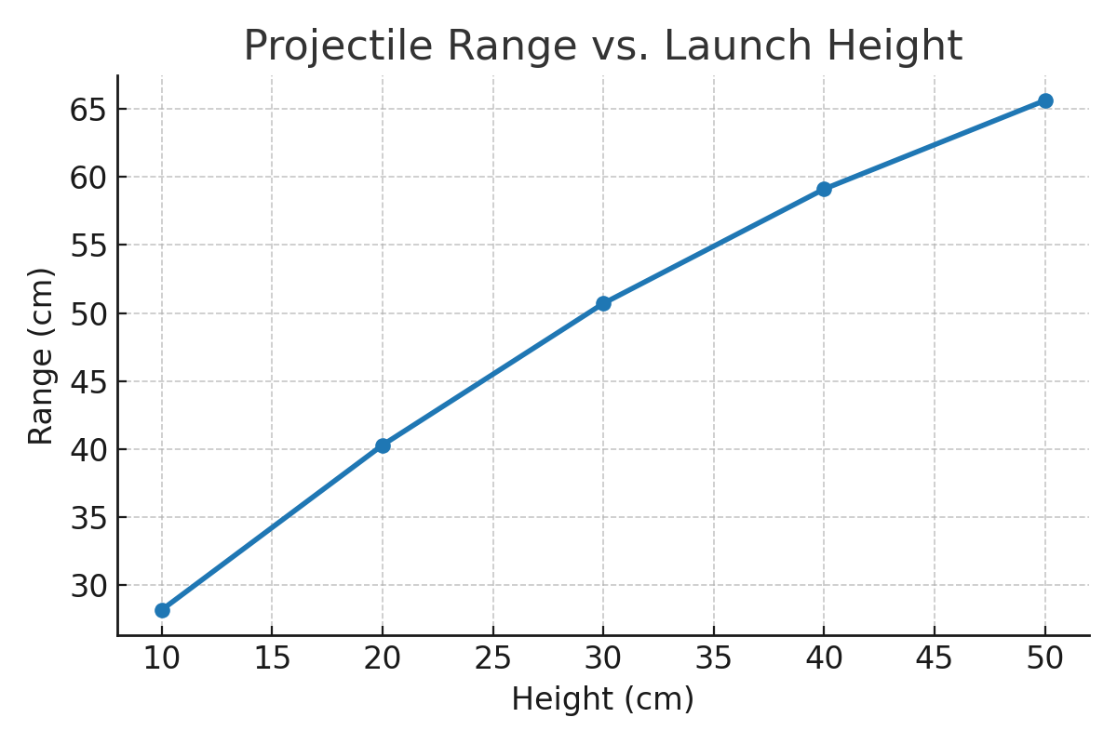

Discussion
The analysis of the data indicates that the relationship between ramp height and projectile range follows theoretical predictions. From energy conservation, velocity at the ramp exit is given by v = √(2gh). Thus, as height increases, velocity increases, and since horizontal distance (R) is related to horizontal velocity (vx) multiplied by time of flight (t), R also increases. Our experimental data showed ranges increasing from 28.2 cm at 10 cm release height to 65.6 cm at 50 cm release height. This consistent increase supports the hypothesis.

Further, the approximate free-fall times matched reasonably well with the theoretical equation t = √(2h/g). At small heights, minor deviations may have occurred due to frictional effects in the ramp, but overall, the results conformed closely to predicted outcomes. The proportional increase in horizontal distance with √h validates the model.
The experiment successfully demonstrated the expected relationship between release height and horizontal range. However, several sources of error and limitations must be considered. Human error in timing measurements may have introduced slight inaccuracies, although repeated trials reduced random error. Systematic errors could arise from uneven ramp surfaces, small angular misalignments, or inconsistencies in marble placement.

Air resistance was assumed negligible, but it could have had a small effect at higher velocities. Friction between the marble and ramp also likely reduced theoretical velocity slightly, causing measured ranges to be somewhat lower than ideal predictions. Despite these factors, the general pattern was clear and reproducible.
An improvement for future trials would be to use motion-tracking software or high-speed cameras to capture release velocity and trajectory with higher precision. This would allow for a more detailed comparison with theoretical models.
Conclusion
The results of this experiment support the hypothesis that increasing the release height of a marble increases its horizontal range due to greater conversion of potential energy into kinetic energy. The experiment applied the scientific method comprehensively: a hypothesis was formed, an experiment was designed and conducted, data was gathered and analyzed, and a conclusion was drawn based on evidence. Beyond confirming basic projectile motion principles, this investigation highlights the importance of careful experimental design and error analysis in physics. By engaging in this process, students gain practical insight into the interplay between theoretical physics and real-world experimentation.

