Mathematical Problem Solving & Data Interpretation Assignment

Information for Instructors
Mathematical Problem Solving & Data Interpretation Assignment
Overview
This assignment addresses the Pathways outcome: Use algebraic, numerical, graphical, or statistical methods to draw accurate conclusions and solve mathematical problems.
Students will identify a mathematical problem or question, apply appropriate problem-solving techniques, and present their reasoning and conclusions in a format suitable for a general audience. They will use algebraic, numerical, graphical, or statistical tools as appropriate, ensuring that their final work demonstrates both the accuracy of their calculations and the clarity of their explanations.

Information for Students
Mathematical Problem Solving & Data Interpretation Assignment
Overview
In this assignment, you will select a real-world question or problem that can be addressed using mathematical methods. You will work through the problem using algebraic, numerical, graphical, or statistical approaches, present your solution, and explain how your results answer the original question. Your final document should be understandable to readers who are not math specialists, while still showing accurate and well-documented reasoning.

As you work to complete this assignment, you will:
- Select a problem that can be addressed using one or more mathematical methods. Possible topics include:
- Modeling the spread of a local event using exponential functions.
- Analyzing the relationship between temperature and electricity usage.
- Calculating the break-even point for a small business scenario.
- Using probability to assess the fairness of a game.
- Estimating population growth using a logistic model.
- Clearly state the problem in your own words.
- Determine the mathematical techniques needed to solve it.
- Perform accurate calculations and document each step.
- Present at least one visual representation (graph, table, or chart) to illustrate your results.
- Interpret your findings and explain how they solve the problem.

Assignment Format & Guidelines
Your assignment will:
- Be 800–1,000 words in length.
- Be suitable for publication in a general-audience venue such as a community newsletter or educational blog.
- Include all calculations and steps in a clear, logical order.
- Use at least one visual representation of your results (graph, chart, or table).
- Clearly explain how the results address the original problem.

Assessment Criteria
Your assignment will be graded on:
- Clarity and accuracy in defining the problem.
- Appropriateness of the mathematical methods used.
- Accuracy and completeness of calculations.
- Effectiveness and clarity of visual representations.
- Clarity of explanation for a general audience.
- Organization, grammar, and adherence to format.
Mathematical Problem Solving & Data Interpretation Assignment Grading Rubric
Criteria | Exceeds Expectations | Meets Expectations | Approaches Expectations | Developing
Defining the Problem  (20 points) | Problem is clearly defined, relevant, and precisely stated.  (16–20 points) | Problem is adequately defined and stated.  (12–15 points) | Problem is partially defined, somewhat relevant, or lacks clarity in scope.  (6–11 points) | Problem is not clearly defined or not well stated.  (0–5 points)
Mathematical Methods  (20 points) | Methods are appropriate, well-chosen, and effectively applied.  (16–20 points) | Methods are generally appropriate and applied with minor errors. (12–15 points) | Methods are not all appropriate or are not consistently applied or lack justification.  (6–11 points) | Methods are inappropriate or applied incorrectly. (0–5 points)
Accuracy of Calculations  (20 points) | All calculations are correct, thorough, and well-documented. (16–20 points) | Most calculations are correct; minor errors present. (12–15 points) | Some calculations are correct, but there are some errors that affect accuracy. (6–11 points) | Numerous errors that make the calculations incorrect or incomplete work.  (0–5 points)
Visual Representation (15 points) | Visuals are clear, accurate, and effectively illustrate the solution.  (12–15 points) | Visuals are adequate but may lack clarity or accuracy.  (9–11 points) | Visuals are present but are unclear, or incomplete, making them somewhat accurate.  (5–8 points) | Visuals are unclear, inaccurate, or missing.  (0–4 points)
Explanation for General Audience  (15 points) | Explanation is engaging, clear, and fully accessible to non-specialists. (12–15 points) | Explanation is mostly clear and understandable. (9–11 points) | Explanation is somewhat understandable but uses unnecessary jargon or lacks clear details. (5–8 points) | Explanation is unclear or overly technical.  (0–4 points)
Organization & Format  (10 points) | Work is well-organized, polished, and meets all formatting requirements. (9–10 points) | Organization and formatting are adequate; minor issues present. (6–8 points) | Work shows limited organization and formatting. (3–5 points) | Work is not organized or missing specific formatting elements.  (0–2 points)

Sample Student Submission

Kennedy Artimus
Math For College Freshmen
Predicting Gasoline Costs Over the Summer Travel Season
Many families plan road trips during the summer, but rising gas prices can make budgeting difficult. I hypothesized that the average monthly price of gasoline in our area could be predicted using data from the last three summers.
I collected price data from the Energy Information Administration for June, July, and August over the past three years. I fit a quadratic regression model to the data, since prices tend to rise in June, peak in July, and then fall slightly in August. The model showed an R² value of 0.94, indicating a strong fit.
Using the model, I predicted that prices in July this year will peak at $4.35 per gallon, about $0.10 higher than last year. The graph below illustrates both the historical data and the predicted curve for this summer.
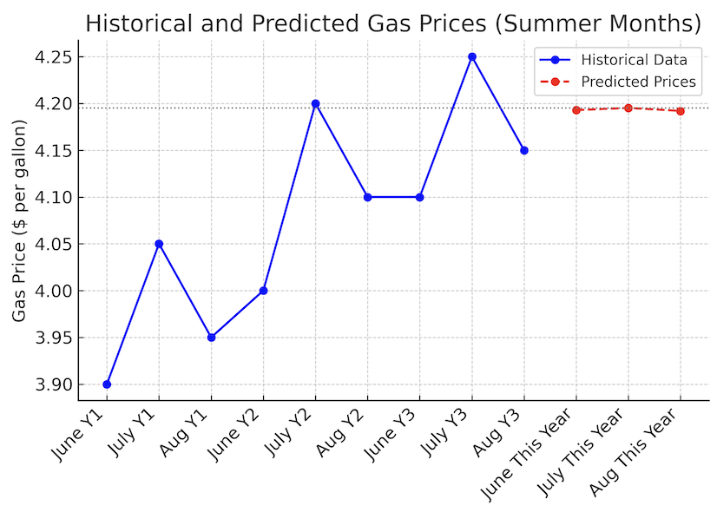
These results can help travelers plan their budgets and potentially adjust travel dates to save money.
References:
- U.S. Energy Information Administration. (2023). Weekly Retail Gasoline and Diesel Prices. https://www.eia.gov/petroleum/gasdiesel/

