Graph Interpretation Assignment

Information for Instructors

Graph Interpretation Assignment

Overview
This assignment addresses the Pathways outcome: Interpret and draw inferences from quantitative representations such as formulas, graphs, and tables.

In the assignment, students will analyze a graph of changes in surface temperature over time. Using the graph, they will answer six questions that will require students to interpret data presented in a graphical form. This assignment builds scientific literacy, critical thinking, and data interpretation skills.

Information for Students

Graph Interpretation Assignment

Overview
In this assignment, you will examine a graph showing global surface temperature changes over time and answer a series of questions. These questions are designed to help you interpret the data and relate your findings to biological and ecological concepts. You will identify trends, make inferences, and connect quantitative information to a real-world problem.

As you work on this assignment, you will:
- Review the climate change graph named, Global Average Surface Temperature (1880–2020).
- Develop answers to the six questions, under the heading Interpretation Questions, included in the assignment.
- Include specific references to data in the graph.

Assignment Format & Guidelines
Your graph analysis will:
- Examine the following graph:
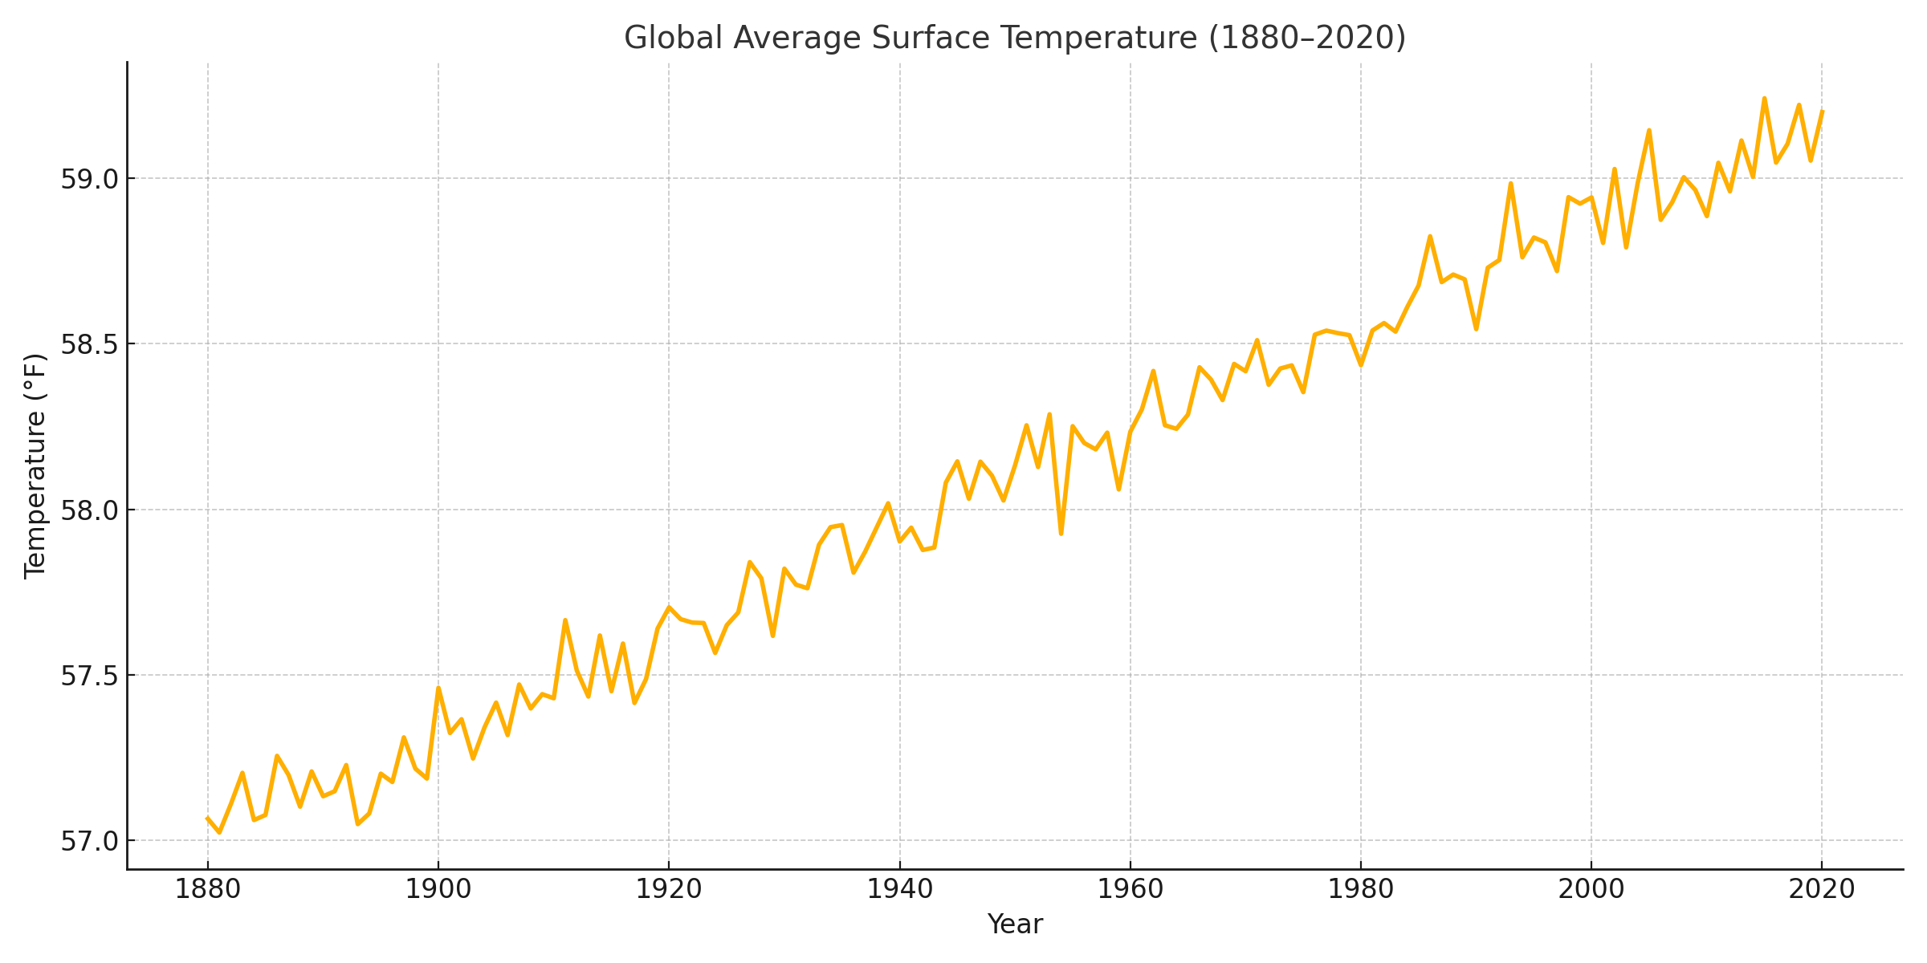
- Include answers to the following questions:
  - What overall trend is observed in global surface temperatures from 1880 to 2020?
  - Identify two periods of notable temperature increase and describe how you determined this.
  - Are there any periods where the temperature trend appears to level off or decrease slightly? What might explain this?
  - What is the approximate temperature in the year 1950 compared to 2020? What is the difference in degrees Fahrenheit?
  - Based on this graph, what prediction could you make about global temperatures in the next 50 years? Support your reasoning with evidence from the data.
  - Why is understanding long-term temperature trends important for studying ecosystems and biodiversity?
- Involve submission of answers to the above questions in a typed document using 12 point font.

Assessment Criteria
Your assignment, specifically the answers to the six interpretation questions, will be graded on your:
- Interpretation of the data.
- Connection to biological concepts.
- Use of appropriate scientific terminology and writing style for an academic audience.

Graph Interpretation Grading Rubric
Criteria | Exceeds Expectations | Meets Expectations | Approaches Expectations | Developing
Data Interpretation  (40 points) | Accurately interprets all graph trends and changes using specific data points.  (36–40 points) | Interprets most graph trends correctly with some data cited.  (28–35 points) | Interpretation is missing some key trends or lacks citing data.  (21–27 points) | Misinterprets or misses key trends; no data cited.  (0–20 points)
Evidence-Based Reasoning  (30 points) | Provides thoughtful and well-supported inferences grounded in the data.  (27–30 points) | Provides generally accurate conclusions; some evidence used.  (21–26 points) | Reasoning is unclear or not sufficiently supported.  (15–20 points) | Reasoning is somewhat inaccurate and not supported.  (0–14 points)
Connection to Biology Concepts (20 points) | Clearly connects climate data to biological relevance (e.g., ecosystems, biodiversity).  (18–20 points) | Makes basic connection to biological concepts.  (14–17 points) | Connection to concepts is somewhat unclear, incomplete, or partially inaccurate.  (10–13 points) | Fails to connect to biological concepts or connection is not incomplete/ inaccurate.  (0–9 points)
Format/Writing Mechanics  (10 points) | Writing is clear, error-free, and appropriate for a scientific & academic setting.  (9–10 points) | Writing is clear, with some minor errors, and mostly appropriate for a scientific & academic setting.  (6–8 points) | Writing has multiple errors or lacks academic tone.  (3–5 points) | Writing is unclear, has frequent errors, and is not appropriate for an academic setting.  (0–2 points)

Sample Student Submission

Name: Jordan Alvarez
Climate Change Graph Interpretation
Course: MAT 101

- The overall trend from 1880 to 2020 shows a steady increase in global surface temperatures. The warming becomes especially sharp after 1980.
- Two notable periods of temperature increase are from 1980 to 2000 and from 2010 to 2020. I determined this by observing the steep upward slope in the graph during these years.
- Between 1940 and 1970, the trend appears to level off slightly. This could be due to increased atmospheric aerosols from industrial activity, which can temporarily cool the Earth.
- In 1950, the temperature was about 56.7°F, while in 2020 it's around 58.8°F. That’s a difference of about 2.1°F over 70 years.
- If the current trend continues, we can predict that global temperatures may increase by another 2–3°F in the next 50 years. This is based on the accelerating rate of temperature rise seen in the last few decades.
- Understanding long-term temperature changes is essential because it impacts biodiversity, migration patterns, breeding cycles, and even extinction risk for species that can't adapt quickly.

