Graph Construction Assignment

Information for Instructors

Graph Construction Assignment

Overview
This assignment addresses the Pathways outcome: Effectively communicate quantitative analysis or solutions to mathematical problems in written or oral form.

In this assignment, students will create a based on data provided and write an explanation of what the graph represents. The goal is for students to accurately construct a visual representation of a quantitative relationship and clearly communicate their interpretation of the graph's meaning, structure, and implications. This assignment strengthens skills in both data visualization and mathematical communication.

Information for Students

Graph Construction Assignment

Overview
In this assignment, you will create a graph and write a short explanation that communicates your understanding of the relationship it represents. The assignment will help you develop both your technical graphing skills and your ability to describe and interpret mathematical visualizations.

As you work on this assignment, you will:
- Create a graph using the data set provided below about study time and exam scores.
- Label all axes and data points clearly.
- Write a short explanation of what your graph shows and how it relates to the situation or equation.
Time Studied (hours) | Exam Score (%)
2 | 65
3 | 68
4 | 72
5 | 75
6 | 78
7 | 85
8 | 88
9 | 90

Assignment Format & Guidelines
Your assignment will:
- Include a graph you create using graphing software, such as Excel) or by hand and scanned/photographed. Include a graph title and label the x and y axes
- Include a 3-t sentence explanation of your graph using appropriate mathematical vocabulary and logic, to describe the relationship and measures in the graph as well as your interpretation.

Assessment Criteria
Your assignment will be graded on:
- Your graph’s construction with labels.
- Your written explanation of the graphs using appropriate mathematical terminology.

Graph Construction Assignment Grading Rubric
Criteria | Exceeds Expectations | Meets Expectations | Approaches Expectations | Developing
Graph Accuracy (30 points) | Graph is accurately constructed and clearly labeled.  (27–30 points) | Graph is mostly accurate with minor errors or omissions.  (21–26 points) | Graph is attempted but several noticeable or incomplete labeling.  (17–20 points) | Graph has major errors or is incomplete.  (0–16 points)
Visual Presentation  (30 points) | Graph is clear, professional, and demonstrates an understanding of the data.  (27–30 points) | Graph is readable and appropriate.  (21–26 points) | Graph is presented but has formatting doesn’t clearly represent an understanding of the data  (17–20 points) | Graph is poorly constructed or poorly formatted.  (0–16 points)
Explanation of Graph  (25 points) | Written analysis is thorough, insightful, and precise.  (23–25 points) | Explanation is generally clear with some detail.  (18–22 points) | Explanation is somewhat unclear or inaccurate.  (14–17 points) | Explanation is minimal or incorrect.  (0–13 points)
Use of Mathematical Language  (15 points) | Uses precise and appropriate vocabulary throughout.  (13–15 points) | Uses some correct terminology.  (10–12 points) | Terminology is attempted but there are several errors or inconsistencies.  (7–9 points) | Incorrect mathematical language.  (0–6 points)

Sample Student Submission
Emmy Noether
College Algebra – MTH 101
Graphing Assignment

Data
Time Studied (hours) | Exam Score (%)
2 | 65
3 | 68
4 | 72
5 | 75
6 | 78
7 | 85
8 | 88
9 | 90

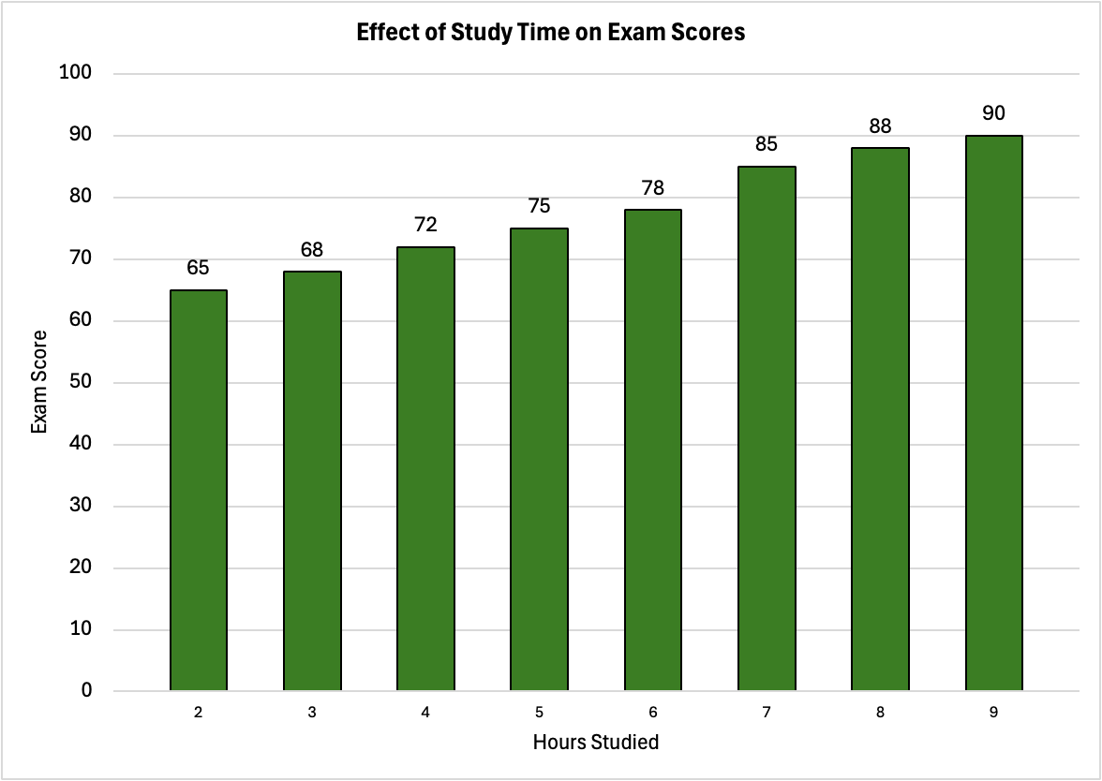

Explanation
This graph plots study time and exam scores. I chose a bar graph and labeled the x axis hours studied and the y axis exam scores. The graph shows that with increased study time, there is an increase in exam scores. The change is not equivalent. If I study 2 hours and earn a 65, it would be expected I would not need to study 10 hours to earn a 90.

