Concept Map (Biology) Assignment

Information for Instructors

Concept Map Assignment

Overview
This assignment will address the Pathways outcome: Identify and apply the fundamental concepts and methods of life sciences.
Students will work on synthesizing concepts about evolution, genetics, and ecology. By developing this concept map, students will be encouraged to think holistically about these three important biological topics. The map will also help them reinforce conceptual understanding through visualization of the relationships between evolution, genetics, and ecology.

Information for Students

Concept Map Assignment

Overview
In this assignment, you will create a concept map that shows how the major biological disciplines of evolution, genetics, and ecology are connected. You begin with a central theme and branch out to include key concepts from each discipline. This assignment will help you understand how genetic variation leads to evolutionary change.

As you work through this assignment you will:
- Start with a central theme (e.g., 'Interconnectedness in Life Sciences').
- Include at least three major concepts from the three biological areas- evolution, genetics, and ecology.
- Use lines with arrows to show relationships. Label each connection with a brief phrase (e.g., 'drives,' relies on, causes').

Assignment Format & Guidelines
As you work through this assignment you will:
- Submit as a digital drawing or a clear photo of your hand-drawn map.
- Write a short reflection (at least 50–150 words) explaining the most important connections and what you learned from creating the map.

Assessment Criteria
Your work will be graded on:
- The accuracy of the biological information included in the concept map.
- The connections you make in your map.
- Demonstrating the integration of multiple concepts in a clear way.
- Your written reflection.

Concept Map Grading Rubric
Criteria | Exceeds Expectations | Meets Expectations | Approaching Expectations | Developing
Content Accuracy  (30 points) | All major concepts are accurately defined and correctly linked.  (27-30 points) | Most concepts are correct; minor errors in links or terminology.  (21-26 points) | Some major concepts are present but definitions or links show noticeable gaps or misunderstandings.  (16–20 points) | Several seminal concepts are inaccurate or missing.  (0-15 points)
Connections and Relationships  (30 points) | Connections are insightful, well-labeled, and demonstrate deep understanding.  (27-30 points) | Connections are mostly appropriate with some labeling issues.  (21-26 points) | Connections are attempted but may be simplistic, incomplete, or loosely labeled.  (16–20 points) | Few or unclear connections; relationships are not well developed.  (0-15 points)
Integration of Concepts  (30 points) | Strong, clear integration of evolution, genetics, & ecology with meaningful intersections.  (27-30 points) | Some integration across the three disciplines.  (21-26 points) | Limited integration; overlaps are present but lack clarity or depth.  (16–20 points) | Concepts presented in isolation; few connections made and concepts are not well integrated.  (0-15 points)
Reflection  (10 points) | Reflective writing shows clear understanding and thoughtful insights.  (0-10 points) | Reflection is general or lacks detail.  (6-8 points) | Reflection is attempted but superficial or a statement of facts.  (3–5 points) | Reflection is missing or shows little reflection on learning.  (0-4 points)

Sample Student Submission

Chuck Linneaus
Concept Map Assignment
General Biology

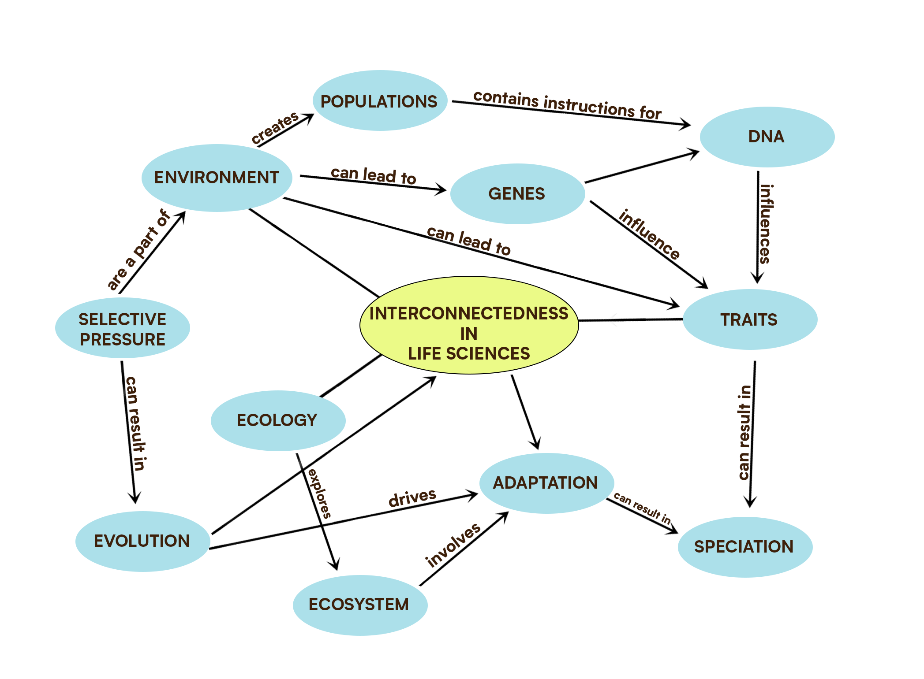

Reflection: Creating this map helped me realize how genetics isn’t just about inheritance—it’s the basis for variation that fuels evolution. I also saw how ecology shapes which traits are favored, completing a loop where environment, genes, and change are constantly interacting. The exercise made it easier to see the big picture and how everything in biology is part of a larger system.

