Helsel Racing Is Selling our 1200 mini sprint program !
DLH with current upgrades 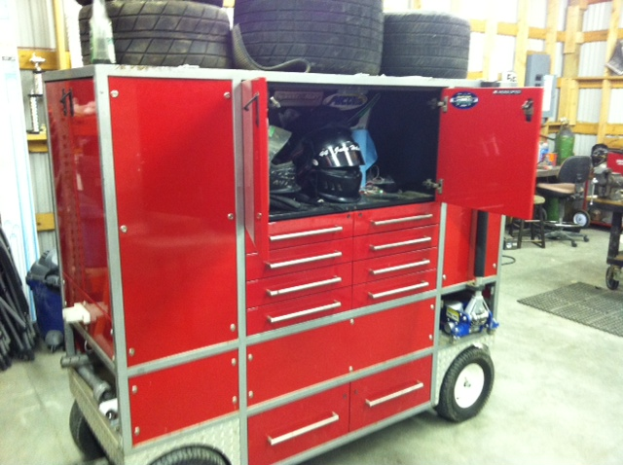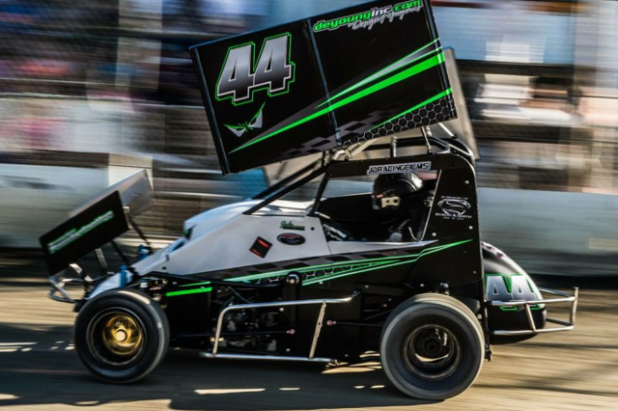
2000 Troy Built ZX1200
Everything was new at the beginning of the 2015 season
List
Afco shocks all with dyno sheets , 2 left rear adjustables

4 Front ends , 2 complete, 2 wingless, 2 winged

3 Right rears , 5 Left rears , 4 fronts
Note I have a bunch of new tires !

New steering box in the car , and a extra one for backup.

Extra Torsion Bars , Stops , shocks , birdcages , steering arms , Torsion arms , brake carrier rotor and caliper , nerf bars , wing actuators and mounts , brand new top wing , Wheel wrench , jack , Stands , chain tensioners , sprockets , 3 rear axles , ecu
Complete Program $12,000.00

I also have a back up 2000 ZX1200
Complete with wiring harness , header and muffler . $2500.00

Or Car and back up motor $14000.00

pit box $3000

Take everything for $16000

Contact : Tony Helsel @ 425 232-1673

