To download discord go to https://discordapp.com/ (this is also where you go to open the web version—but note the web version is really only for the text channels). You will need to login or create an account (https://discordapp.com/register) (Note: your username does not need to be related to your WoW characters name[include?])
Once your logged in, a prompt to set up your server will pop up, which you can just skip
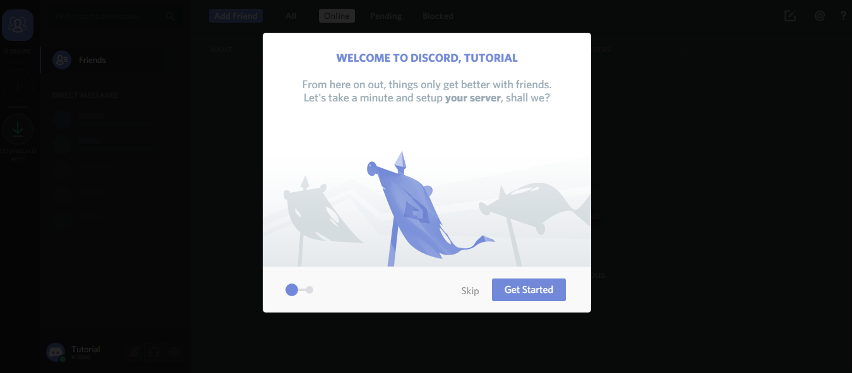
Now your window should look like this:
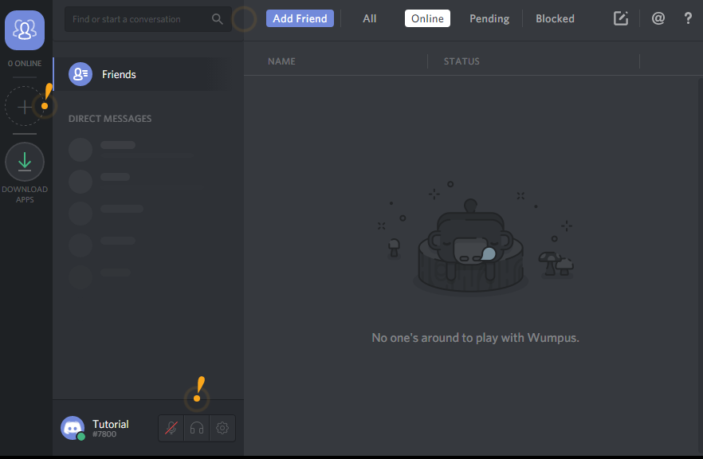
You can click the yellow arrows for information on what those buttons do.

Joining our server
Click on the big circled plus sign on the left hand bar, then select Join a Server (Green box on the right side). Then you can paste the link for our server (https://discord.gg/ WUQ8q84). Ta-Da you’re in and ready to start shenaniganning with your guildies!
Setting your nickname
How you show up in the user list can be set/changed for each server you are a member of. So to change your nickname on our server, first make sure you are in/on our server. Then you just find your name in the right side bar, right click, and then select Change Nickname
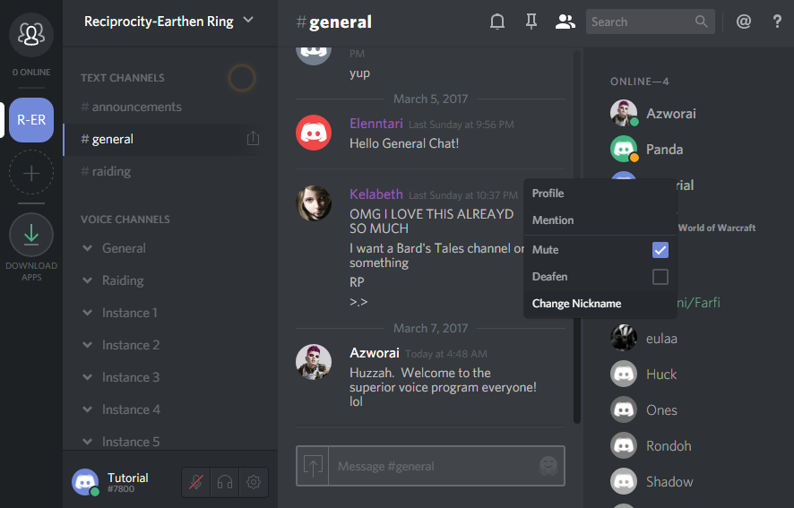

Adjusting your Audio Settings
To adjust user settings (including voice options), click on the gear to the right of your USERNAME (bottom left of window)
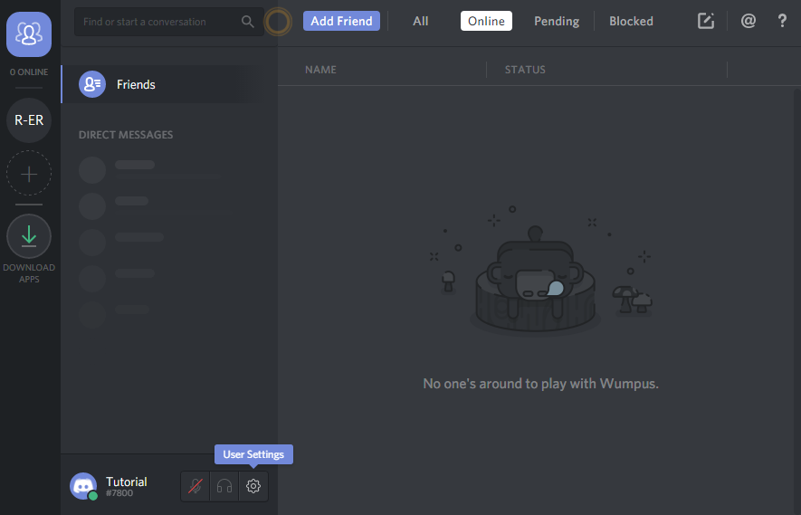
Then about half way down are the voice options
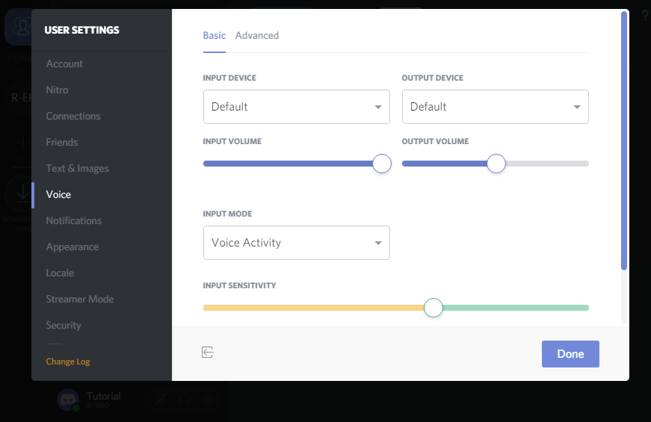
Make sure you change the Input Mode to Push to Talk and set your keybind!
If people say you sound funny you might want to try unchecking some options in the “Advanced” tab (particularly Echo Cancellation and Noise Suppression)
Adjusting other’s volume
Simply right click on the name of whoever’s blasting your ears out and move the volume slider
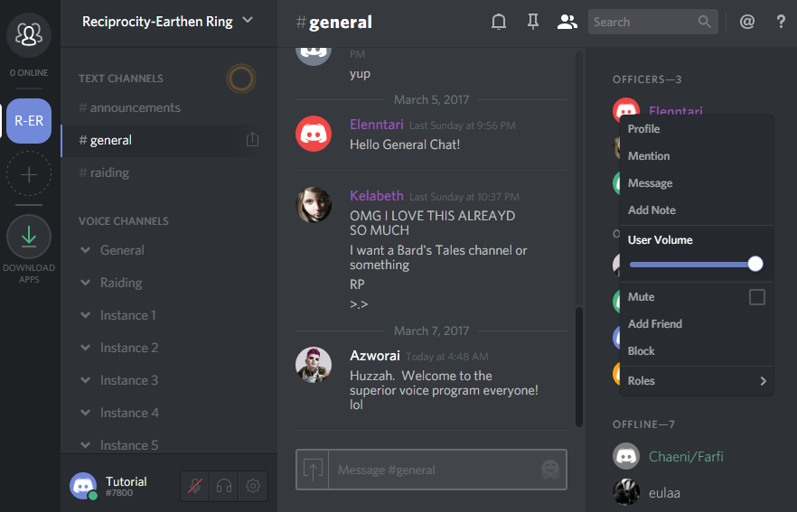
(if you have the Overlay feature on you can right click names on the overlay and adjust volumes without tabbing out! We’ll cover the Overlay feature in more depth in a later tutorial covering extra features and info).

