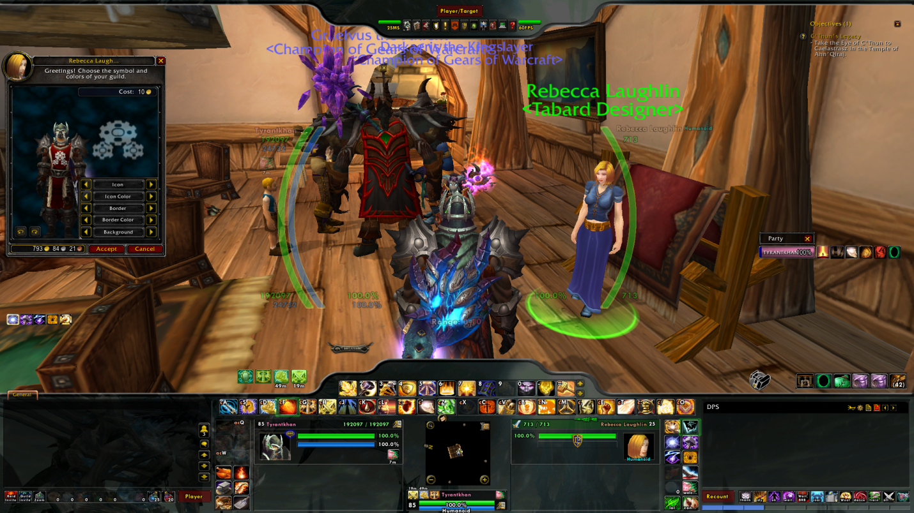
Tabard Change
Colors suggested by Graelvus.

