**Title: Run with Endurance**

**Hebrews 12:1-2**

**Aaron Birk**

**Faith East August 31, 2025**

**Faith West September 7, 2025**

Intro

[PPT INSERT PICTURE]

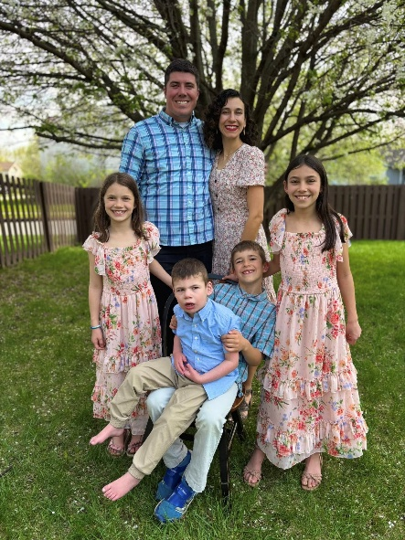

During a crisp California summer, as a 14-year-old teenage boy, I went to a Christian summer camp in the mountains of the Siearra Nevada California.

Churches from around southern California assembled upon the sacred mountain to compete in a version of the summer Olympic games.

I was not normally the type to visit a Christian summer camp because often I preferred playing sports during the summer, but when I was invited and heard about the Olympic competitions I decided to go.

After all the rewards for the winners of these games would receive medals in the form of giant spray-painted gold, silver, and bronze, metal trash can lid that could be worn with a chain around the neck. For me it seemed at the time the closest thing to eternal glory.

When I arrived at camp, being the competitive person that I was, I noticed that only a few people entered the Bible memory competition.

So, I decided to do the memory competition because I wanted to win the prize. I was given a list of passages to memorize and then recite later.

I walked off to a bench in the woods overlooking the valley and opened my Bible to one passage and began to read these words from God…

Hebrews 12:1-2 – “Therefore, since we have so great a cloud of witnesses surrounding us, let us also lay aside every encumbrance and the sin which so easily entangles us, and let us run with endurance the race that is set before us, fixing our eyes on Jesus, the author and perfecter of faith, who for the joy set before Him endured the cross, despising the shame, and has sat down at the right hand of the throne of God.”

As I read those words I was struck to the heart with conviction about the evil of my life.

The passage described the Christian life like an athlete in a race who is running with endurance. The Christian finds encouragement by God’s faithfulness to Christians from the past.

* I did not find encouragement from the bible stories, I thought they were boring, and irrelevant to my life. God’s faithfulness and promises to his people were not an encouragement to me.

The passage described the Christian life as a race being run with endurance where you are willing to lay aside sin.

* I was challenged that instead of laying aside, I was living in it.

The passage described the Christian life as a race being run with endurance with your eyes fixed on Jesus. He is the goal, he is the reward, he is what awaits you at the finish line.

* Jesus was not who I was following, I was not running toward him.
* My life was in no way focused on Jesus as the passage described.

For the first time in my life, my heart were opened to the extent of my sinfulness.

* Here I was about to get in front of all these people and recite this verse, knowing that I was the opposite of what the passage described.
* I thought if even when I try to do “good” things like memorize the Bible and I am doing it just to win, but not for Jesus, how bad must I be!

The Lord used this verse to help me see why I needed to live by faith in Jesus, the Son of God.

I could not rely on myself nor what I was doing to be saved from my sin. I needed Jesus, the Son of God, my Messiah. I needed him because Jesus is greater than my heart and my life, so he can rescue me from my sin.

Even the good things I was doing at camp were like filthy rags in Jesus’s eyes. But Jesus endured the cross for my sins, died, was buried, and was raised from the dead declare me righteous by faith in him!

That summer I was born again, repented of my sin, and trusted in Jesus Christ and I have been running the Christian race with endurance since. So I want to invite you to turn with me to Hebrews 12 this morning as we get to dive into a passage that the Lord used to save me and has continued to use in my Christian life.

We are continuing our series in the book of Hebrews **Fixing Our Hearts on Jesus.**

The title of our series is based on verse 2 of our passage this morning.

Before we jump into our passage this morning, I want to remind us of how this passage fits with the bigger picture of what God has been emphasizing the past few weeks.

In Hebrews 10:35-36 we were commanded:

**Hebrews 10:35–36 – “Therefore, do not throw away your confidence, which has a great reward. For you have need of endurance, so that when you have done the will of God, you may receive what was promised.”**

We need endurance to continue to live by faith doing God’s will, so that we can receive the great reward of what God promised.

And God emphasized in Hebrews 10 that the righteous live by faith and Christians:

**Hebrews 10:39 – “But we are not of those who shrink back to destruction, but of those who have faith to the preserving of the soul.”**

Christian faith is characterized by stamina. *ENDURANCE.*

* Faith that pleases God does not shrink back when faced by suffering and opposition.
* Faith that pleases God looks forward in hope clinging to God’s promises fulfilled in Christ.

Question: What does that look like?

Answer: Hebrews 11 gave us the “Hall of Faith.” Example after example of men and women who were examples of living with this faith.

After giving example after example, God continues to make his case for the need for endurance and how we, **Run with Endurance.**

READ Hebrews 12:1-2.

Hebrews 12:1-2 – “Therefore, since we have so great a cloud of witnesses surrounding us, let us also lay aside every encumbrance and the sin which so easily entangles us, and let us run with endurance the race that is set before us, fixing our eyes on Jesus, the author and perfecter of faith, who for the joy set before Him endured the cross, despising the shame, and has sat down at the right hand of the throne of God.”

How do we run with endurance?

1. **Be encouraged by the great crowd of witnesses that cheer of God’s faithfulness.**

The “Hall of Faith” of Old Testament people of faith mentioned in Hebrews 11 give motivation to run with endurance. The image of the word, “cloud” means a great gathering of people, like a crowd.

**v. 1 – “Therefore, since we have so great a cloud of witnesses surrounding us”**

God uses this image of the Christian race, like a runner surrounded by a crowd when they are competing in the games like the Olympics.

The crowd for an athlete is a reason for encouragement.

When I ran 300 hurdles, 400 hundred in High School, I recall some races where I was about to just collapse and fall...where my legs were starting to feel like jello, and thought “I am not going to make it…” then coming around the last 100 meters…seeing the crowd just motivated you to keep going and running and its like a second wind to finish the race.

The crowd that encourages the Christian to run with perseverance, to endure with faith in Christ are not passive spectators.

It’s not like the saying goes for football, “We still have 50,000 people in the stands who need exercise, and 22 boys down on the field who need rest” (1959).

No, these “witnesses” are not passive spectators, but those who were active participants in the race.

They are not spectators in need of exercise, but those who exercised their faith through hardships and sufferings and didn’t shrink back.

This great crowd of saints who have gone before us, testify that God is faithful.

They are a crowd who have finished the race that is set before us now.

Commentator F.F. Bruce says, “it is not so much they who look at us as we who look to them.” *Epistle to the Hebrews,* 333.

They bear witness to God’s faithfulness to keep his promises.

God wants us to see their lives as actively testifying and encouraging us as the church today!

v.4 – Abel… “through faith, though he is dead, he still speaks.”

v.13-14 **–** “For those who say such things”

Their cheer from the stand might be - “God is faithful, Keep living by Faith! Keep running!”

Application:

God wants us to know there are not a few, but a great crowd of examples that we can look to that cheer of God’s faithfulness to encourage us to run the Christian race with endurance.

Don’t quit. Don’t throw away your confidence which is a great reward.

* When you are fighting to live by faith, but it seems like you have lost everything; relationships and resources. We count those blessed who endured.

James 5:11 – “You have heard of the endurance of Job and have seen the outcome of the Lord’s dealings, that the Lord is full of compassion and *is* merciful.”

* For the sister who is discouraged and fainthearted to live by faith in the Lord when they receive news another negative pregnancy test, or experience another miscarriage.
  + There is Sarah, and Hannah, and Elizabeth, who considered Him faithful who had promised.
* For the brother and sister enduring with a disability or a lingering pain
  + Jacob/hip
  + Moses/speech
* For the brother or sister whose life was characterized by sexual sin,
  + Samson
* But some of the faithful were not named….
  + Personal examples for you…
    - Names not known to many, but to you and written in the Lamb’s book of life.

The point is these people’s lives are all encouraging testimonies that shout and cheer GOD IS FAITHFUL!

I hope you are excited to for the stadium celebration on Sept 7th as the Lord in his goodness gives us the opportunity to celebrate the Lord’s faithfulness to our church and Faith Christian School family as we surround like a great crowd and celebrate and praise and thank the Lord for his faithfulness.

* It’s like a little foretaste and a visual picture of this passage….
  + The crowd of those seeking to live by faith.
  + I am praying for the opportunity to impact student athletes for Christ that they would run the race set before them fixing their eyes on Jesus.
    - Every game/lap the students would be considering how they are running the race set before them fixing their eyes on Jesus.

The second way of running the race well with endurance is…

1. **Lay aside everything that hinders you from running.**

Some things must be thrown off and rejected if we are to run the race set before us with endurance.

**v. 1 – “let us also lay aside every encumbrance and the sin which so easily entangles us, and let us run with endurance the race that is set before us”**

1. **Every encumbrance.**

Often in the context of physical running, things like cumbersome clothing, or weight and mass like body fat which hinder running with endurance must be put off.

I am sure you have noticed:

* + most marathon runners choose not to run in Carhartt’s, and steel toed boots, though I would love to see that…
  + most runners of marathons are not 300 pounds, but 140 lbs.

In our spiritual life, the Christian race has similar encumbrances that can hinder us running well, and they are not always things that are sinful themselves but can be good gifts.

For example, the apostle Paul talks about how he is running to win with perseverance by not exercising certain rights and freedoms as a Christian and choosing instead to not to be encumbered by even good gifts, so that he can seek to run with endurance for the advancement of the gospel.

1 Corinthians 9:4–5 – “Do we not have a right to eat and drink? **5**Do we not have a right to take along a believing wife, even as the rest of the apostles and the brothers of the Lord and Cephas?...22 To the weak I became weak, that I might win the weak; I have become all things to all men, so that I may by all means save some. **23**I do all things for the sake of the gospel, so that I may become a fellow partaker of it.”

So, some encumbrances that might need to be laid aside are not bad things, but they are not the best things to help you endure in living by faith with your eyes fixed on Jesus.

In other words, you don’t live as faithfully with these things clinging to you.

Application:

* + Entertainment/Video games/TV
  + Athletics/physical training
  + Work success
  + Rest/Ease/Comfort
  + Reading/Books

The writer emphasizes running with endurance which means this is not a short sprint, but a life-long race.

A small encumbrance in the short term may not seem like a big weight at first, but over the long haul can be a hindrance to running well.

The challenge is that encumbrances for some that need to be put off, don’t encumber others in the same way so it’s not like you can point the finger and say enjoyment of that thing is always sinful.

"I believe God made me for a purpose - but He also made me fast. And when I run, I feel His pleasure." Eric Liddell, *Chariots of Fire*.

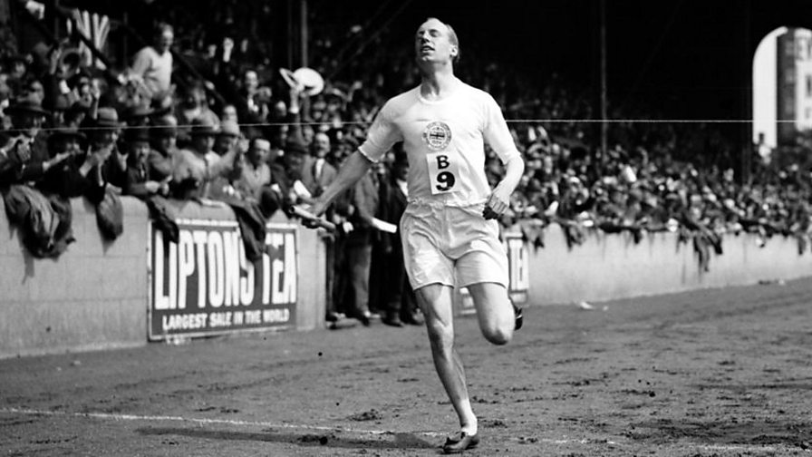

**PPT ONLY**

**"Many of us are missing something in life because we are after the second best. I put before you what I have found to be the best - one who is worthy of all our devotion - Jesus Christ." – Eric Liddell**

**PPT ONLY**

**“It has been a wonderful experience to compete in the Olympic Games and to bring home a gold medal. But since I have been a young lad, I have had my eyes on a different prize. You see, each one of us is in a greater race than any I have run in Paris, and this race ends when God gives out the medals.” – Eric Liddell**

Running for Christ, was a joy that Eric Liddell, found was even greater than running as an athlete. So he went as a missionary to China throwing off encumbrances some even good things that would hinder him from following Jesus who is better.

Questions for determining encumbrance:

* Do I use my encumbrance as an excuse for not drawing near to God?
* Does this help me run the race keeping focused on Jesus?
* Do I respond sinfully when my “encumbrance” is taken away or cannot enjoy it?
* Do I use my encumbrance as an excuse for not obeying the Lord in serving one another like Hebrews has said “not forsaking one another, provoking to love and good works, encouraging one another daily?”
* Am I proud of my “encumbrance”? Do I boast about it or talk about it more than I talk about my Savior?

Encumbrances are shared with sin in that the source of the problems is in the heart of the person.

Desires are at work in encumbrances just as desires are at play with sin. So, encumbrances can reveal a heart that is not fixed on Jesus.

“It has been a wonderful experience to compete in the Olympic Games and to bring home a gold medal. But since I have been a young lad, I have had my eyes on a different prize. You see, each one of us is in a greater race than any I have run in Paris, and this race ends when God gives out the medals.”  
― **Eric Liddell**

He also explains further that sin that clings so closely needs to be put off because it is an encumbrance as well.

1. **The sin which so easily entangles.**

* What are the patterns of sinfulness you most readily and easily commit?
* What are the common reoccurrences for you?

We are not all tempted toward sinful desires, thoughts, and actions in the exact same manner.

* Because of our desires/background/experiences with certain sin and temptations.

There might be a temptation for me that would not be a regular strong temptation for you. And this passage encourages us to throw it off, to lay aside those sins.

* Like taking off old clothes.

[Gospel Appeal]

For believers, caring for one another:

* Confession and Repentance
* Reminding one another of the Gospel, forgiveness
* Encouraging with the power of the Gospel to live righteously
* Watching over one another for deceitfulness of sin in desires/unbelief.

Running with endurance means that we are 1) laying aside encumbrances and sin that easily entangles and 2) being encouraged by the witness of God’s faithfulness to those who lived by faith in the past…

We might think that because of the great cloud of witnesses that encourages us that our eyes should be fixed on them to endure. But instead, he encourages us to…

1. **Fix your eyes on Jesus to finish the race.**

**v. 2 – “fixing our eyes on Jesus, the author and perfecter of faith”**

Jesus is not only the best example of what it means to live by faith,

* he is the source of such enduring faith
* the object and reward of our faith
* and the one who brings our faith to completion so we cross the finish line.

1. **The “Champion” of faith.**

This word “author” some translations say “founder/forerunner/leader” We saw this used earlier in Hebrews 2:10 and we chose the word Champion is a possible translation. Especially in light of the athletic imagery of the context.

**Hebrews 2:10 – “For it was fitting for Him, for whom are all things, and through whom are all things, in bringing many sons to glory, to perfect the *author* of their salvation through sufferings.”**

This faith is victorious and pleasing to God because of Jesus Christ, Our Champion, won salvation for us through his death and resurrection on our behalf. He ran the race of faith ahead of us and finished victoriously.

**Hebrews 6:20 – “This hope we have as an anchor of the soul, a *hope* both sure and steadfast and one which enters within the veil, where Jesus has entered as a forerunner for us”**

Our trust is in him! If our faith is not in Jesus it is in vain!

He initiated faith and will finish it as the…

1. **The Perfector of faith.**

Jesus’s perfect saving work on the cross Jesus announced “it is finished.” The Father approved of Christ sacrifice for our sins on the cross in our place by raising Christ from the dead and vindicating him.

**Hebrews 10:14 – “For by one offering He has perfected for all time those who are sanctified.”**

When Hebrews has us fix our eyes on Jesus, you see thoughtful consideration of how great Jesus is that it motivates endurance like Christ…

* Jesus is so great he is the champion of faith.
* Jesus is so amazing he is the perfecter of faith.
* Jesus is so marvelous….

1. **Jesus endured the cross for the sake of the joy set before him.**

The victorious champion who initiated such faith in your life, the one who completes it…is also the one who knows about endurance and knows the temptation to grow weary and lose heart.

**v. 2 – “who for the joy set before Him endured the cross, despising the shame, and has sat down at the right hand of the throne of God.”**

To endure you have the perfect example of faith and help from a sympathetic Savior who endured the cross living faithfully.

Remember how the joy of the reward motivated the faithful of the past…

Abraham… Heb 11:10 – “he was looking for the city which has foundations, whose architect and builder is God.”

We saw earlier how Moses Hebrews 11:26 “considering the reproach of Christ greater riches than the treasures of Egypt; for he was looking to the reward.”

Such faith comes from God, and Jesus as the forerunner of such faith was looking forward “for the joy set before Him” – being “sat down at the right hand of the throne of God”

For the sake of such a joy and reward Jesus, endured the cross, despising the shame, regarding the shameful suffering of the cross as little consequence for the reward promised him.

Application:

* Are your eyes fixed on Jesus?
* Is he your motivation?
* Is he your goal and reward for faithful endurance?
* Is considering Jesus making a difference in your life for living for him?
  + Jesus is better

While, not all of us would say we feel great pleasure in the Lord when we physically run, may we find joy in getting to run this Christian race for Jesus.

* The joy because of what Jesus did to give us such faith.
* The joy because of Jesus’s presence with us to help us endure.
* The joy of knowing that Jesus is a rewarder of those whose eyes are fixed on him.

Let’s Run with Endurance!!

1. Being encouraged by the great crowd of witnesses that cheer of God’s faithfulness.
2. Laying aside everything that hinders you from running.
3. Fixing our eyes on Jesus, the champion and perfecter of faith.

Let’s consider him so we don’t grow weary and lose heart. Let’s pray.