Introduction: Remembering where we are in Hebrews:

Hebrews 4:14-16 introduces the central section of Hebrews and 10:19-25 conclude it.
Kari, can you put this in a single slide?
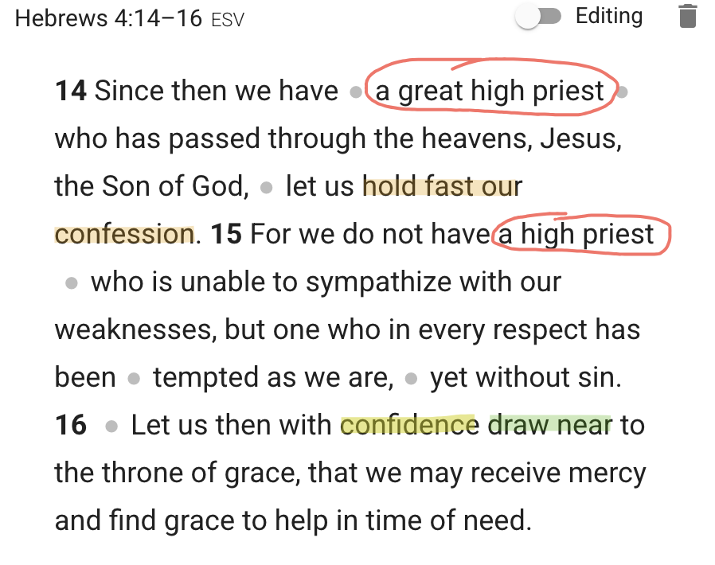
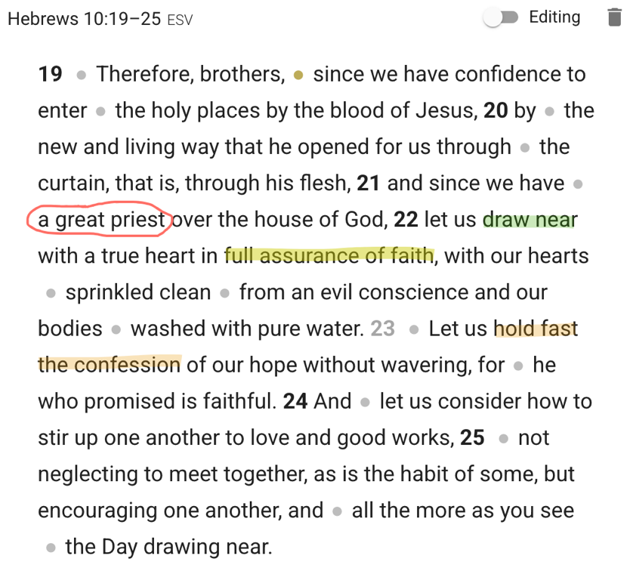

The central theological arguments of Hebrews 5–10:18 are summarized in Hebrews 10:19-21.
Hebrews 10:19–21
¹⁹ Therefore, brethren, since we have confidence to enter the holy place by the blood of Jesus, ²⁰ by a new and living way which He inaugurated for us through the veil, that is, His flesh, ²¹ and since we have a great priest over the house of God.

Jesus is our sinless, great high priest forever (Hebrews 5-7).
Hebrews 6:19–20 This hope we have as an anchor of the soul, a hope both sure and steadfast and one which enters within the veil, ²⁰ where Jesus has entered as a forerunner for us, having become a high priest forever according to the order of Melchizedek.

Hebrews 7:23–25 The former priests, on the one hand, existed in greater numbers because they were prevented by death from continuing, ²⁴ but Jesus, on the other hand, because He continues forever, holds His priesthood permanently. ²⁵ Therefore He is able also to save forever those who draw near to God through Him, since He always lives to make intercession for them.
Hebrews 7:26–27 ²⁶ For it was fitting for us to have such a high priest, holy, innocent, undefiled, separated from sinners and exalted above the heavens; ²⁷ who does not need daily, like those high priests, to offer up sacrifices, first for His own sins and then for the sins of the people, because this He did once for all when He offered up Himself.

Jesus is the mediator of the New Covenant that brings the Old Covenant to an end (Hebrews 8-10).
Hebrews 10:9 ...He takes away the first in order to establish the second.
Hebrews 9:12–15 and not through the blood of goats and calves, but through His own blood, He entered the holy place once for all, having obtained eternal redemption... ¹⁵ For this reason He is the mediator of a new covenant, so that, since a death has taken place for the redemption of the transgressions that were committed under the first covenant, those who have been called may receive the promise of the eternal inheritance.

Jesus is the perfect sacrifice that brings about the complete forgiveness of sins (Hebrews 10:11-14).
Hebrews 10:11–14
¹¹ Every priest stands daily ministering and offering time after time the same sacrifices, which can never take away sins; ¹² but He, having offered one sacrifice for sins for all time, SAT DOWN AT THE RIGHT HAND OF GOD, ¹³ waiting from that time onward UNTIL HIS ENEMIES BE MADE A FOOTSTOOL FOR HIS FEET. ¹⁴ For by one offering He has perfected for all time those who are sanctified.
- Responses to Christ’s Sacrificial and Priestly Work
You’ll see in the outline of these three responses/commands that the first one drawing near encourages faith, the second command of holding fast is encouraging hope and the final one of stimulating to love and good deeds encourages love. This seems to follow the pattern of 1 Corinthians 13:13 But now faith, hope, love, abide these three; but the greatest of these is love.
So hopefully that helps you see how these three commands fit together.
So first....

Draw near to God - FAITH (v.22)
Hebrews 10:22 let us draw near with a sincere heart in full assurance of faith, having our hearts sprinkled clean from an evil conscience and our bodies washed with pure water.
As we saw in the introduction the command to draw near first was mentioned in Hebrews 4:16.
Hebrews 4:16 Therefore let us draw near with confidence to the throne of grace, so that we may receive mercy and find grace to help in time of need.
The next time it shows up is in chapter 7, which we looked at that verse in the introduction as well...
Hebrews 7:25 Therefore He is able also to save forever those who draw near to God through Him, since He always lives to make intercession for them.
So both of those uses of the word “draw near” emphasize that our confidence to draw near is in who Jesus is...he is our great high priest who sits on a throne of grace ready to give mercy and help!
He is also the great high priest who lives forever...meaning he is always, for all eternity living to intercede for us to the Father. So we should have confidence that we can draw near to God because of Jesus’ eternal priesthood.
The next use of “draw near” emphasizes how the Old Covenant didn’t provide the same kind of confident faith to draw near to God that we have now...
Hebrews 10:1 For the Law, since it has only a shadow of the good things to come and not the very form of things, can never, by the same sacrifices which they offer continually year by year, make perfect those who draw near.
Under the old covenant they were still to draw near to God, but those sacrifices didn’t make them perfect...Jesus’ sacrifice does make those who draw near perfect which is why we should have tremendous faith and assurance. But that is confidence in...

With confidence in the object of your faith = Jesus (22b-c)
Hebrews 10:22b-c...true heart, and full assurance of faith....
This is very important to understand and be reminded of...our confidence and full assurance of faith is because of Jesus and not because of us.
Let me illustrate what happens when our confidence and assurance is based on us...
- If your confidence is based on you, then when you fail and sin you’re going to be slow to go to God.
- If you sin seriously, you may shrink away from God or doubt if he really wants you to read your Bible, pray to him, or sing to him in church and so forth.
- The guilt and shame of our failure, if our faith is not in Jesus but rather in our performance, results in us not confidently drawing near to God!
When the text says we draw near with a true heart.
- This is connected back to one of the most significant promises of the New Covenant which he has just unpacked in chapters 8-10.
He repeats this significant promise just a few verses earlier...
Hebrews 10:16 “THIS IS THE COVENANT THAT I WILL MAKE WITH THEM AFTER THOSE DAYS, SAYS THE LORD: I WILL PUT MY LAWS UPON THEIR HEART, AND ON THEIR MIND I WILL WRITE THEM,”
So why can we draw near confidently with full assurance? Because in the new covenant he writes his law on our heart. Or as other passages promise in the new covenant, he removes our heart of stone and puts in a new heart of flesh (Ezekiel 36).
At the moment a person trusts in Jesus Christ as Lord and Savior and confesses their sin and asks forgiveness, God gives them a new heart...a true heart, that now they can draw near to God with full assurance.
- This is really basic...but often times it’s the most basic things we need to be reminded of...but the only people that need to draw near to Jesus are sinful people!
- How ironic, that our sin is often the reason that we think God wouldn’t want us to come to him...Jesus didn’t go to the cross for sinless people!
That gets to the next point...we are to draw near to God with full confidence in Jesus...not ourselves. The way we can have that full confidence of faith is...

By means of Jesus’ washing and cleansing blood (22d-e)
Hebrews 10:22d-e... having our hearts sprinkled clean from an evil conscience and our bodies washed with pure water.
This is referring to the powerful washing and cleansing that Christ’s blood has on his people.
In chapter 9 the world “sprinkled” was used three times talking about how under the Old Covenant the sprinkling of the blood of animals was used to sanctify and purify people, and all the vessels in the temple. But the blood of animals couldn’t purify and perfect what they cleansed for all time, which is why more sacrifices and sprinkled blood had to occur.
In Hebrews 9:18-19 sprinkling of blood and water are connected.
Hebrews 9:18–19 Therefore even the first covenant was not inaugurated without blood. 19 For when every commandment had been spoken by Moses to all the people according to the Law, he took the blood of the calves and the goats, with water and scarlet wool and hyssop, and sprinkled both the book itself and all the people

Hold fast to your confession - HOPE (v.23)
Hebrews 10:23 Let us hold fast the confession of our hope without wavering, for He who promised is faithful;
The hope here is to be unwavering...this is much like the previous command we looked at where our confidence and assurance to draw near is because of who Jesus is and what he has done, not us.
‘Hope’ in Hebrews describes the objective content of hope (rather than the act of hoping), and it relates to both present and future salvation.( Peter T. O’Brien, The Letter to the Hebrews PNTC, 368)
The manner in which we are to hold fast our confession is “without wavering.” That is probably pretty self-explanatory, but it means without doubting, with absolute confidence and certainty.
- Now for many people the command to hold fast the confession of hope without wavering, that might be scary or seeming unattainable. And this goes back to the same problem as people struggling to have full assurance in the faith.
- Often what people are looking for is the evidence or sign in themselves that they have strong enough faith, or confident enough hope.
  - And usually that sign is based primarily on their performance...I have strong faith, and hope in the Lord if I’m meeting some standard.
- But notice...the basis of this command to hold fast the confession without wavering is not based on your faithfulness and your ability.
  - The command is actually based on God’s faithfulness.
That is so key, when we fail and sin we’ve—
- like Peter who by faith walked out on the water when Jesus called Peter out the boat, turned away from looking at Jesus to looking at the waves and storms around us that see far too big for us—which they are!—
- Or we’ve turned to look at our own abilities and skills and put our hope and faith in my capacity to “get things done.”
When Peter began to sink because he looked away from Jesus, “He cried out, ‘Lord save me!’”
And what did Jesus do?
Matthew 14:31 Immediately Jesus stretched out His hand and took hold of him, and said to him, “You of little faith, why did you doubt?”
Amazing. Peter’s faith is weak...he is not faithful, but Jesus is. Jesus doesn’t let him drown because he didn’t have perfect faith...
Jesus is faithful...our hope and our faith are in the God who never, ever fails!
Now, perhaps you’re here and you’re thinking...well that’s great for Peter. But I’m not Peter...how do I know that Jesus will be faithful to me?
- There is a lot that could be said on that point, but let me offer a brief suggestion.
First, really spend time meditating on God’s character in Scripture.
- In Hebrews 6:13-20 that we covered back at the end the spring, how far God has gone so that we’d have full confidence in his faithfulness and promises.
Hebrews 6:13 For when God made the promise to Abraham, since He could swear by no one greater, He swore by Himself,
Hebrews 6:17–20 In the same way God, desiring even more to show to the heirs of the promise the unchangeableness of His purpose, interposed with an oath, ¹⁸ so that by two unchangeable things in which it is impossible for God to lie, we who have taken refuge would have strong encouragement to take hold of the hope set before us. ¹⁹ This hope we have as an anchor of the soul, a hope both sure and steadfast and one which enters within the veil, ²⁰ where Jesus has entered as a forerunner for us, having become a high priest forever according to the order of Melchizedek.
God did not have to make promises to us...but he has! Because he loves us and he wants us to confident faith and hope IN HIM!
- God did not have to swear with an oath...but he made an oath to give us STRONG ENOUCRAGEMENT to take hold of the hope set before us.
- He has spoken and done things so we’d have strong encouragement in him and his character and his faithfulness.
Second, pray that God would help you read the Bible and know that this is God’s Word to you—his child!
- The Bible is not just general truth, or a history book. Hebrews 4:12 says...
Hebrews 4:12 For the word of God is living and active and sharper than any two-edged sword, and piercing as far as the division of soul and spirit, of both joints and marrow, and able to judge the thoughts and intentions of the heart.
- The Bible is God’s active, living word directed at you, his child!
If you don’t see that...of course you’re going to struggle with faith and hope.
I had friends growing up whose parents would make promises to them like, “If you get these grades then I’ll take you to Disney world.”
- The promises to my friends, from their dad, did nothing to give me confidence that I’d be going to Disney world if I got good enough grades!
- WHY? Because those promises were made from a father to HIS KIDS!
If you are a child of God, then these promises are from YOUR Father, to YOU!!
So 1) really meditate on the character of God, and passages that highlight his love and faithfulness. And 2) ask God to help you read the whole Bible as his personal word to you—his child!
That will help you start to have full assurance of faith and hold fast your confessing without wavering.

Intentionally consider one another – LOVE (v.24-25)
Hebrews 10:24–25 and let us consider how to stimulate one another to love and good deeds, ²⁵ not forsaking our own assembling together, as is the habit of some, but encouraging one another; and all the more as you see the day drawing near.
The way the Greek reads is just two words for the command...word one means intentionally consider one another...word two is “one another.”
What’s the purpose of intentionally considering one another?

Purpose: To encourage love and good works (v.24b)
Hebrews 10:24b ...how to stimulate one another to love and good deeds...

How do we accomplish stimulating one another to love and good deeds?

By being in committed groups where you know one another (v.25a-b)
Hebrews 10:25a-b ²⁵ not forsaking our own assembling together, as is the habit of some...
The way the ESV or NIV put this is, “not to neglect MEETING together.”
Now what’s meant by that word meeting. If I say, “I have a meeting,” what does that imply?
- It implies an appointed, agreed upon time.
- Now I realize we do say things like, “That was a chance meeting” which describes an unplanned event.
- But in general a ‘meeting’ refers to something that is planned and agreed upon. That’s very important to recognize.
Second, the text says that some are in the “habit” of neglecting to meet.
- That reinforces the idea that these meetings are planned, but adds additionally that this is not just a one time, or infrequently planned meeting. The meetings that are being addressed here are regularly planned.
  - And unfortunately there are people who are regularly not attending these meetings.
Now that is all very important...but the we must keep in mind the purpose of these meetings

By giving and receiving encouragement (v.25c)
Hebrews 10:25c ...but encouraging one another...
Hebrews 3:12–13 Take care, brethren, that there not be in any one of you an evil, unbelieving heart that falls away from the living God. ¹³ But encourage one another day after day, as long as it is still called “Today,” so that none of you will be hardened by the deceitfulness of sin.

By increasing encouragement until Christ returns (v.25d)
Hebrews 10:25d ...and all the more as you see the day drawing near.
2 Timothy 3:12–13 Indeed, all who desire to live godly in Christ Jesus will be persecuted. ¹³ But evil men and impostors will proceed from bad to worse, deceiving and being deceived.
Matthew 24:12–13 Because lawlessness is increased, most people’s love will grow cold. ¹³ But the one who endures to the end, he will be saved.

Peter T. O’Brien, The Letter to the Hebrews (The Pillar New Testament Commentary; Grand Rapids, MI; Nottingham, England: William B. Eerdmans Publishing Company, 2010), 368.

