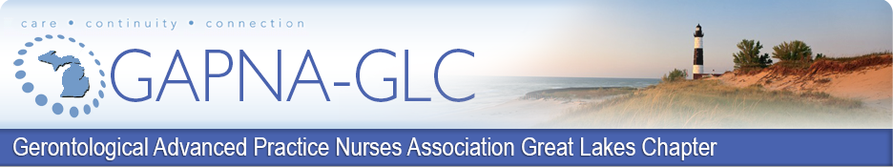

Advanced Practice Registered Nursing

Student Scholarship Award 2026

The GAPNA Great Lakes Chapter will recognize outstanding advanced practice nursing students who exemplify GAPNA's goals. Cash awards ($1,000.00 each) will be presented to the recipient(s) at the 19th Annual Great Lakes Chapter Annual Conference on Saturday, November 7th, 2026.

Purpose: The GAPNA Great Lakes Chapter intends to promote the future of advanced practice nursing in this state by offering a scholarship to be used towards the cost of advanced practice nursing education and encourage commitment to improved nursing care for older adults. The GAPNA Great Lakes Chapter is accepting applications for a scholarship award for the student(s) enrolled in an advanced practice nursing program at an accredited school.

Application Deadline: Nominations (self or for others) are due October 5th, 2026.
Awarders: GAPNA Great Lakes Chapter Board of Directors
Award Notification: Recipient(s) notified at the 19th Annual GLC Conference on November 7th, 2026

Stipulations: Recipient(s) must be registered (at the student rate) and attend the Great Lakes Chapter Annual Conference on November 7th, 2026, where the scholarship will be presented.

Eligibility Criteria: To be eligible, the individual must have:
- a State of Michigan license as a registered nurse.
- Proof of acceptance or enrollment in an Advanced Practice Nursing Master’s (CNS, NP) degree education program in good standing OR
- Proof of current NP/CNS certification and acceptance/enrollment in an Advanced Practice Nursing (DNP or PhD) degree education program in good standing.
- A written statement by the student addressing career and education goals and the award criteria (length not to exceed two single-spaced typed pages).
- Submitted Curriculum Vitae.
- Completion of the application and receipt on or before the stated due date.
- Proof of membership (active or student) in GAPNA.
The GAPNA Great Lakes Chapter scholarship will be awarded to a student(s) based on contributions to the mission of the GAPNA Great Lakes Chapter. Please submit a single-spaced, two-page typed narrative addressing your contributions according to the following award criteria:
- Advocates quality care for older adults
- Promotes the professional development of advanced practice nursing
- Provides continuing gerontological education for nursing staff
- Encourages communication and professional collaboration among healthcare providers
- Supports research related to the care of older adults
Please submit all nomination materials in a single email to our President and the Awards/Scholarship Committee Member(s): GAPNA Great Lakes Chapter President at GAPNAgreatlakeschapter@gmail.com. Thank you and Best Wishes.

GAPNA Great Lakes Chapter
Advanced Practice Nursing Student Scholarship Award Application

Please type:

Nominator Name (if applicable)

Nominator Contact Information: phone , email

Nominee Name

Credentials (including NP/CNS certification # and certifying body, if enrolled in DNP, PhD program)

Home Address

Home Phone Cell

Email Address

Education (school attended, highest degree, discipline, year)

Michigan RN License Number

APN Program (school attending program)

Faculty Advisor & Contact Information

Present position/title/affiliation

Business Address

Business Phone Fax

Attestation:
By my signature, I agree to attend the 19th Annual GLC Conference on November 7th, 2026. I also certify that all information submitted with this application is accurate and complete to the best of my knowledge:
Signature Date

Revised 12/30/2025

