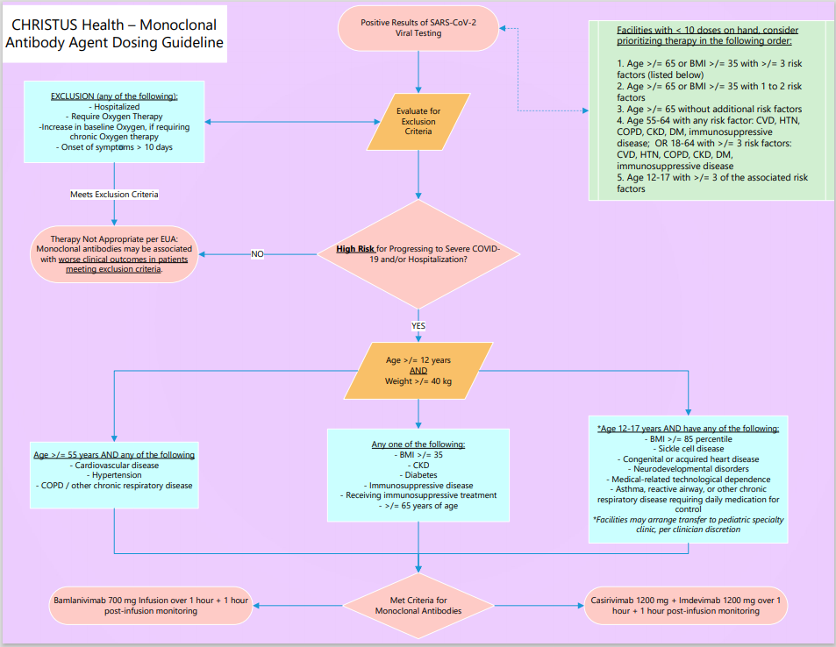

I have reviewed the above algorithm and the patients meet the following criteria for administration:

_________________________________________________________________________________________________________________________________________________________________________________________________________________________________________________________________________________________________________________________________________________________________________________________________________________________________________Date of initial symptoms:____________________________________________________________________________

Date of Positive PCR Test: ________________________________________________________________

Provider Signature: ____________________

Printed: ____________________________

Date: _______________________

CLINIC Nurse BACKLINE OR MANAGER Phone:___________________________________