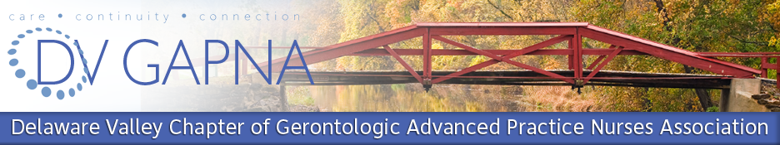

**Practice Updates in Geriatrics**

**April 8, 2017**

**Living and Learning Center 1**

**Schmidt Multipurpose Room**

**Neumann University**

**1 Neumann Drive, Aston, PA**

***7:15am-8:15am***- Industry sponsored breakfast: “Transform the Treatment of Parkinson’s Disease Psychosis with Nuplazid” – Susan Scanland, MSN, CRNP, GNP-BC, CDP, CSP (Acadia Pharmaceuticals)

***8:30am -9:30am***- “Prescribing for Seniors: Pearls and Pitfalls”- Thomas Lawrence, MD, CMD

***9:45am-10:45am***- “Pelvic Organ Prolapse: Assessment and Management in Older Women” – Uduak Umoh Andy, MD

***10:45am -11:15am* –Break for Networking and visit exhibits**

***11:15am-12:15pm***- “Primer on Palliative Care” – Mary Evans Greene, MSN, CRNP, ACHPN-BC, RN

***12:15pm-12:30*** *Closing remarks , Please turn in surveys in the boxes provided in the room.*

**$50.00 for GAPNA member, $60.00 for non- members and $25.00 for students.**

Register on the DelVal GAPNA ENP site .

This continuing educational activity is provided by the Delaware Valley Gerontological Advanced Practice Nurses Association.

In order to receive credit you must attend at least 80% of the entire activity, providing the activity is greater than 1.0 credit hour.

Pending Approval: This activity has been submitted to American Nephrology Nurses Association for approval to award contact hours. American nephrology Nurses Association – Approver is accredited as an approver of continuing nursing education by the American Nurses Credentialing Center’s Commission on Accreditation.

.