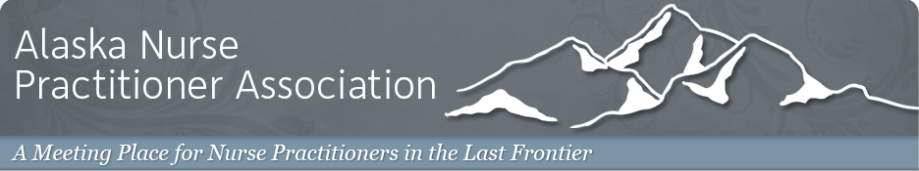

The Alaska Nurse Practitioner Association and Imaging Associates Cordially Invite You to Join Us For:

Tuesday Night Radiology Series for Nurse Practitioners.

**Speaker:** Dr. Gerald York, MD. Board Certified Diagnostic Radiologist, subspecialty certification in Neuroradiology.

**Topic:** Advancements in Traumatic Brain Injury

**When:** March 7, 2017 6-8PM

**Where:** Imaging Associates, Piper St, Anchorage, AK 99508

**RSVP to:** Shannon Hilton at shannonhiltonanp@gmail.com or Jeff Sandys at Jeff.Sandys@imagingak.com

We welcome you to join your colleagues for an evening of learning and networking

Refreshments will be served

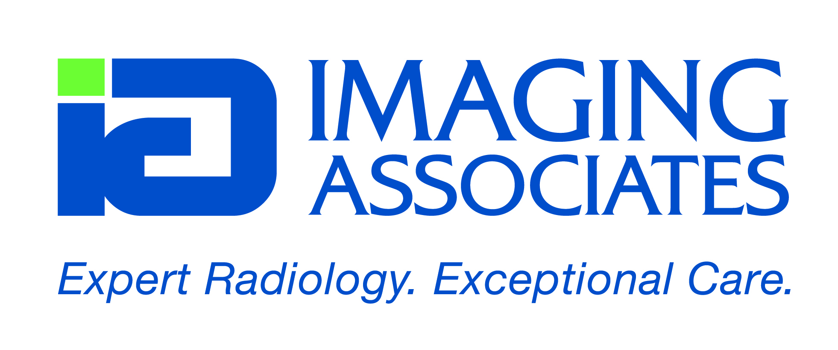

***This event is generously sponsored by Imaging Associates***