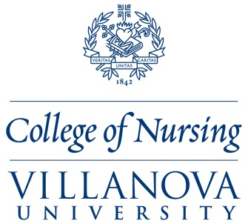

Dear Family Nurse Practitioner,
You are invited to participate in a research study conducted by Rebecca Mueller, MSN, RN, FNP-BC a current doctoral student from Villanova University. I hope to learn more about the growth of mHealth applications as a health promotion tool, and to determine if FNPs recommend mHealth apps to their patients to complement patient care plans.

The purpose of this study is to measure FNPs’ use and behavioral intention to use mHealth apps for health promotion, using the Unified Theory of Acceptance and Use of Technology Model. The results will contribute to the completion of my dissertation study, Family Nurse Practitioners’ Use of mHealth Apps for Health Promotion with Patients.

Your input is greatly valued and will contribute to the limited body of knowledge related to this topic. This survey is open to board-certified family nurse practitioners who practice in ALL settings. The survey will take approximately 5-15 minutes to complete, depending on your responses. Those who participate will have two chances to win a $50 Amazon gift card. If you decide to participate in this confidential study, the survey can be accessed from: https://www.surveymonkey.com/r/FNPmhealthapps.

Please feel free to share this survey link with other FNP colleagues within your own professional networks.

Thank you for your consideration in completing this survey,
Sincerely,

Rebecca Mueller, MSN, RN, FNP-BC

