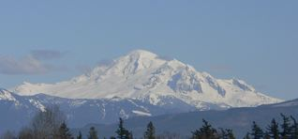

The Mount Baker Nurse Practitioner Association’s

8th Anniversary Business Meeting / Get together

Come Celebrate

Nurse Practitioner Week!

Attend our annual business meeting

Update on Washington & national NP concerns

Vote for board members

Network with colleagues and meet

new members and student NP’s

Appetizers and light refreshments will be provided

Tuesday, November 15, 2016

6:00 - 8 pm

Place: Squalicum Yacht Club

2633 S Harbor Loop Dr, Bellingham, WA 98225

RSVP on the Website: <http://www.MBNPA.org>

Or email Janice-taylor@comcast.net