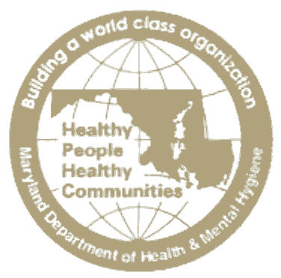
STATE OF MARYLAND

DHMH

Maryland Department of Health and Mental Hygiene
Larry Hogan, Governor - Boyd Rutherford, Lt. Governor - Van Mitchell, Secretary

The Department of Health and Mental Hygiene would like to make health care providers and medical laboratories aware of a recent change in the law regarding laboratory testing for Lyme disease.

Information on New Lyme disease Notice Requirement

Section 20-1701 of the Health – General Article requires that patients receiving a laboratory test for the presence of Lyme disease receive the following notice at the time that blood is drawn:

Your health care provider has ordered a laboratory test for the presence of Lyme disease for you. Current laboratory testing for Lyme disease can be problematic and standard laboratory tests often result in false negative and false positive results and, if done too early, you may not have produced enough antibodies to be considered positive because your immune response requires time to develop antibodies. If you are tested for Lyme disease and the results are negative, this does not necessarily mean you do not have Lyme disease. If you continue to experience unexplained symptoms, you should contact your health care provider and inquire about the appropriateness of retesting or initial or additional treatment.

Who Must Provide the Notice?

- A licensed health care provider who draws the blood of a patient to perform a laboratory test for Lyme disease; or

- A medical laboratory that performs a laboratory test for the presence of Lyme disease.

