**Maryland GAPNA Chapter Presents:**

Student/New Graduate NP Scholarship to attend Annual Gerontological Advanced Practice Nurses Association conference September 21-24, 2016 in Phoenix, AZ.

**\*\*\* Qualifications *** 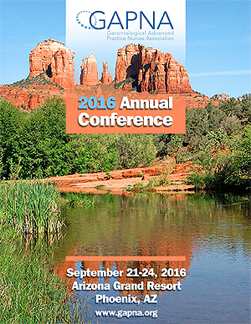**

*Scholarship will include $500 for the recipient to use toward conference expenses*

**Must be an active student GAPNA member or new graduate GAPNA member within the first year of clinical practice. Membership must be active at time of conference.**

To apply please submit the following information to Allison Carew via email at [acarew5@gmail.com](mailto:acarew5@gmail.com)

* Attached Application
* 250 word essay that describes your career goals and how attendance at the conference will enhance your learning and contribute to professional development

All applications must be received by August 5, 2016. Award Recipient will be notified no later than August 12, 2016.

Questions or inquiries please contact Allison Carew, Maryland GAPNA Chapter Secretary at [acarew5@gmail.com](mailto:acarew5@gmail.com)

Go to [www.gapna.org](http://www.gapna.org) for more details about the conference and membership

Student Scholarship to attend Annual GAPNA conference in Phenoix, AZ - September 21-24, 2016

Application

Applicant Name________________________________________________________

Applicant Phone Number_________________________________________________

Applicant email address__________________________________________________

Applicant Address______________________________________________________

_____________________________________________________________________

Name of School currently enrolled__________________________________________

Name of Specialty Program (ex: Adult/Gero, Family, Acute Care) _________________

Please attach the following:

* 250 word essay that describes your career goals and how attendance at the conference will enhance your learning and contribute to Professional Development.

*Send completed application to:*

*Allison Carew –* [*acarew5@gmail.com*](mailto:acarew5@gmail.com)

**\*\*\*Must be an active student GAPNA member or new graduate GAPNA member within the first year of clinical practice. Membership must be active at time of conference to qualify for the scholarship\*\*\***