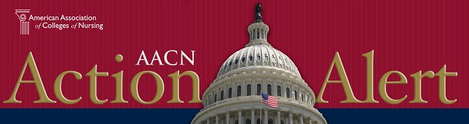

Dear AACN Stakeholder,

On May 25, the U.S. Department of Veterans Affairs (VA), Veterans Health Administration (VHA) released a proposed rule in the Federal Register that would have monumental implications for certain Advanced Practice Registered Nurses (APRNs). This proposed rule would grant full practice authority to all APRNs serving in the VHA. You may be aware that AACN, in collaboration with our APRN colleagues, has been urging the VHA to move in this direction for over three years. (For more background information on this issue, read AACN's press release). The VHA is soliciting public comments through July 25, 2016 on this proposed rule. To move this policy forward, we must ensure a robust response from vested stakeholders, including academic nursing. You are receiving this message as our records indicate you have not yet responded. To do so, please click on the link at the bottom of this email.

The VHA will consider all submitted comments (both in support and in opposition) to this proposed rule, which will ultimately impact its decision. To date, nearly 30,000 comments have been submitted, and a large portion of these express opposition to APRN full practice. Therefore, each and every voice in support of the proposed rule is of critical importance. Thank you for considering this request!

Please click on the link at the bottom of this email and tailor your message, especially if you are a Veteran, have cared for Veterans, serve as an APRN, educate APRNs, or partner with a VA site. Our goal is to present a united front on behalf of the profession. Thank you in advance for mobilizing this effort.

If you have any questions, please contact AACN's Government Affairs staff members, Suzanne Miyamoto at Smiyamoto@aacn.nche.edu or Lauren Inouye at Linouye@aacn.nche.edu.

Sincerely,

Deborah Trautman, PhD, RN, FAAN

President and Chief Executive Officer

American Association of Colleges of Nursing

Please note that any comments submitted will be publicly posted online on www.regulations.gov.

Click the link below to log in and send your message:

<https://www.votervoice.net/BroadcastLinks/j2MlLXNM5bVaNQyXMsricQ>