**Congratulations to MJ Henderson who was recently awarded the 2016 Lifetime Achievement Award from NONPF.**

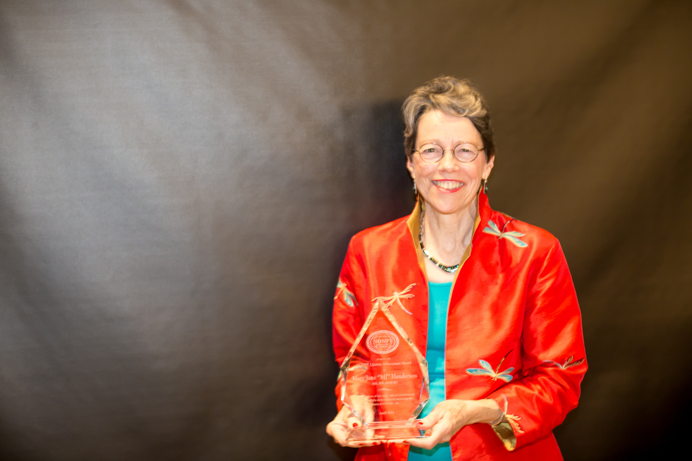

<http://www.nonpf.org/page/LifetimeAchievement>