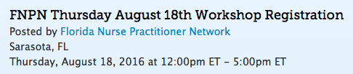 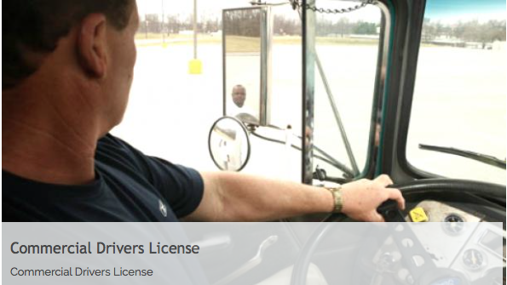

COMMERCIAL DRIVER

MEDICAL EXAMINER

TRAINING COURSE

Faculty:

Dr.Jean Aertker,DNP,ARNP,COHN-S,FAANP and Wendy Paracka MS, ARNP-BC, FNP

4.5 CE Hrs applied for through AANP

The content in this 5 hour training program meets the requirements in the Federal Motor Carrier Safety Administration’s (FMCSA) final rule for the National Registry of Certified Medical Examiners (National Registry) Core Curriculum Specifications. In accordance with 49 CFR 390.105(b), this training includes the eight topics which must be covered in the core curriculum specifications. Following completion of this training, participants will receive the proof of training certificate required by NRCME to take the certification exam.

Lorem Ipsum Dolor Sit Amet.

Quisque et orci vel lorem pulvinar elementum. Morbi et nulla euismod sapien ultrices pretium.

This training course will enable   
Medical Examiners the ability to interpret and apply the Federal rules for commercial motor vehicle drivers and motor coach driver medical examinations, ensuring   
that drivers are physically and mentally   
fit to safely operate a commercial   
motor vehicle (CMV).

The goal of the National Registry for Certified Medical Examiners,   
a division of the Federal Motor Carrier Safety Administration, is to promote and preserve the highest level of professional standards of training and care among medical examiners and requires that medical examiners performing commercial driver medical driver examinations   
be trained and certified.

**Location:**

Hyatt Regency Sarasota

1000 Boulevard of the Arts

Sarasota, FL 34236

**Start time for this workshop course:**

Thursday, August 18, 2016 at 12:00pm ET

Register at: fnpn.enpnetwork.com

This course is a pre-conference workshop of the FNPN Annual Conference and requires a separate registration and fee. Space is limited. Register at: fnpn.enpnetwork.com

FNPN Annual Conference starts:

Friday, August 19, 2016 at 8:00am ET - Saturday, August 20, 2016 at 5:00pm ET