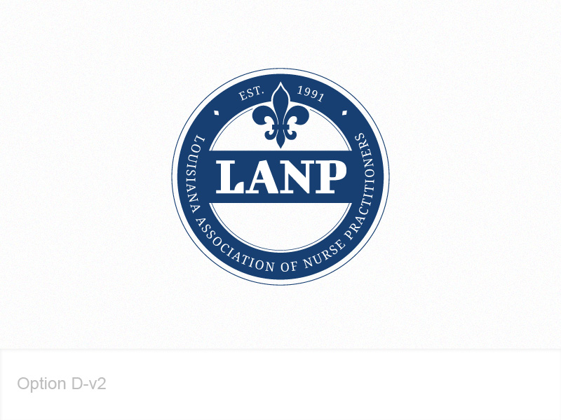 | Louisiana Association of Nurse Practitioners  P O Box 1359, Thibodaux, LA 70302  225-293-7950 • www.lanp.org • office@lanp.org
Louisiana Association of Nurse Practitioners
2016 22nd Annual Primary Care Conference
“Nurse Practitioners: The Force Awakens”

Tax ID #: Upon Request
Dear
Attn:

The Louisiana Association of Nurse Practitioners (LANP) asks for your support of our 22nd Annual Primary Care Conference (PCC) to be held from September 18-21, 2016 at the Hilton Riverside in New Orleans, Louisiana. We are requesting a donation of an item of your choice to be raffled in the Silent Auction during our conference, items for our 800 registration bags, and/or gifts for door prizes. We are also in need of advertising in our Program Guide Magazine and cash donations to help assist with the expenses of our educational program.
Louisiana Association of Nurse Practitioners (LANP) is a 501 C (6) non-profit professional organization of registered nurses who have completed advanced education and training in the diagnosis and management of common medical conditions, including acute and chronic illnesses. We have 1150+ members out of 2,200 licensed Nurse Practitioners (NPs) in the state of Louisiana. NPs serve clients of all walks of life including many of the underserved in our state and are often the only source of health care providers in the community. It is critical that we offer quality training in not only the areas of family medicine, but also provide training in meeting the mental health needs of the disenfranchised in our state. RNs, PAs, & CNs are also being invited to attend and we are expecting approximately 800 participants.

We will be including a list of all contributors in our Program Magazine that will be provided in each attendee’s registration bag. Furthermore, sponsors will be acknowledged on poster boards visible at the conference registration site. Depending on the Donation Choice, Donors would be eligible to advertise on our website, in our quarterly newsletter, and vocally named at our business meeting.

Our major goals are to provide the best possible continuing education, provide opportunities for networking with peers in a live setting, assist NPs and other healthcare professionals maintain professional competence, and to stay abreast of changes in evidence based practice areas to meet the diverse needs of our patients.

We would like to thank you for your support of professional Nurse Practitioners and LANP. We hope that you will decide to help make our conference be the best yet as we anticipate a higher level of participation in New Orleans than usual. Please do not hesitate to contact one of us if we can provide additional information. Your consideration of a donation is greatly appreciated.

Sincerely,

Jennifer Cameron, FNP-C Rebecca Thibodaux Anna Lehmann, RN
PAC Chair LANP Executive Director LANP PAC Volunteer
jcameronnp@gmail.com 225-293-7950 504-460-5220
318-773-1447 execdir@lanp.org annalehma@cox.net

