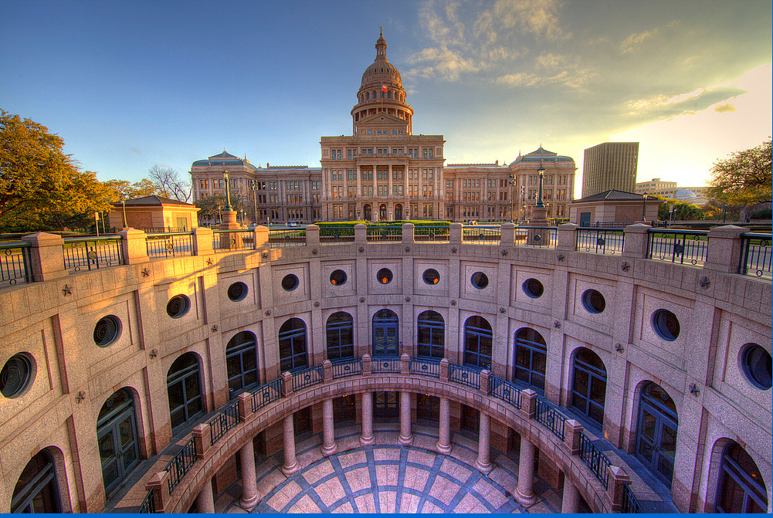

YOU ARE INVITED TO OUR TNP PAC RECEPTION

Saturday, February 27, 6:30-9:30 pm

$50 ticket-make checks to TNP PAC

Hosted by Dr. John Stevens, DNP

3004 Southwestern Blvd, Dallas, Texas 75225

Senator Don Huffines, Invited Guest

RSVP: Peggy Ostrander ([pegostrander63@me.com](mailto:pegostrander63@me.com))

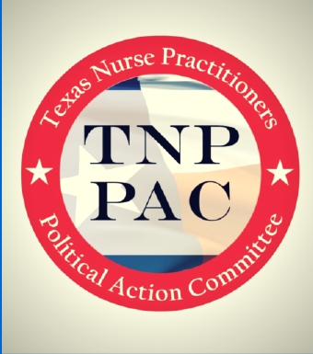 

Promote political education and participation in the political process among members of the Nurse Practitioner profession