

13th Annual Student Mentorship Night
Madonna University Welcome Center Room 120
Thursday, March 26th, 2026

Thursday, March 26th, 2026
5.30 - 6:00 pm Doors open, Light Refreshments with Networking
6.00 – 6:05 pm Welcome
Roxanne Roth, DNP, RN, CNE,
Dean of College of Nursing Madonna University
6:05 - 6:30 pm I’m Graduating, Now What? Discussion on boards, NPI, DEA
and what to expect
Laura Kremer AGPCNP-C
6:30 – 7:00 pm The New NP experience
Petrit Hila MSN, AGPCNP-BC
7:00 – 7:30 pm Employment contracts (things to think about)
Dave Kotzian Attorney
7:30 – 7:55 pm Networking, Policy Making, and Getting Involved as an NP
Deborah Dunn EdD, MSN, GNP-BC, ACNS-BC, GS-C
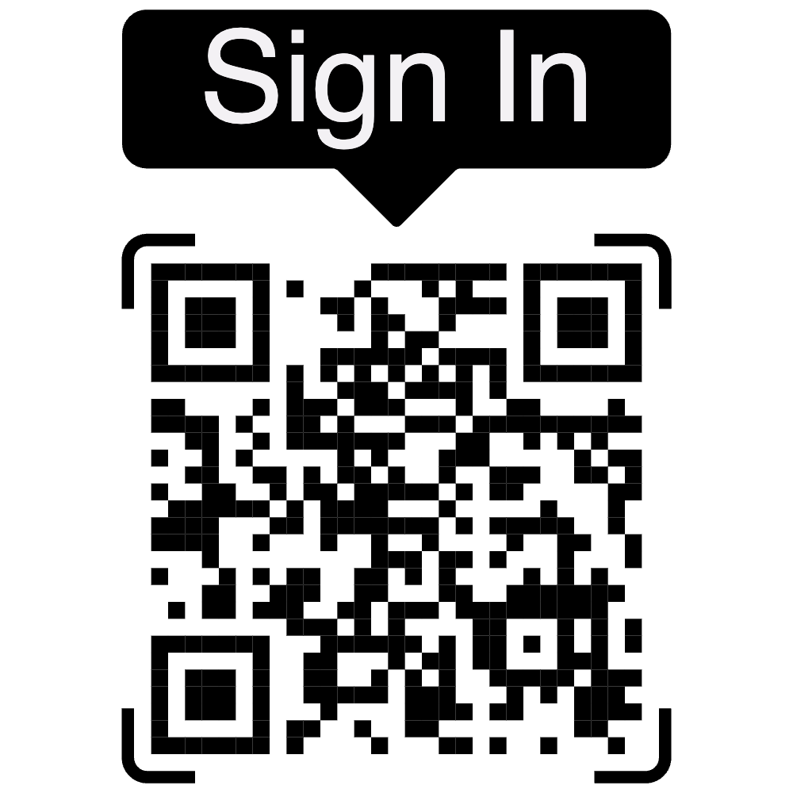
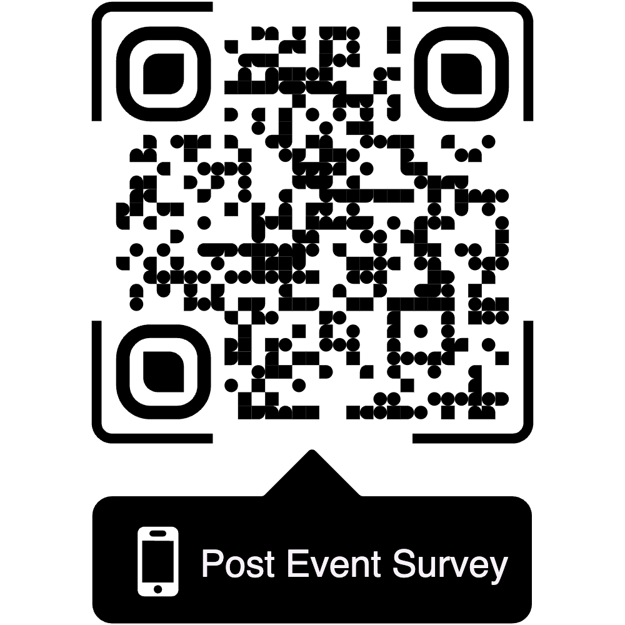
7:55 – 8:00 pm Wrap Up

