**Long Acting Reversible Contraception Education Series for Vermont Health Care Providers**

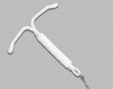 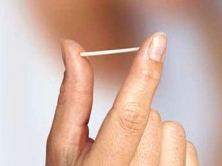 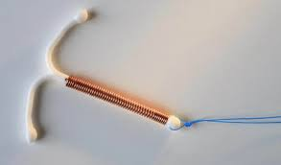

The Vermont Child Health Improvement Program (VCHIP), in conjunction with the Vermont Department of Health and University of Vermont Medical Center are presenting three webinars covering different topics around use of Long-Acting Reversible Contraception (LARC). These webinars are designed to give an in-depth overview of LARCs, offering providers information that they can use to incorporate these methods more effectively into their practice.

**Register now to confirm your spot for the webinars**

Webinar 1: Wednesday February 10th from 12-1pm

***LARC 201: Update on Long Acting Reversible Contraception***

Elisabeth Wegner, MD, Associate Professor, University of Vermont College of Medicine

For more information and to register for this webinar:

[**https://uvm-vchip.adobeconnect.com/larc-reg/event/event\_info.html**](https://uvm-vchip.adobeconnect.com/larc-reg/event/event_info.html)

Webinar 2: Friday March 11th from 12-1pm

***Addressing Insurance, Systems and Practice Barriers to LARC Usage***

Katherine Mariani, MD, Assistant Professor, University of Vermont College of Medicine

For more information and to register for this webinar:

**[https://uvm-vchip.adobeconnect.com/larc-reg2/event/event\_info.html](https://uvm-vchip.adobeconnect.com/larc-reg2/event/event_info.html" \t "_blank)**

Webinar 3: Wednesday April 6th from 12-1pm

***Contraceptive Counseling Techniques and LARC Referrals***

Erica Gibson, MD, Assistant Professor, University of Vermont College of Medicine

For more information and to register for this webinar:

**[https://uvm-vchip.adobeconnect.com/larc-reg3/event/event\_info.html](https://uvm-vchip.adobeconnect.com/larc-reg3/event/event_info.html" \t "_blank)**

***Application for CME credit has been filed with the American Academy of Family Physicians. Determination of credit is pending.***

If you have any questions, please contact Adrienne Woike at VCHIP, [Adrienne.woike@med.uvm.edu](mailto:Adrienne.woike@med.uvm.edu) or 802-656-9191.