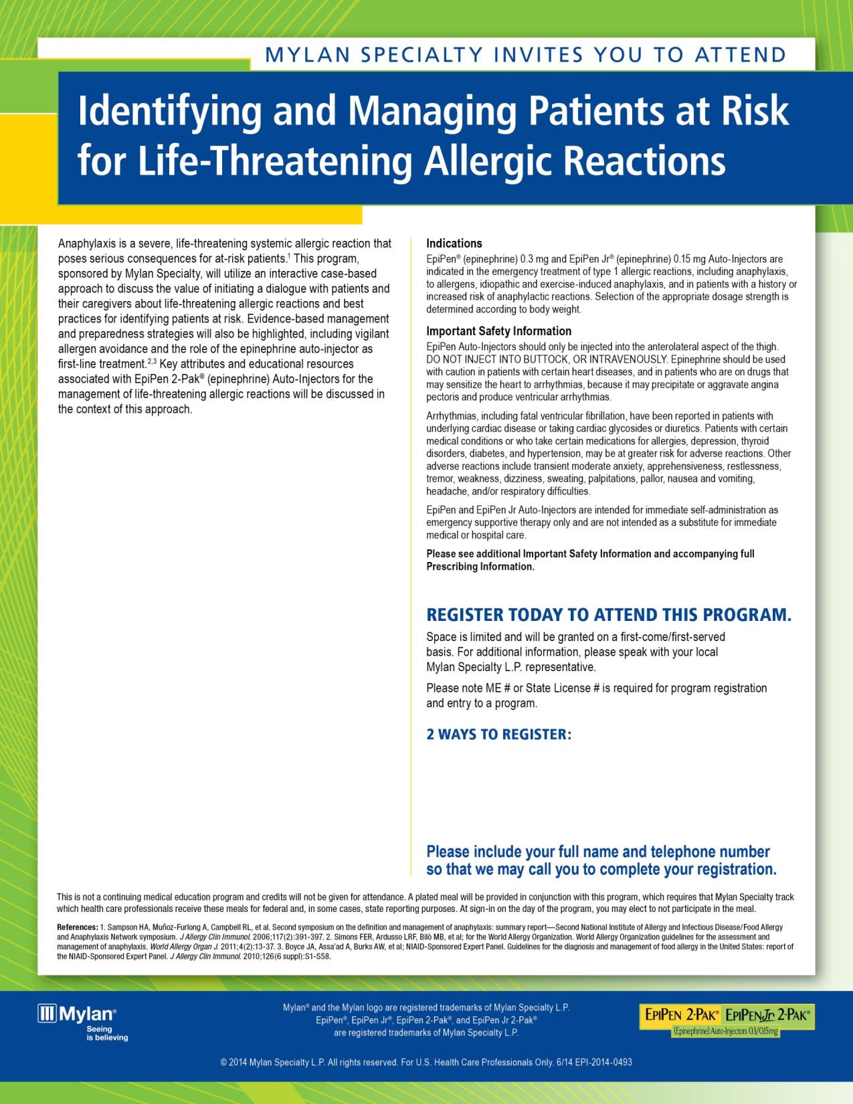
Tuesday, January 26, 2016 6:30 PM
Dinner
and Presentation

Restaurant Cotton
101 N Grand St
Monroe, LA 71201
(318) 325-0818

Faculty Presenter
Ben Close, MD, FACP

- Call Scott Latham at .
- Send an email to scott.latham@mylan.com.

