AdVanced Practice Nurses of the Permian Basin (APNPB)
-------------------------------------
2026 Planning Session, Networking, & Social
-------------------------------------
Wenesday
December 10th, 2025
6:30 pm
Dos Compadres
2200 W Wadley Ave #1, Midland, TX 79705
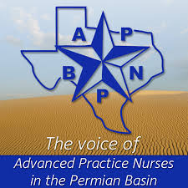 | Please RSVP via APBNP website  https://apnpb.enpnetwork.com/log-in  Happy Nurse Practitioner Week  Nurse Practitioner (NP) Week is celebrated annually in the second week of November to recognize the contributions of nurse practitioners in healthcare. This includes the second full week of November, with the 2025 dates being November 9–15. The week highlights the role NPs play in providing patient care, which can include diagnosing illnesses, prescribing medication, and performing a wide range of health services.  THANK YOU FOR ALL YOU DO!

