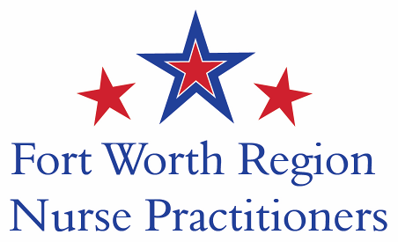
2025 Annual Education Conference
October 25, 2025
Agenda

Start | Stop | Topic
7:00 | 7:50 | Registration, Breakfast, Non-CE Sponsored Event (Inspire)
7:50 | 8:00 | Conference Introduction
8:00 | 9:00 | Thyroid Management: Principles for Primary Providers with Tips, Quirks and Pitfalls Emily Berkowitz PhD, ANP-C, CVNP-BC
9:00 | 10:00 | Lipid Management in Primary Care  Nusrat Khan MD, MBA, CMQ and Cindy Bernard APRN FNP-C
10:00 | 10:15 | Break / Vendor Visits
10:15 | 11:15 | MASH  Ashwini P. Mehta, DO
11:15 | 12:15 | Breaking Barriers: Integrating Mental Health and Substance Use Treatment Across Care Settings  Thomas C. Sargent DNP, APRN, PMHNP-BC
12:15 | 1:00 | Non-CE Sponsored Talk - Unlocking the Treatment Potential of Rezdiffra
1:00 | 2:00 | Persistent Dyspnea: Could It Be Pulmonary Hypertension?  Adrian Felder MS, APRN, AGNP-C
2:00 | 3:00 | Reimagining Nursing Practice, Research, and Community Care Through AI and Digital Innovation for Healthier Communities.  TonyChris Nnaka PhD, MPH, RN, CPH
3:00 | 3:15 | Break / Vendor Visits / Snacks
3:15 | 4:15 | It’s Not Just Hot Flashes  Shelagh Larson DNP, APRN, WHPNP-BC, MSCP, IF, FAANP
4:15 | 5:15 | Billing & Coding  Lisa Taylor PhD, APRN, CNS, FNP-BC
5:15 | 5:30 | Wrap Up

