Objectives for presentation on Thrombotic Microangiopathy (TMA) and triggers of disease. The title of the presentation: Complement-Mediated Thrombotic Microangiopathy (TMA) in the Context of Concomitant Conditions
. The objectives are:

- Gain an understanding of TMA etiologies and their contributions to TMA pathophysiology
- Learn to recognize the triad of TMA diagnosis including thrombocytopenia, microangiopathic hemolysis and organ dysfunction
- Understand the potential causes (triggers) of TMA and the management approaches for those triggers

Early recognition of TMA is critical to avoid, and potentially reverse end organ damage caused by ischemia.

Yes — the complement system is classically known for its role in the immune system, but it’s also increasingly recognized as having important effects in neurology. Here’s the connection:

1. Immune Surveillance in the Brain
- The brain isn’t completely “immune-privileged” — immune molecules, including complement proteins, are present in the central nervous system (CNS), especially in the cerebrospinal fluid (CSF) and on the surfaces of brain cells.
- Complement helps tag and clear pathogens or damaged cells in the CNS, which is vital because even small infections or debris can be harmful in brain tissue.

2. Role in Synaptic Pruning
- During development (and even in adulthood), the brain refines its neural circuits by eliminating unnecessary synapses.
- Complement proteins C1q and C3 can bind to synapses that need to be removed.
- Microglia (the brain’s resident immune cells) detect these complement tags and engulf the marked synapses.
- This process is essential for healthy brain wiring — but when dysregulated, it can contribute to disease.

3. Neurological Diseases Involving Complement
Complement overactivation or dysregulation is linked to several disorders:
Condition | Complement Role
Multiple Sclerosis (MS) | Complement contributes to demyelination and nerve injury.
Alzheimer’s disease | Excessive complement-mediated synaptic pruning may worsen cognitive decline.
Neuromyelitis optica (NMO) | Antibodies trigger complement activation, damaging astrocytes.
Stroke & brain injury | Complement can amplify inflammation and worsen neuronal death after injury.
Myasthenia gravis | Complement damages the neuromuscular junction in antibody-mediated forms of the disease.

4. Therapeutic Implications
- Drugs that inhibit complement (e.g., eculizumab, a C5 inhibitor) are now used for some neurological autoimmune conditions like NMO.
- Research is ongoing into whether blocking complement could slow Alzheimer’s or MS progression.

In short:
The complement system is not just a bloodstream immune pathway — in neurology, it’s both a guardian (clearing debris, fighting infection) and, if uncontrolled, a troublemaker (damaging healthy brain cells and synapses).

If you’d like, I can map out a visual diagram showing how complement interacts with neurons, synapses, and microglia so it’s easier to picture.
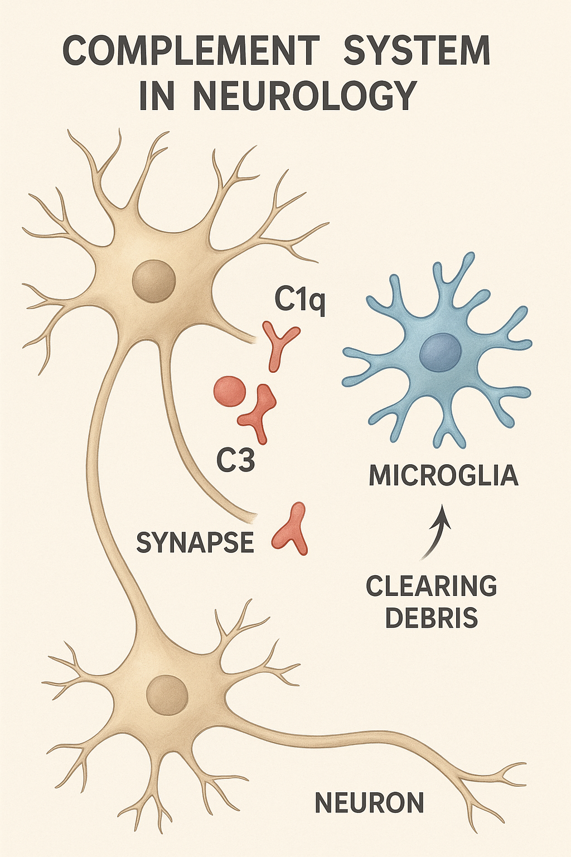

Foundational Review Articles
1. Stevens et al., 2007 – “The Classical Complement Cascade Mediates CNS Synapse Elimination”
A seminal study demonstrating that complement component C1q initiates synaptic tagging and elimination, and microglia act to prune these synapses. This was one of the first major insights linking complement to neural circuit refinement.
2. Schafer et al., 2012 – “Microglia Sculpt Postnatal Neural Circuits in an Activity and Complement-Dependent Manner”
Expands on Stevens et al. to show how neuronal activity and complement coordinate microglial pruning during development.
3. Hong et al., 2016 – “Complement and Microglia-Dependent Synapse Elimination in Pathological Conditions”
Focuses on Alzheimer’s disease models, showing how complement-mediated pruning by microglia contributes to early synapse loss.

Key Reviews on Complement in Neurological Health & Disease
- Ricklin et al. (2010): A comprehensive review of complement activation pathways and regulation—critical for understanding therapeutic targeting.
- Fotuhi et al. (2020): Offers an overview of complement roles in multiple sclerosis, neuromyelitis optica, and neuroinflammation.
- Rogers et al. (2021): Discusses complement in aging, neurodegeneration, and even psychiatric disorders—great for exploring broader implications.

How to Access These Papers
Method | Description
PubMed or Google Scholar | Use titles like "The classical complement cascade mediates CNS synapse elimination" or author names to search.
University Access | If you're affiliated with an academic institution, you may have free access to journals like Neuron, Nature, or Trends in Neurosciences.
Open Access Preprints | Check platforms like bioRxiv or medRxiv—authors often upload pre-publication versions.

Summary of Learnings
- Developmental role: Complement components C1q and C3 tag redundant synapses, which microglia subsequently remove—vital for brain circuitry refinement (Stevens et al. 2007; Schafer et al. 2012).
- Pathological overactivation: In Alzheimer’s models, this mechanism becomes excessive, leading to neurodegeneration (Hong et al. 2016).
- Broader disease relevance: Complement factors contribute to demyelination (e.g., multiple sclerosis), autoimmune attacks (e.g., neuromyelitis optica), and can exacerbate inflammation after brain injuries.

Suggested Reading List (For Search Use)
- The classical complement cascade mediates CNS synapse elimination – Stevens et al., Neuron, 2007
- Microglia sculpt postnatal neural circuits in an activity and complement-dependent manner – Schafer et al., Neuron, 2012
- Complement and microglia-dependent synapse elimination in pathological conditions – Hong et al., Alzheimer’s context, mid-2010s
- Complement system in neurological diseases – Reviews in journals like Trends in Neurosciences, Nature Reviews Neurology, Journal of Neuroinflammation

