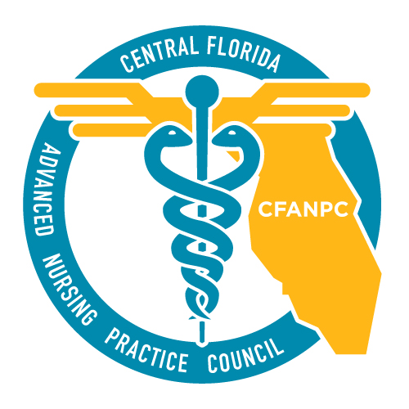

**CFANPC Legislative Update**

**Week of January 10th**

**Authored by: Joseph (Joey) Knoll, MSN, ARNP, CFANPC Legislative Chair**

|  |  |  |  |
| --- | --- | --- | --- |
| **Bill #**  **State / House** | **Supporters & opponents** | **Summary** | **CURRENT STATUS:** |
| **HB 423**  **“Drug Prescription by APRNs and PAs”**  **✪** | Filed by Pigman  (CO-SPONSORS) Combee; Fresen; Latvala; Rouson; Van Zant | *Allows the prescription of controlled substances by Nurse Practitioners and PAs.  *Allows Nurse Practitioners to order medically necessary brand medications. | \***Favorable** by health quality committee 1/8/16 (Votes 12Y;1N)  *Health care appropriations committee **1/12/16 1:30pm** |
| **SB 152**  **“Ordering of medications”**  **\*LIKELY to be Superseded by SB946** | Filed by Grimsley | *Allows the prescription of controlled substances by Nurse Practitioners and PAs. *in Nursing homes and Hospitals only. | \***Favorable** by health policy committee 10/20/15 (votes 9Y:0N)  \***Favorable** by Appropriations Subcommittee on Health and Human Services11/18/15 (votes:8Y:0N) |
| **HB 1241 “Ordering of medication”** | Filed by Plasencia | *Allows the prescription of controlled substances by Nurse Practitioners and PAs. *Under “certain circumstances” (?) | **\*FILED** 1/8/16 |
| **SB 946**  **“Authorized Practices of Advanced Registered Nurse Practitioners and Licensed Physician Assistants”** | Filed by Grimsley | *Allows the prescription of controlled substances by Nurse Practitioners and PAs *in Nursing homes and Hospitals only. | **\*Filed** 11/23/15  * Referred to Health Policy; Appropriations Subcommittee on Health and Human Services; Appropriations |
| **HB 1061**  **“Nurse Licensure Compact”** | Filed by Pigman | *Organizing statutes and allowing Florida to join the “compact states”. This would make RN & LPN licensure would be valid in all participating states. Nurse Practitioners are included. | **\*Filed** 12/29/15  *On agenda for Select committee on Affordable Healthcare Access 1/11/15 |
| **SB 1316**  **“Nurse Licensure Compact”** | Filed by Grimsley | *Organizing statutes and allowing Florida to join the “compact states”. This would make RN & LPN licensure would be valid in all participating states. Nurse Practitioners are included. | **\*Filed** 1/4/16 |
| **HB 325**  **“Involuntary Examinations under the Baker Act” 1 CS** | Filed by Campbell  with Health Quality Subcommittee and Campbell and Plasencia (CO-SPONSORS) Rehwinkel Vasilinda | *Allows Nurse Practitioners (ALL) to perform involuntary examinations under the Baker Act. | *Favorable by Civil Justice Subcommittee 12/2/15 (Votes12Y: 0N)  *Health Quality Subcommittee (Votes 11Y:0N *WITH SUBSTITUTE FILED)  *In Health & Human Services Committee |

Important People:

Steve Crisafulli, Republican, District 51 (Speaker of the house)

Andy Gardiner, Republican, District 13 (Senate President)

Cary Pigman, Republican, District 55 (Health Quality Subcommittee Chair, Healthcare Advocate)

Denise Grimsely, Republican, District 21 (Republican Deputy Majority Leader, Healthcare Advocate)

CLICK HERE -> [Find your Legislator!](http://www.flsenate.gov/senatros/results)

CLICK HERE -> [Find your HOUSE Representative!](http://www.myfloridahouse.gov/sections/representatives/representatives.aspx)