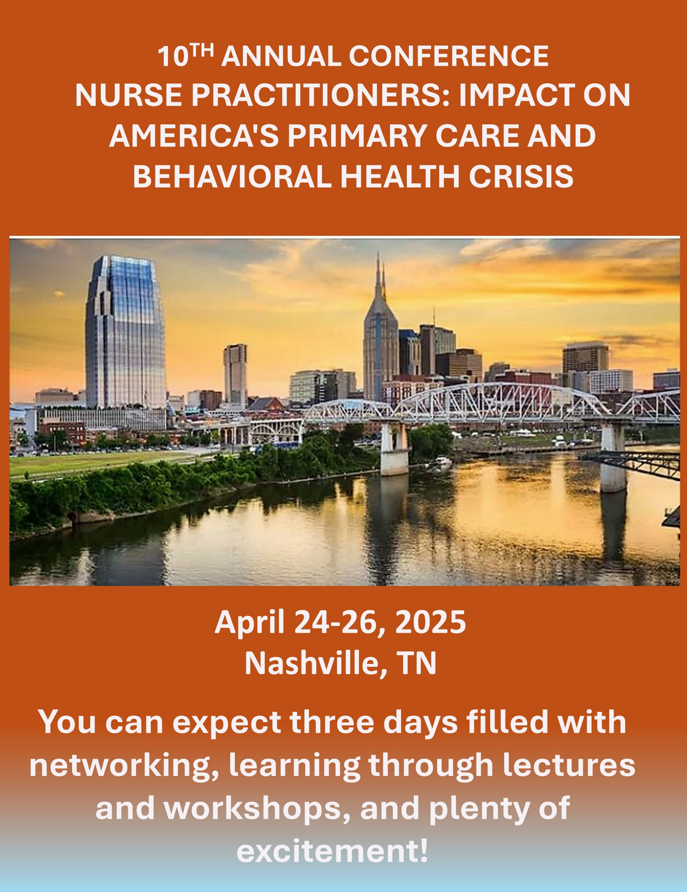



**10th Annual Statewide Conference**

**Gaylord Opryland Resort**

**Nashville, TN**

**April 24-26, 2025**

**“NURSE PRACTITIONERS: IMPACT ON AMERICA'S PRIMARY CARE AND BEHAVIORAL HEALTH CRISIS”**

|  |  |
| --- | --- |
| **THURSDAY, APRIL 24, 2025** | |
| 7:45 am to 8:00 am | **Opening Session/Welcome**  **Dr. Irene Bean, DNP, FNP-BC, FAANP** |
| 8:00 am to 9:00 am | Presentation: Drug Update  **Speaker: Dr. Margaret Fitzgerald** |
| 9:00 am to 10:00 am | Presentation: Complex Case Studies  **Speaker:** **Dr. Margaret Fitzgerald** |
| 10:00 to 10:15 | **Break – Visit the Vendors** |
| 10:15 am to 11:15 am | Presentation: Identifying Addiction and Approach to Treatment in Primary Care  **Speaker:** **Stacey Maltman, FNP-BC, CEN** |
| 11:45 am to 1:00 pm | Sponsored Lunch/Exhibit Hall  **Product Theatre (Non-CE)** |
| 1:00 pm to 2:00 pm | Presentation: Artificial Intelligence and Nurse Practitioners  **Speaker: Dr. Stephen Ferrara, DNP, FNP-BC, FAAN, FAANP, FNAP, FNAM** |
| 2:00 pm to 3:00 pm | Presentation: Management of Co-occurring Mental Health Disorders in Patients with End Stage Kidney Disease (ESKD)  **Speaker: Toddra Liddell,**  **MSN, APRN, FNP-C, PMHNP-BC** |
| 3:15 pm to 3:30 pm | **Break – Visit the Vendors** |
| 3:30 pm to 4:30 pm | Presentation: Adding GLP-1 Drugs for Diabetes and Weight Loss to Practice  **Speaker** |

**CE’s = 6**



**10th Annual Statewide Conference**

**Gaylord Opryland**

**Nashville, TN**

**April 24-26, 2025**

**“NURSE PRACTITIONERS: IMPACT ON AMERICA'S PRIMARY CARE AND BEHAVIORAL HEALTH CRISIS”**

|  |  |
| --- | --- |
| **FRIDAY, APRIL 25, 2025** | |
| 8:00 am to 9:00 am | Presentation: Medical Billing and Coding  **Speaker:** **Diane Rybacki, ACNP-BC** |
| 9:00 am to 10:00 am | Presentation: Identifying Outcomes of APRN Practices  **Speaker: Dr. Ruth Kleinpell, PhD., ACNP-BC, FAAN, FAANP, FNAP, MCCM** |
| 10:00 am to 10:15 am | **Break – Visit the Vendors** |
| 10:15 am to 11:15 am | Presentation: Know your Why and Know your Worth – NP Practices Say it All  **Speaker: Dr. April Kapu, DNP, APRN, ACNP-BC, FAANP, FCCM, FAAN** |
| 11:30 am to 12:45 pm | Sponsored Lunch/Exhibit Hall  **Product Theatre (Non-CE)** |
| 1:00 pm to 2:00 pm | Presentation: Seeing the Forest for the Trees: Recognizing Potential Amyloidosis in Your Patients  **Speaker: Dr.**  **Dan Lenihan, MD, FACC, FESC, FIC-OS** |
| 2:00 pm to 3:00 pm | Presentation: The Invisible Battles: Nurse Practitioners, Mental Health, and the Cost of Caring  **Speaker: Dr. Irene Bean, DNP, FNP-BC, PMHNP-BC, FAAN, FAANP, FNAP** |
| 3:00 pm to 3:15 pm | **Break – Visit the Vendors** |
| 3:15 pm to 4:15 pm | Presentation: Alzheimer's Disorder/Virtual Reality Simulation  **Speaker: Dr. Kanah Lewallen,**  **DNP, AGPCNP-BC, GNP-BC, CHSE** |

**CEs = 6**



**10th Annual Statewide Conference**

**Gaylord Opryland**

**Nashville, TN**

**April 24-26, 2025**

**“NURSE PRACTITIONERS: IMPACT ON AMERICA'S PRIMARY CARE AND BEHAVIORAL HEALTH CRISIS”**

|  |  |
| --- | --- |
| **SATURDAY, APRIL 26, 2025** | |
| 8:00 am to 9:00 am | Presentation: Professional Development  **Speaker: Diane Rybacki, ACNP-BC** |
| 9:00 am to 10:00 am | Presentation: Nursing Entrepreneurship: What the Future Holds  **Speaker:** Veronica Smith (Vee the NP) |
| 10:00 am to 10:15 am | **Break – Visit the Vendors** |
| 10:15 am to 12:15 pm | Presentation: Pain Management & Opioids: A Patient-Centered Approach  **Speaker:**  **Theresa Mallick-Searle, MS, PMGT-BC, ANP-BC** |
| 12:15 pm to 1:00 pm | Sponsored Lunch/Exhibit Hall  **Product Theatre (Non-CE)** |
| 1:00 pm to 4:00 pm | Presentation: BOTOX WORKSHOP  **Speaker: Dr. Collette Domenicone, DNP, FNP-BC, NP-C** |
| 1:00 pm to 4:00 pm | Presentation: TRIGGER POINT INJECTION WORKSHOP  **Speaker:** |
| 1:00 pm to 4:00 pm | Presentation: EKG WORKSHOP  **Speaker:** |

**CEs = 4**

**Workshop CEs = 3 per workshop**

**Total: CEs = 16 for lectures**

**\*\*An additional 3 CEs for workshop = 19 CEs**