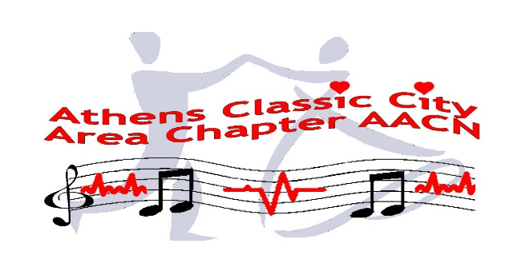

**AACN Chapter Symposium**

**Friday, October 23, 2015 from 0900-1200**

**St Mary’s Hospital Assembly Room, 1230 Baxter St, Athens**

**0900-1000 Dr. Amit Shah, Cardiologist**

**Non-pharmacologic Treatment for Tachycardia**

**1010-1050 AACN Webinar**

**It’s all about breathing: ETCO2**

**1100-1200 Dr. Roger Lovell, Infectious Disease**

**Treating Infection in the Diabetic Patients**

**Contact hours TBD**

**Free to AACN chapter members. Non-member $15.00 fee. Registration starts at 0830**

**Light refreshment will be provided**

**Parking on your own**

**RSVP: Margie Nicolaus, RN, CCRN-CMC Chapter President-elect**

**706-247-1966 (C) or** [**mnicolaus@windstream.net**](mailto:mnicolaus@windstream.net)