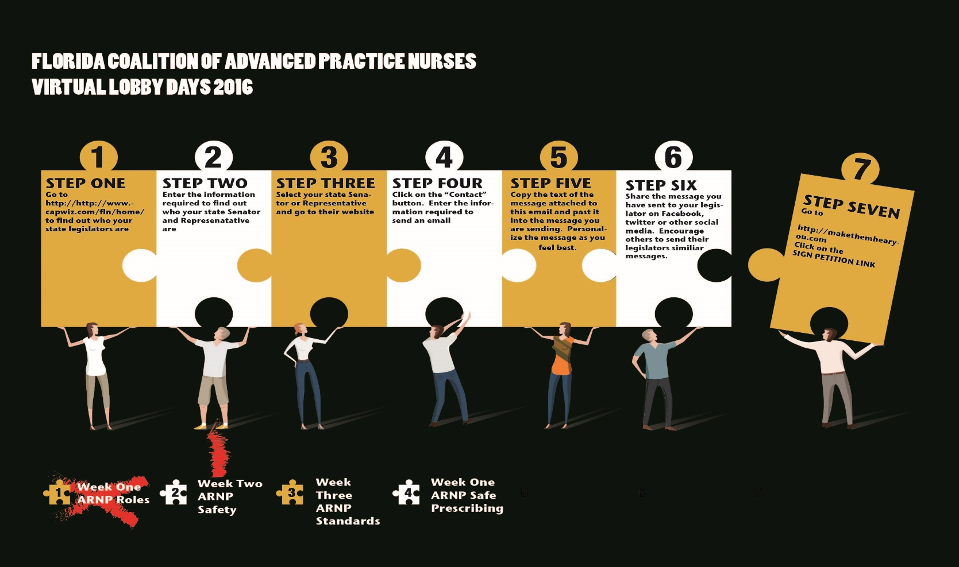

Florida Nurse Practitioner Network is participating in a coordinated weekly Virtual Lobby Day project with the other advanced practice nursing associations in the Florida Coalition of Advanced Practice Nurses. Your involvement is imperative in order to make this a success. Each week you will be receiving an email with a prepared message. Please take a few minutes to send the communication to your legislators. Please try to send on Wednesdays if possible, but if you miss Wednesday, send it out as soon as you can.

By working together with all the advanced practice nursing associations and speaking with one voice we can have a successful campaign!

Thank you in advance for your participation.

Links to finding your legislators :

House of representatives address to find representatives:

http://www.myfloridahouse.gov/Sections/Representatives/representatives.aspx

Senate link to find senators:

http://www.flsenate.gov/Senators/Find

**THE GOAL FOR WEEK 2 OF VIRTUAL LOBBY DAYS : Educating Legislators about the proven safety of Advanced Practice Nurses**

Sign The Petition:

Please take a moment to sign the petition target at key legislators:

https://www.change.org/p/andy-gardiner-dorothy-hukill-tom-lee-john-legg-bill-montford-joe-negron-eleanor-sobel-kellistargel-increase-access-to-care-in-florida?recruiter=41346252&utm_source=share_for_starters&utm_medium=copyLink

Telephone Message:

Please call, write or email your Legislators and tell them the following:

Email Message:

Dear Representative or Senator) ______________________

My Name is __________________________. I wanted to share some important information about Advanced Practice registered Nurses ( ARNPs). Please feel free to contact me if you have any questions about ARNPs in Florida.

**APNs: Setting the Standards of Safety**

Advanced Practice Nurses (APNs) include Nurse Practitioners (“ARNP” in Florida), Certified Nurse Midwives (CNMs) and Certified Registered Nurse Anesthetists (CRNAs).

* **More than 50 years of research supports the safety, effectiveness and high quality of care that Advanced Practice Nurses provide to their patients**.  Healthcare outcomes have been found to be comparable between Advanced Practice Nurses and Physicians nationwide.  Notably, patient satisfaction rates are typically higher with healthcare provided by an Advanced Practice Nurse.
* The Institute of Medicine (IOM) report entitled *The Future of Nursing: Leading Change, Advancing Health* states, “…what nurse practitioners are able to do once they graduate varies widely for reasons that are not related to their ability, education or training, or safety concerns, but to the political decisions of the state in which they work” (page S-4).
* “Full Practice Authority” laws have passed in **19 states** and the District of Columbia allowing Advanced Practice Nurses to evaluate, diagnose, order and interpret diagnostic tests, initiate and manage treatments (including the ability to prescribe medication) under the exclusive licensure authority of the state Board of Nursing.  No state has ever rescinded Full Practice Authority laws once passed.
* “**No studies suggest that care is better in states that have more restrictive scope-of-practice regulations for APNs than in those that do not.**  Yet most states continue to restrict the practice of APNs beyond what is warranted by either their education or their training” (IOM, page 3-13).

There are over 14,000 Advanced Practice Nurses that are licensed in the state of Florida.  If they were able to provide care to their full potential, more Floridians would have access to safe, highly quality, patient-centered health care.

Sincerely,

Your Name

Your Address