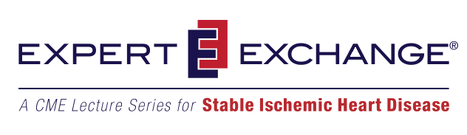

You are invited to attend a certified CME/CE Activity

Wednesday, October 07, 2015
7:00 PM - 8:30 PM
Athens, GA

Special Guest Educator:
Kathleen Drinan, DO
Associate Member, Section of Cardiology
University of Chicago

Presenting:
Women and SIHD

Porterhouse Grill
459 East Broad St
Athens, GA 30605

To view the full text of the invitation, which includes the course objectives and accreditation information, please open the attachment to this email.

Please register your response by clicking here
or by visiting, http://www.expertexchange-sihd.com, clicking Attendee Registration and entering the Event Code code below (no invitation code is required).

Event Code: 23530025

If you need any further assistance or information please contact me using the information below:
Roberta Bartlett
Lead Project Director
Practice Point Communications
630 Brooker Creek Blvd.
Suite 305
Oldsmar, FL 34677
813.891.6999

