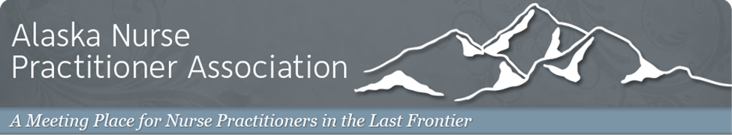

General Membership and Executive Board Meeting Agenda  
 Wednesday, October 30th, 2019 @ BP Energy Center

**President**- Jill Jasinski

* National NP Week (November 10-16)
* Holiday Party- January *
* Conference Planning 2020
* Nominations for President-Elect and Secretary *
* Spring Training Event-hosted by Imaging Associates
* Ideas for increasing general membership
* APRN Alliance and Lobbyist agreement *

**Immediate Past President-** Nick Manwaring

* Legislative update

**Secretary-** Nicole Zonzel

**Treasurer-** Stephanie Packard

* Financials from 2019 ANPA Conference

**Assistant-** Charity Manwaring

* Conference wrap-up

The next ANPA General Membership and Executive Board meeting will be on Tuesday, November 26th at 6:15pm in the BP Center.

There will not be a General Membership meeting in December.

(*) Executive Board agenda