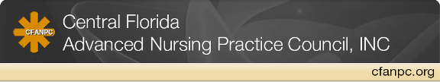**CFANPC SCHOLARSHIP APPLICATION**

**INFORMATION:** (Please include checklist and required items with application)

1. APPLICANT’S NAME:
2. HOME ADDRESS:
3. PHONE:
4. E-MAIL ADDRESS:

**RN LICENSE NUMBER AND STATE:**

**APN PROGRAM INFORMATION:**

Name of current program:

Type of program and degree sought:

Expected graduation date:

Current graduate grade point average:

Name and Phone number of program Director:

**MEMBERSHIP:** Are you a current CFANPC member? _____ Applicants must be a member in order to apply for this scholarship. See website for membership information.

**EDUCATIONAL BACKGROUND:**

COLLEGE / UNIVERSITY DEGREE DATE OF COMPLETION

**PROFESSIONAL EMPLOYMENT:** (Include only past 5 years)

EMPLOYER POSITION DATE OF EMPLOYMENT

**COMMUNITY / VOLUNTEER SERVICE ACTIVITY:** (include dates)

**PROFESSIONAL ASSOCIATIONS AND OFFICES HELD:** (include dates)

**ESSAY:** (Limit to 500 words or less)

*Why did you want to become an Advanced Practice Nurse? Discuss your journey.*

**Mail Application to Susan Smith 3234 Wald Road Orlando Florida 32806.**

**Email Questions/applications to susan.smith4@orlandohealth.com**