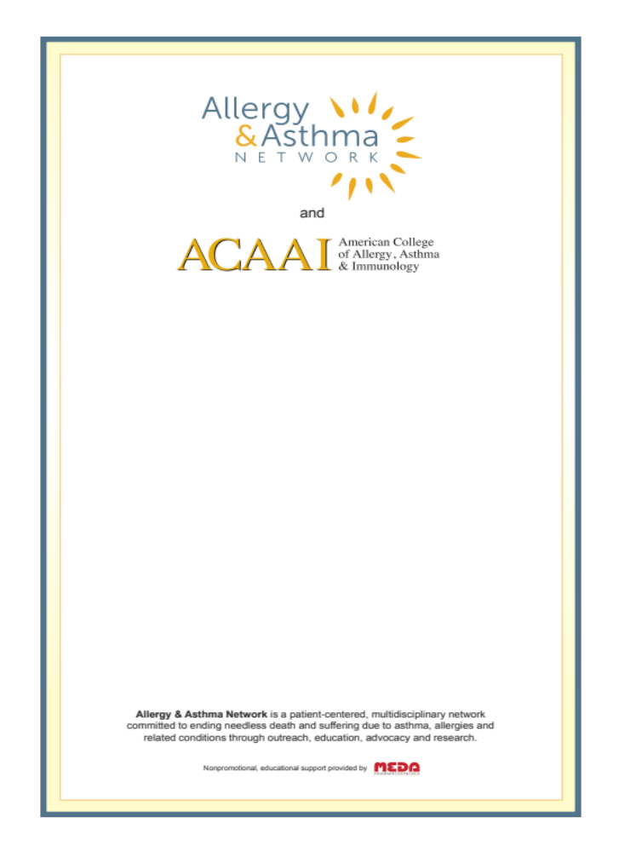
Goals of Pediatric Rhinitis & Wheeze Case CME:

- Share best practices for managing rhinitis & wheeze in children
- Reinforce evidence-based guidelines care & discuss new treatments
- Create patient-centered collaborative healthcare teams throughout the US
- Have fun learning while enjoying a delicious meal
Allergy & Asthma Network is the leading nonprofit family health organization whose mission is to end needless suffering and death due to asthma, allergies and related conditions through outreach, education, advocacy and research.

The organization was founded as Mothers of Asthmatics in 1985 to help families affected by asthma and allergies. Today, Allergy & Asthma Network’s core areas of expertise remain the same----outreach, education, advocacy and research. From diagnosis to control, from diapers to adulthood —--- The Network is your one-stop, family-to-family support network.

The American College of Allergy, Asthma and Immunology, established in 1942, is a professional association of more than 6,000 Allergists/Immunologists and allied health professionals.

The College provides its members with continuing medical education, publications and representation to managed care organizations, medical organizations, consumer and patient groups, and government and regulatory agencies. The College also develops and disseminates educational information to patients, other physicians, health professionals and health plan administrators.

Problem-Based Learning is an interactive case-based format that progressively discloses relevant clinical data while participants are encouraged to actively think through the case just as they would in their offices or clinics. It is dependent on each of you actively participating while remembering there are no right or wrong answers. 1 credit of AMA PRA CME & dinner will be provided free of charge.

