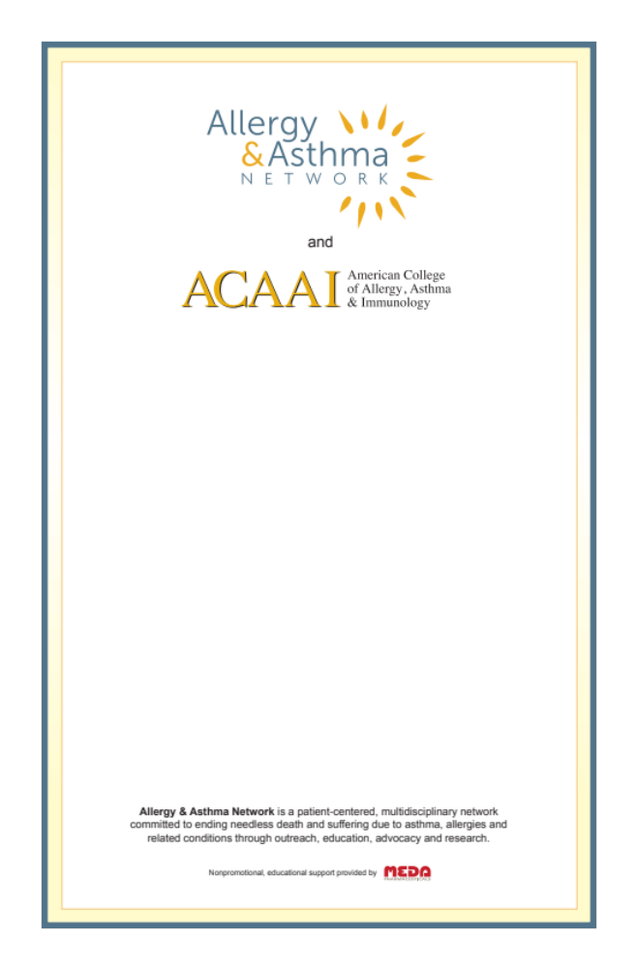

invite you to attend an
Interactive Case Discussion
Pediatric Rhinitis & Wheezing
Dr. Rohit Katial
Wednesday, May 20, 2015 and
Thursday, May 21, 2015
6:30 PM - 8:30 PM
Marriott Tech Center, 4900 S Syracuse, Denver, CO
CME offered • Dinner served
No charge
Space is limited to first 20 registrants each night.
Must RSVP to
http://denver-cme.eventbrite.com

