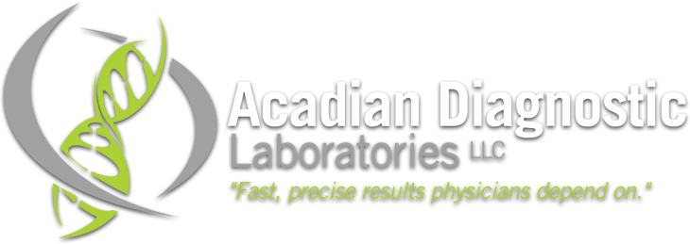

Please join us for dinner and a presentation on

“Urine Drug Screening: Practical Guidelines for Clinicians”

Drago’s Seafood 3232 N. Arnoult Rd. Metairie, LA 70002

March 12, 2015 6:30

Contact info: Shari Taylor Regional Marketing Specialist Acadian Diagnostics (985) 778-9141