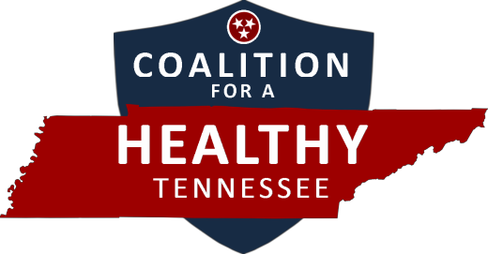

Insure Tennessee Day on the Hill

WHEN Feb. 3, 2015
9 a.m. – 3 p.m.

WHERE Tennessee State Capitol
Nashville, TN

NASHVILLE Meet at James K. Polk Theater (505 Deadrick St.), 9 a.m. for
ATTENDEES: briefing

OUT-OF-TOWN
ATTENDEES: James K. Polk Theater (505 Deadrick St.), 11 a.m. for briefing

CLICK HERE TO COMMIT

(The registration link is being hosted by THA for use by you and other non-THA
members for this event.)

Follow the Coalition

On Facebook: https://facebook.com/insuretennesseenow

On Twitter: @InsureTNNow

At the website: www.coalitionforahealthytennessee.com

