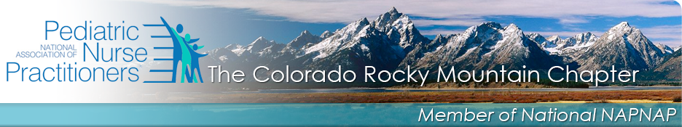

Date: MONDAY, January 12, 2015 Location: Ronald McDonald House Denver
6:15 – 6:45 PM Board Meeting 1300 East 21st Avenue
6:45 to 8 PM Lecture/Discussion Conference Room
Denver, CO 80205

Speakers:
From Infant Massage USA

Will speak on:
Infant Skincare, Touch, and Massage
Course Outcomes

- Identify three benefits of infant massage for babies.

- Identify three benefits of infant massage for parents.

- Define the elements of the LEARNS approach when interacting with babies.

- Describe two ways to implement nurturing touch in their practice setting.

Accreditation by the National Association of Pediatric Nurse Practitioners (NAPNAP) for 1.5 NAPNAP CE contact hours.

Please click on this link to reserve a place by January 9th, 2015, https://rmnapnap.enpnetwork.com/nurse-practitioner-events/36351-january-board-member-meeting-ce. Register early to reserve your place. SEATING IS LIMITED: RESERVE EARLY

Please contact Amy Goodier at a.goodier@pediatrics5280.com with any questions.

Development of the Chapter Lecture Series was supported through an educational grant from Johnson & Johnson Consumer Companies, Inc.

