Florida Gulf Coast NAPNAP Chapter
presents

6TH Annual Developments in Pediatric Heath Care Conference
Saturday January 10, 2015
8:00 am- 1:00pm

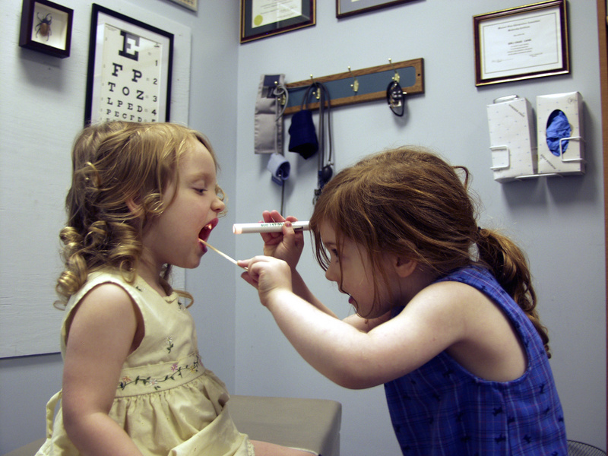

All Children’s Hospital
Education Conference Center
701 4th Street South
St. Petersburg, Florida 33701

3.5 CEU’s

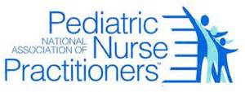

Schedule
7:30-8:00 Registration/ Breakfast
8:00-9:00 Addressing Parental concern about Vaccine Safety
David Berman, D.O., F.A.A.P
9:00-920 Break/Vendors
9:20-10:20 Minor Injuries: When to Treat and When to Refer
Amanda Rae Daniels, ARNP, DNP, PPCNP-BC, CPNP-AC
10:20-10:40 Break/Vendors
10:40-1230 Human Sexual Trafficking: Clinical Perspectives for Pediatric Practice Jennifer Marks, MA
C Ernewein, MSN, ARNP, FNP-C
12:30-1:00 Evaluations/Raffle

Registration by mail or on line at www.flgulfcoastnapnap.org
COST:
$40 Members
$50 Non-Members
$30 Students/Retirees

Checks Payable to:
Florida Gulf Coast NAPNAP Chapter
Mail to:
5202 Hampton Beach Place
Tampa, FL, 33609

REGISTRATION:
Name__________________________________________________________________
Member Number:________________________________________________________
Address:_________________________________________________________________
__________________________________________________________________
Email:___________________________________________________________________

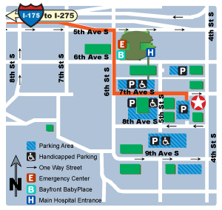

SPEAKERS:

David Berman, D.O., F.A.A.P
Division of Pediatric Infectious Disease
All Children’s Hospital-Johns Hopkins Medicine

Amanda Rae Daniels, ARNP, DNP, PPCNP-BC, CPNP-AC
All Children’s Hospital
General Surgery

Jennifer Marks, MA
World Relief Tampa

C Ernewein, MSN, ARNP, FNP-C
Hillborough County School District



