It is time to celebrate!

Mt Baker Nurse Practitioner’s Association’s 5th Anniversary

And

Nurse Practitioner Week



Tuesday, November 11, 2014

7-9 pm

at

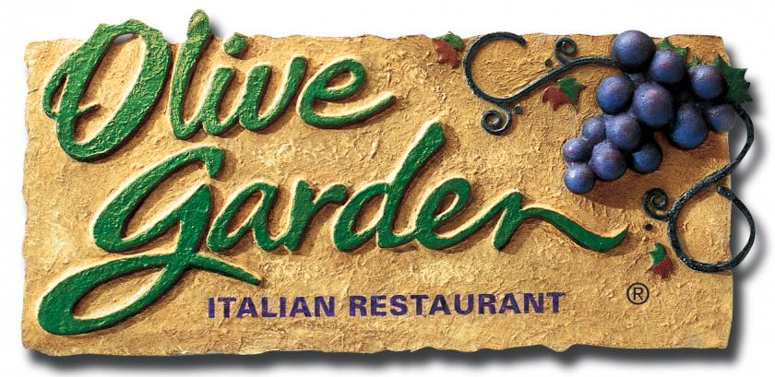

4276 Guide Meridian, Bellingham, WA 98226

Attend our brief annual business meeting

Network with colleagues from across the county

Appetizers & light refreshments provided

Wine available for purchase

Free to all members, guests $15.00

Check website to see if your membership has lapsed, if you renew at the event or at the website prior to event it will still be free.

RSVP at: [www.MBNPA.org](http://www.MBNPA.org)