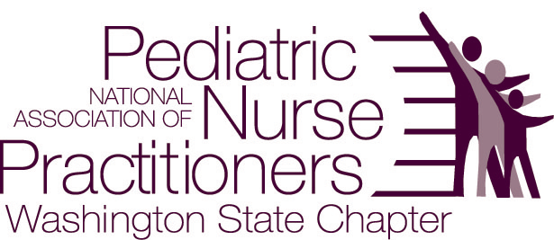

Pediatric Otology: A Hands-on Approach to Improving Your Ear Exam
Presented by Patricia Cleary, ARNP; Ronna Smith, ARNP; Ashley Harris-Deutch, ARNP
Jennifer Mussman, ARNP Seattle Children’s Hospital Otolaryngology Clinic
Monday, May 5, 6-8pm
6-6:15 introductions and light dinner provided
6:15-7:15 didactic presentation designed to increase confidence in the exam of the pediatric ear, differentiate AOM and OME, improve identification of otologic abnormalities, and improve management of cerumen and foreign bodies
7:15-7:45 hands-on skill stations
7:45-8:00 questions and answer session
Where: Seattle Children’s Hospital, Otolaryngology Clinic, Ocean 8. Meet in the waiting room and follow the arrows to the conference room
Electronic Registration by May 1st: http://wanapnap.enpnetwork.com Please list your National NAPNAP member number
Registration is limited to 20 participants. We anticipate a waiting list, so if your plans change please let us know ASAP by contacting: Anne Pettinger, apettinger@pedsnw.net
Cost: No charge for NAPNAP members $10 for non-members. Payable at the door (cash or check)
This program is approved for 2.0 contact hours of which 0.25 contain pharmacology (Rx) content per the National Association of Pediatric Nurse Practitioners Continuing Education Guidelines

