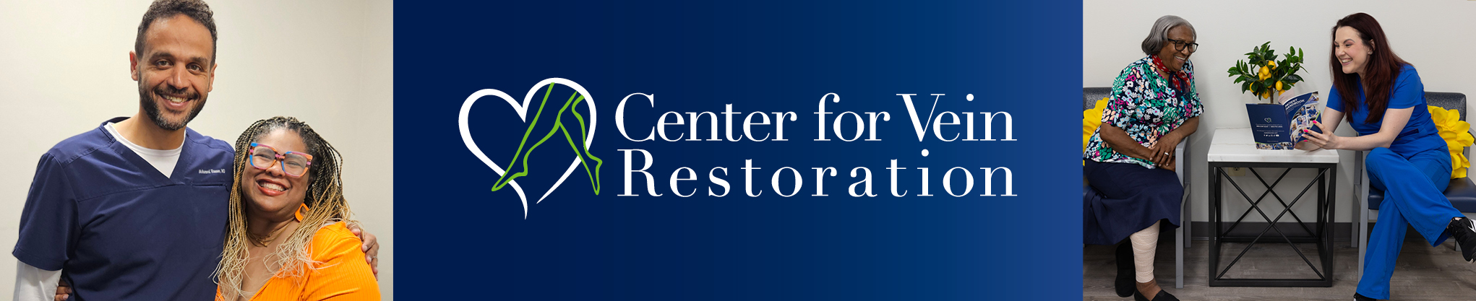
Southern Delaware/Maryland’s Eastern Shore NP/PA’s
Dinner sponsored by:
Center for Vein Restoration
Location: Rare Steak House
17252 North Village Main Blvd.
Lewes, DE 19958
302-550-7961
Date: Wednesday, June 3rd
Time: 5:30 – 7:30PM
Speaker: Dr. Robert Fried, Cardio-Thoracic Surgeon
Please RSVP to Greg Kucera, Physician Liaison for CVR
Gregory.kucera@centerforvein.com
484-723-9678
Dinner will be buffet style and will include:

Steak
Seafood
Salad options
Dessert

Cash Bar

